Ohio Migrant Education Program Comprehensive Needs Assessment 2018

PRODUCED BY C H SMITH & ASSOCIATES, LLC

REVISED OCT. 10, 2018

Acknowledgements
The comprehensive needs assessment process was funded by the Ohio Department of Education.
This document was produced by C H Smith & Associates, LLC, 289 C Northland Blvd, Springdale, OH 45246.

Project Team:
Calista H. Smith
Andrew Menger-Ogle, Ph.D.
David Sparks
Kelly Sparks

Table of Contents
Acknowledgements 2
Table of Figures 4
Table of Tables 4
Executive Summary 6
Comprehensive Needs Assessement Purpose And Process 7
Preliminary Work 9
Program Goals 9
Migrant Student Profile 11
Exploring What is 15
Migrant Education Program Implementers and Services 15
Seven Areas of Concern 17
Concern Statements 18
Gather and Analyze Data 20
Results on Initial Need Indicators 20
Strengths, Weaknesses, Opportunities, Threats Analysis 31
Making Decisions 36
Proposed Solutions 36
Suggestions for measurable program outcome metrics 40
Supporting Research and Promising Practices 42
Conclusion 45
Appendix A 46
Definitions Used in the Needs Assessment Process 46
Appendix B 47
Needs Assessment Committee Membership List 2017-2018 47
Appendix C 48
Monthly Qualifying Arrival Trends by Site 48
Appendix D 52
Alignment of Needs Statements, Solutions, Potential Implementation Metrics and Potential Outcome Metrics 52

Table of Figures
Figure 1: Needs Assessment Process. 7
Figure 2. Selected Demographics of the Ohio Migrant Student Population in the 2016-2017 School Year. 10
Figure 3: Ohio Migrant Student Population & Migrant Education Program Trends. 10
Figure 4. Location of Local Education Agencies that are Migrant Education Program Summer Program Sites in 2016-2017. 15
Figure 5: Percentage of Students at or Above Proficiency in Reading/Language Arts. 19
Figure 6:Percentage of Students at or Above Proficiency in Math. 20
Figure 7: Proficiency and Representation of Migrant Education Program Students with LEP Designation for the Ohio Reading and Language Arts Assessment. 22
Figure 8. Proportion of Migrant Children and Adults who Received Different Levels of Vision Health Services. 22
Figure 9. Proportion of Migrant Children and Adults who Received Different Levels of Dental Health Services. 23
Figure 10: Percentage of Students Who Were Enrolled in Grades 7-12 and Graduated or Were Promoted to the Next Grade Level (School Year 2016-2017). 24
Figure 11: Percentage of Students Who Entered 11th Grade and Received Full Credit for Algebra I or Who Were Enrolled in Non-remedial Math Courses for Which Algebra I Was a Prerequisite. (School Year 2015-2016). 25
Figure 12. Out-of-School Youth Identified and Served. 26
Figure 13: What Additional Resources do you [as a Parent] Believe Schools Should Provide? 28
Figure 14: What Needs do you [as a Parent] Have for Assisting your Child Educationally at Home? 29

Table of Tables
Table 1. 2025-2026 ESSA Goals of Selected Academic Domains for all Ohio Students and Select Student Groups. 10
Table 2: Ohio Migratory Work and LEA Locations. 12
Table 3: Migrant Student Population Profile (School Year 2016-2017) 14
Table 4: 2018 concern statements and related U.S. Department of Education Office of Migrant Education Areas of Concern. 18
Table 5: Concern Statement Topic and Related Initial Need Indicators. 19
Table 6: Ohio Reading Language Arts Proficiency Data and Need. 21
Table 7: Ohio Math Proficiency Data and Needs. 22
Table 8: Ohio English Language Proficiency Assessment Data and Needs. 22
Table 9: Health Data and Needs. 24
Table 10: High School Performance Data and Needs. 26
Table 11: Out-of-School Youth Participation Data and Need. 28
Table 12: Early Learning Data and Need. 29
Table 13: Themes and Quotes Regarding What Migrant Education Program Parents Thought Schools Should Provide. 29
Table 14: Themes and Quotes about what Migrant Education Program Parents Wanted for Additional Educational Support at Home. 30
Table 15: Parent Survey Data and Needs. 31
Table 16: Proposed Solutions for Needs Statements. 36
Table 17: Proposed Measurable Program Outcomes for Monitoring Progress in the Key Areas. 40

Executive Summary
The Ohio Migrant Education Program addresses the educational needs of Ohio youth in migratory families. The U.S. Department of Education requires each state that receives Title I, C funds for migratory student education to do a comprehensive assessment of these students’ needs. This report of Ohio’s comprehensive needs assessment outlines a process, needs and potential solutions for improving educational results for Ohio’s migratory students.
Of Ohio’s 1.7 million students, 1,146 are members of migratory families. They attend schools in 62 school districts where local industries hire migratory workers. Of those students, the Ohio Migrant Education Program serves 751. Services include summer programs, fall supplemental services and theme-based Improving Migrant Academic Gains Educationally (IMAGE) programs.
Ohio Migrant Education Program participation rates by grade level are between 60 percent and 80 percent. Prekindergarten students, 11th grade students and 12th grade students participate at lower rates, ranging from 40 percent to 45 percent. Of all the students served by Migrant Education Program, 47 percent were designated as a Priority for Service.

Ohio’s comprehensive needs assessment committee examined four areas to identify for the state concerns about educating migratory children:
- Ohio’s profile of current migrant students;
- Past performance of the Ohio Migrant Education Program;
- Seven concerns pinpointed by the U.S. Department of Education’s, Office of Migrant Education; and
- Current Ohio Migrant Education Program operations.

Here are Ohio’s eight concerns:
- Lack of educational continuity, instructional time and school engagement that affect migrant students’ proficiency in math, reading and language arts;
- Need for English language development at all stages of a migrant student’s education;
- Importance of student access to health services to ensure success;
- Barriers to instructional time, school engagement and services that hinder high school students from collecting course credit and preparing for postsecondary success;
- Lack of participation of out-of-school youth in educational and vocational services that would help them develop social responsibility and secure productive employment;
- Opportunity to provide the youngest migrant students with instructional time and access to services through early learning programs;
- Chance to strengthen parents’ knowledge of Migratory Education Services; parents’ comfort in navigating education systems; students’ access to learning materials and technology; and guidance on balancing education and work priorities for high school students.

The committee pinpointed initial evidence – or indicators – of need and gathered data related to those indicators. The data showed that Ohio needs to seek increases in the percentage of Migrant Education Program students scoring proficient in reading, English language arts and math. Because less than 15 percent of Migrant Education Program students take Ohio’s State Tests, Ohio also must increase student learning in reading and math domains broadly as measured by other indicators. Progression in English fluency among Migrant Education Program English learners also is a priority.

Ohio’s comprehensive needs assessment committee also considered the health needs of migrant students, noting schools and districts are screening many students for dental and vision services but not identifying their medical, emotional, and social needs and connecting them to those kinds of services. Committee members called for ensuring that students are receiving the needed vision and dental treatments, as well as their social and emotional needs.

The data showed that Ohio needs to increase Migrant Education Program participation among high school and out-of-school youth. While Ohio high school graduation and Algebra I completion rates do not reflect some Migrant Education Program student data, Ohio still needs to increase the rates to meet goals and the performance rates of all Ohio students called for in the Every Student Succeeds Act.

Ohio has not collected Kindergarten Readiness Assessment data for Migrant Education Program students who received early learning services, but leaders want the kindergarten readiness rates of those students to match that of all Ohio children.

The needs assessment committee also looked at parent survey data and included a parent representative on the needs assessment committee to pinpoint educational supports families need at home and support increased student performance.

The committee matched data from the needs indicators with quantitative and qualitative data from past evaluations to set up an analysis of the Migrant Education Program’s strengths, weaknesses opportunities and threats (a SWOT analysis). Conclusions from the analysis would help the needs assessment committee make decisions. Informed by a variety of resources, the needs assessment committee proposed solutions for the service delivery plan. The committee anticipates some of the solutions will call for significantly more effort than previous solutions include. They include the following:
- Empowering students through student-led, project-based learning;
- Using the San Diego Quick Assessment in the student identification process;
- Providing more in-home instructional services and access to technology for IMAGE students;
- Conducting consistent and continuous professional learning for Migrant Education Program instructors and supplemental school staff on English language development;
- Giving migrant students more career-technical educational experiences;
- Offering more parent education on Migrant Education Program services, especially about working-age children, potentially relying on parent-to-parent conversations and engagement.

Measurable Program Outcome metrics for both implementation outcomes and student performance outcomes were proposed to inform the next service delivery plan.

The needs assessment concludes with a list of resources, information and next steps for disseminating the assessment and using it to guide the service delivery plan.

Comprehensive Needs Assessment Purpose And Process

The U.S. Department of Education requires states receiving Title I, Part C funding to produce a Comprehensive Needs Assessment as a part of a continuous improvement cycle. This needs assessment document builds a bridge between program evaluation data over the last three years and the 2019-2020 service delivery plan by taking the lessons from the past and an understanding of the present to give direction for the future of Migrant Education Program. It identifies needs and potential solutions based on the process recommended in the “Migrant Education Comprehensive Needs Assessment Toolkit” produced by the U.S. Department of Education’s Office of Migrant Education. The figure below summarizes the steps and definitions of terms found in Appendix A.

Figure 1: Needs Assessment Process.

Preliminary Work
The foundational work of the needs assessment started with a Request for Proposal process selecting C H Smith & Associates as program evaluator and facilitation consultants of the needs assessment process. Both the migrant education director and C H Smith & Associates reviewed Office of Migrant Education regulations, program goals and guidance. The director also assembled the needs assessment committee consisting of district Migrant Education Program directors and staff, Ohio Migrant Education Center leaders, state support team representatives, Ohio Department of Education staff members and a parent. The needs assessment committee membership roster appears in Appendix B.

C H Smith & Associates, with additional support from Maple Grove Objective, produced an Ohio migrant student profile based on the 2016-2017 program year. It shared the profile with all Migrant Education Program district and community school program directors and the needs assessment committee in meetings held during March and April 2018.The profile also appears in this document and informed the program evaluation.

Exploring What Is
March 15, 2018, the Migrant Education Program district program directors and additional staff reviewed data from the migrant student profile and 2017 program evaluation. The group then reviewed the Migrant Education Program Concern Statements from 2014, comparing them to the current state analysis; the U.S. Department of Education, Office for Migrant Education seven concern areas; Ohio’s Migrant Education Program goals and the Ohio Every Student Succeeds Act (ESSA) plan goals. Participants proposed revisions and potential need indicators based on the information presented and their experiences working with migrant students. The group discussed areas where they saw areas of need and opportunities to review or collect additional data. Needs assessment committee members refined the proposed concern statements in an April 9, 2018, meeting.

Analyze and Gather Data
The consultants reviewed data on the current state of the Ohio Migrant Education Program and conducted surveys and interviews. It surveyed needs assessment committee members to identify priorities for future efforts, allocation of resources, bolstering strengths and addressing weaknesses. The consultants then interviewed stakeholders from the Ohio Migrant Education Program districts to gain more specific insight into items identified through the needs assessment committee survey.

The aforementioned SWOT analysis summarized the state of the Ohio Migrant Education Program in based on the 2017 program evaluation focus (2015-2016 program activities), the 2017 National Summer Learning Association Report on the Ohio Migrant Education Program, 2017 parent surveys, results from the needs assessment committee survey and insights from stakeholder interviews.

C H Smith & Associates gathered additional data and prepared an analysis based on the 2016-2017 performance period and performance trends over the last three years. The consultants looked at available data related to the concern statements and prepared a gap analysis (a summary of unmet needs) for the needs assessment committee.

On April 9, 2018, the needs assessment committee discussed the gap analysis and needs statements proposed. In small groups, participants began discussing solutions to address the needs.

The evaluation team then researched best practices in the field to review the suggested solutions. The resources from which the team drew those best practices can be found in the Supporting Research and Promising Practices section of this report.

Make Decisions
June 12, members of the needs assessment committee met to review needs statements and prioritize solutions. Members divided into work groups to explore solutions for the concerns and needs statements. Each group described the activities, if they were evidence- based, and what level of effort should be allocated to this strategy compared to previous years. Review of solutions related to needs statements occurred as a group, except for health and social needs and early learning due to time constraints.

C H Smith & Associates compiled the notes from the conversation and drafted the needs analysis. The needs analysis was sent to Ohio Migrant Education Center and the Ohio Department of Education for initial review and feedback and then submitted to needs assessment committee members for final approval.

Preliminary Work

Program Goals
As stated in the executive summary of this report, of Ohio’s 1.7 million students in 2016-2017, 1,146 are members of migratory families. The Ohio Migrant Education Program, sponsored by federal Title I, Part C, is implemented by the Ohio Department of Education with help from the Ohio Migrant Education Center and eight school districts. The federal migrant program asks states to root programs in the ESSA performance targets, either specifically designated for migrant students or for all students. Ohio does not have separate ESSA performance targets for migrant students. The Ohio ESSA performance targets for all students by academic year 2025-2026 are:
- 80 percent of all students will be at least proficient in English and English language arts achievement.
- 80 percent of all students will be at least proficient in mathematics achievement.
- 75 percent of all English learners will make annual progress toward English language proficiency.
- The four-year cohort high school graduation rate will be 93 percent for all students.
- The percentage of Ohio high school graduates meeting Prepared for Success Standards is 93 percent.

While all students should be held to high standards, the population of Ohio migrant students is comprised of recognized students groups for which ESSA contains distinct goals. These groups are Hispanic, economically disadvantaged and English learners. See Table 1 for each group’s ESSA goal for selected academic areas.
Table 1. 2025-2026 ESSA Goals of Selected Academic Domains for all Ohio Students and Select Student Groups.
2025-2026 Goals | All | Hispanic | Economic Disadvantaged | English Learners
ELA test proficient or better | 80.0% | 70.4% | 69.7% | 64.1%
Math proficient or better | 80.0% | 72.1% | 71.2% | 79.1%
4-Year Graduation Rate | 93.0% | 86.0% | 85.7% | 77.2%
5-Year Graduation Rate | 95.0% | 87.1% | 87.1% | 87.8%
Prepared for Success* | 93.0% | 59.1% | 57.0% | 56.1%
English Language Proficient | -- | -- | -- | 75.0%
Chronic Absenteeism* | 5.0% | 10.1% | 11.9% | 8.1%

The high degree of overlap between the Ohio migrant students and these demographic groups appears in Figure 2. In the view of the needs assessment team, 100 percent of Ohio migrant students who also carried the economically disadvantaged designation justifies the Migrant Education Program adoption of ESSA goals for students who are economically disadvantaged as a benchmark. This is in addition to the goals for all students.

Figure 2. Selected Demographics of the Ohio Migrant Student Population in the 2016-2017 School Year.

To achieve these goals, migrant education programs are delivered through on-site summer programs, the home-based IMAGE summer activities and fall supplemental services. Almost two-thirds (65 percent) of the migrant students take part in at least one educational service program, with 43 percent of migrant students participating in summer programming. Figure 3 shows that while the Ohio migrant student population has dropped over the past three years, the percent of the population served by Migrant Education Program has remained constant.
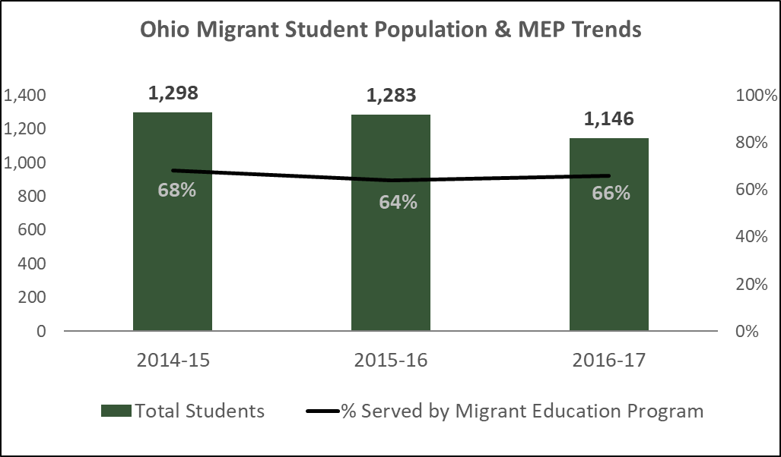
Figure 3: Ohio Migrant Student Population & Migrant Education Program Trends.
Migrant Student Profile
Sixty-two local educational agencies have industries with migratory work; see Table 2. The most prevalent migratory industry among districts is farming fruits and vegetables.

Table 2: Ohio Migratory Work and LEA Locations.
LEA | Seasonal |  |  |  |  | Temporary
 | Farming Fruits/Veg | Nursery | Sod Farm | Cannery | Packing/Warehouse | Dairy Farm | Egg/ Chicken Farm | Poultry Processing | Livestock | Meat Processing | Greenhouse
Amherst Exmpt Village Schools | X
Anthony Wayne Local Schools |  |  |  |  |  |  |  |  |  |  | X
Benton Carroll Salem Local |  |  |  | X
Bowling Green City Schools | X
Celina City Schools |  |  |  |  |  |  |  | X
Clyde Green Springs Exmpt  Village Schools | X
Cory Rawson Local Schools | X
Dayton City Schools |  |  |  |  | X
Delphos City Schools | X
Dover City Schools |  |  |  |  |  | X |  | X |  | X
Eastwood Local Schools | X |  |  | X
Edison Local Schools | X | X
Elmwood Local Schools | X |  |  |  | X | X
Evergreen Local Schools | X
Fairborn City Schools |  | X
Firelands Local Schools | X
Fremont City Schools | X |  |  | X
Genoa Area Local Schools | X
Gibsonburg E V Schools | X
Holgate Local Schools | X |  |  |  |  | X
Huber Heights City Schools | X
Lake Local Schools (Stark Co.) | X
Lakota Local Schools | X
Leipsic Local Schools | X |  |  |  |  | X
Liberty Center Local Schools | X
Lima City Schools | X |  |  |  |  |  | X
Lorain City Schools |  | X
Margaretta Local Schools | X
Marlington Local Schools | X
Miami East Local Schools | X |  |  |  | X
Mississinawa Valley Local School | X
Napoleon City Schools | X
Northmont City Schools |  | X
Northridge Local Schools | X
Norwalk City Schools |  | X
Old Fort Local Schools | X
Ottawa Glandorf Local Schools | X |  |  | X
Painesville City Schools |  | X
Pandora Gilboa Local Schools | X
Patrick Henry Local Schools | X |  |  | X
Perrysburg Exmpt Village Schools | X
Pettisville Local School District |  |  |  |  |  |  |  |  |  |  | X
Pike Delta York Local Schools | X |  |  | X |  |  |  |  |  |  | X
Plymouth-Shiloh Local Schools | X |  |  |  | X
Port Clinton City Schools | X
Sheffield-Sheffield Lake |  | X
South Central Local Schools | X
Springfield City Schools | X | X |  |  | X
Springfield Local Schools  (Lucas Co.) | X
St. Henry Consolid. Local Schools |  |  |  |  | X
Swanton Local Schools | X | X |  |  |  |  |  |  |  |  | X
Tecumseh Local Schools |  | X | X |  | X |  |  |  | X | X
Tipp City Ex Village Schools |  |  |  | X | X
Upper Scioto Valley Local Schools |  |  |  |  |  | X
Urbana City Schools | X |  |  |  | X
Wapakoneta City Schools |  |  |  |  |  |  |  |  |  |  | X
Washington Local Schools | X
Wauseon Exmpt Village Schools | X
West Clermont Local Schools | X
Westerville City Schools
Willard City Schools | X |  |  |  | X
Woodmore Local Schools | X | X
Source: Ohio Migrant Education Center

Most migrant students and families arrive in Ohio in June and July and often remain in the state as late as October, depending on the crop season and nature of work in the region. In some communities, like Tecumseh, families may arrive as early as January for nursery, sod farm or warehouse work. Appendix C shows migrant family arrival patterns for districts that receive Title I, Part C subgrants.

See Table 3 for more demographic data on Ohio’s migrant students. The table describes the demographic profiles of Migrant Education Program participants served by the summer program, those served by the summer and/or fall programs, the total Ohio migrant population and all Ohio public school students for school year 2016-2017.

Table 3: Migrant Student Population Profile (School Year 2016-2017)
 | Migrant Education Summer Program* | Migrant Education Summer and/or Fall Program* | Ohio Migrant Population* | All Students in Ohio#
All students | 503 | 751 | 1,146 | 1,674,341
PreK students | 73 | 88 | 194 | 38,726
K | 28 | 33 | 44 | 114,350
1st | 45 | 66 | 81 | 124,198
2nd | 53 | 76 | 99 | 127,333
3rd | 49 | 64 | 79 | 132,144
4th | 30 | 62 | 78 | 130,143
5th | 31 | 48 | 70 | 129,038
6th | 51 | 78 | 98 | 126,535
7th | 27 | 41 | 55 | 129,520
8th | 23 | 40 | 60 | 129,780
9th | 25 | 45 | 65 | 138,241
10th | 17 | 34 | 56 | 132,462
11th | 12 | 25 | 43 | 110,904
12th | 6 | 18 | 40 | 108,923
Out-of-school | 33 | 33 | 83
Percent of population in student subcategories
Priority for Service | 59% | 47% | 31%
Limited English Proficiency | 47% | 37% | 26% | 4%
Students with Disabilities | N/A | N/A | N/A | 15%
American Indian or Alaskan Native | 0% | 0% | 0% | 0%
Asian | 0% | 0% | 0% | 2%
Pacific Islander | 0% | 0% | 0% | 0%
Black (non-Hispanic) | 0% | 0% | 0% | 17%
Hispanic | 100% | 99% | 99% | 5%
Multiracial | 0% | 0% | 0% | 5%
White (non-Hispanic) | 0% | 0% | 0% | 70%
Male | 56% | 55% | 55% | 51%
Female | 44% | 45% | 45% | 49%
Economically disadvantaged | 100% | 100% | 100% | 51%
* Source: Ohio Migrant Education Center, Ohio Migrant Student Information System

As the executive summary of this report states, the Ohio Migrant Education Program serves 751 of Ohio’s 1,146 migrant students. Migrant Education Program participation rates by grade level in the summer and fall programs are generally between 60 percent to 80 percent. However, prekindergarten students, 11th grade students and 12th grade students participate at lower rates, ranging from 40 percent to 45 percent

Of the students served by Migrant Education Program, 47 percent were designated as Priority for Service. Priority for Service students are migrant students who have been determined to be both at-risk of academic failure and have experienced interruption in their education during the regular school year.

All migrant students are economically disadvantaged, and almost all the migrant population are Hispanic. One-quarter of the migrant population is limited English proficient, which is significantly higher than the comparable percentage for the total Ohio student population.

Exploring What is
Migrant Education Program Implementers and Services
Most migrant students are based in the rural communities of Northwest Ohio, with other concentrated pockets of migrant students located in Northeastern and Central Ohio. Eight school districts (See Figure 4) provide direct educational services to students with Title I C funding:
- Fremont City (IRN: 044016)
- Marlington Local (IRN: 049882)
- Northwest Ohio Educational Service Center (IRN: 124297)
- Old Fort Local (IRN: 049726)
- Putnam County Educational Service Center (IRN: 049304)
- Tecumseh Local (IRN: 046243)
- Willard City (IRN: 045096)
- Woodmore Local (IRN: 049577)

Figure 4. Location of Local Education Agencies that are Migrant Education Program Summer Program Sites in 2016-2017.
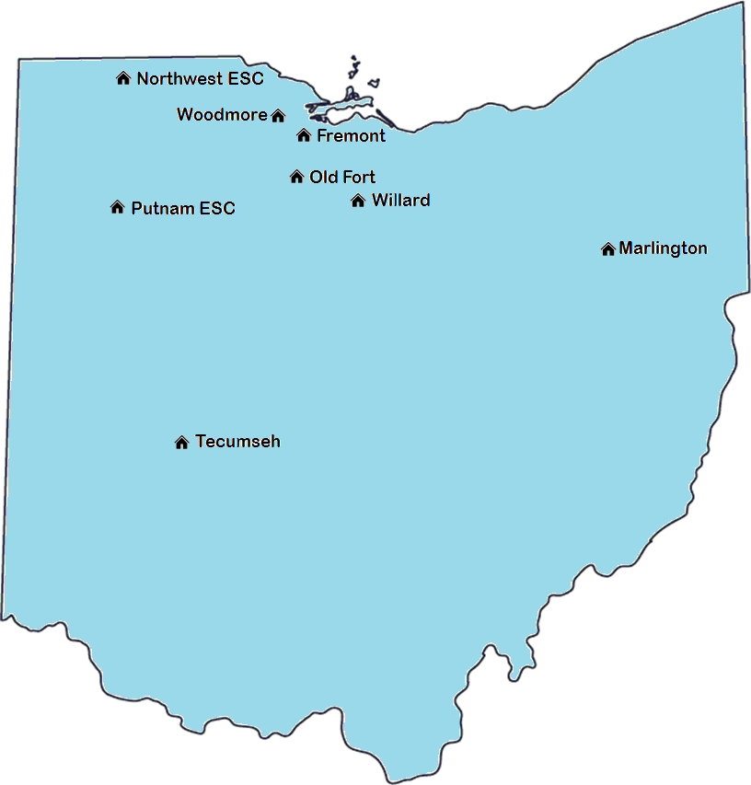

The primary services these districts deliver to students include:
- Summer sessions: Each district designs structured summer programs based on the needs of migratory students in their communities. Sites may offer activities such as:
  - Early learning enrichments for students ages 3-5 years old;
- Academic instruction in reading and math, grades K-12;
- Blended learning course credit recovery for students in grades 7-12;
- Mentoring and tutoring from peers or volunteers;
- Field and career-technical educational experiences;
- Family nights with education components;
- Coordination with health fairs and follow-up services; and
- Connections to community resources.

- Improving Migrant Academic Gains Educationally (IMAGE): This initiative reaches migratory students outside the service areas of the Title I-C subgrantees. Improving Migrant Academic Gains Educationally coordinates the delivery of academic services in homes to work with each student for 10 contact hours.

- Supplemental Programming: Districts provide supplemental education services to migrant students during the traditional school year, typically with the help of paraprofessionals. Students who remain in the area for at least a portion of the school year have access to academic resources to supplement, not supplant, all applicable Title I, Title III and Individuals with Disabilities Education Act Part B funding streams. Most supplemental programs occur in the fall, but districts are offering more spring-term services with students, based on their arrival patterns.

The Ohio Migrant Education Center, operated by the Northwest Ohio Educational Service Center, supports the districts’ work. The migrant education center identifies and recruits migrant students; selects some curricula; monitors implementation; collects data; manages transfer of records; provides technical assistance and professional development; coordinates the Texas STAAR (State of Texas Assessment of Academic Readiness) state assessment, and networks with complementary resources and organizations to serve the needs of migrant children and families.
Seven Areas of Concern
In the spring meetings, both the Migrant Education Program site administrators and needs assessment committee reviewed past performance data, the migrant student profile and the current scope of services considering the seven areas of concern:

- Educational Continuity: Migrant students move from school to school and state to state, each with different curriculum, school policies and more. This creates inconsistency in the student experience and introduces greater risk to academic success. Research also shows that incomplete or missing student records between transitions prevent schools from understanding the learning needs of students and may result in their being placed in the wrong grades or courses.

- Time for Instruction: The mobility of migrant children affects their attendance in school, including interruptions in enrollment. Migrant students benefit from programs that help them make up for lost time.

- School Engagement: Migrant students may face barriers to engaging in academic, social or extracurricular activities, and these factors often are related to positive academic results. These students also may find it challenging to connect with teachers and peers and achieve a sense of belonging in school. Their engagement may be hindered when schools fail to cultivate self-esteem and self-awareness in these students or lack culturally relevant literature and subjects.

- English Language Development: With a significant number of migrant students having home languages other than English, it is important to make sure their English language skills are strong enough to acquire academic content knowledge. Migrant students’ mobility poses a unique challenge that is beyond the scope of support students may receive as English learners under Title III. Free and Konecnik (2014) found that in some instances, districts retains migrant students in their grades because their limited English proficiency prevents them from communicating with teachers about what they know.

- Educational Support in the Home: Many migrant parents support a strong education for their children but may have limitations in the support they are able to give because of their migratory lifestyles. It is important to consider a student’s ability to access reading materials, educational games and internet technology at home. Also, parents may need more information about various education systems and services available to their students. Parents also may benefit from general information and best practices to help their children succeed. Studies show migrant students who chose to continue their educations beyond high school and were successful had families who played strong roles in their educational decisions.

- Health: Migratory families often need help in addressing health issues that interfere with their students’ abilities to learn. This may include vision, dental, medical and mental health needs. Migratory students often are at greater risk of poor health conditions from exposure to pesticides, farm injuries, heat-related illnesses, poverty and lack of insurance and access to care.

- Access to Services: Because of mobility and temporary residence in a community, many migrant children and their families may not know how or when to get services. These services may be educational, or they may be for needs such as food, clothing and housing. In addition, there may be misconceptions among migrant families, community members and resource providers about the rights of migrant children to access services.

Concern Statements
Through reviews, the needs assessment committee identified these concern statements for the Migrant Education Program based on the program’s current work and the areas of concern:

Table 4: 2018 concern statements and related U.S. Department of Education Office of Migrant Education Areas of Concern.
2018 Concern Statement | Area of Concern
- We are concerned migrant students lack continuity in their educational experiences and do not receive enough instruction to achieve proficiency in reading/language arts due to their high mobility. | Educational Continuity, Instructional Time, School Engagement
- We are concerned migrant students lack continuity in their educational experiences and do not receive enough instruction to achieve proficiency in mathematics due to their high mobility. | Educational Continuity, Instructional Time, School Engagement
- We are concerned migrant students who are English learners may need additional help and instructional assistance to become fluent in English, ready for school, proficient in critical content areas and graduate from high school. | English Language Development
- We are concerned other needs, such as health and social needs, may be affecting the ability of migratory children to effectively participate in school. | Health, Access to Services
- We are concerned migrant high school students are not receiving enough instruction to accrue and recover credit for high school graduation and are not accessing robust services to prepare them for postsecondary success. | Instructional Time, School Engagement, Access to Services
- We are concerned migrant out-of-school youth are not accessing educational and vocational services that would aide them in responsible citizenship and productive employment. | Access to Services
- We are concerned gaps may exist in access to early learning services for migrant children, up to 5 years of age. This may affect their readiness to enter school. | Instructional Time, Access to Services
- We are concerned migrant students do not have stronger educational supports at home, including parents’ knowledge of Migrant Education Program services; parents’ comfort in navigating the Ohio education system and its resources; access to learning materials, technology and internet service; and guidance on balancing education and work priorities for high school students. | Educational Supports in the Home

The needs assessment process encourages migrant education programs to align need indicators to concern statements. The need indicators measure progress, or lack of progress, in meeting these concerns. Ideally, these indicators also can help determine where programs need to be compared to other groups or in absolute performance. Table 5 contains the needs indicator initially identified for comparison with concern statements

Table 5: Concern Statement Topic and Related Initial Need Indicators.
Concern Statement | Initial Need Indicators for Data Review
Reading and ELA (#1) | Ohio Reading and Language Arts test performance level
Math (#2) | Ohio Math test performance level
English Learners (#3) | Disaggregated State Test data for English learners
Health and Social Needs (#4) | Health fair screening, referrals, and treatments
High School Students (#5) | Graduation rates, Algebra I credit by 11th grade, Migrant Education Program participation rate
Out-of-School Youth (#6) | Migrant Education Program participation rate
Early Learning (#7) | Kindergarten Readiness Assessment
Education Supports at Home (#8) | Parent survey responses

In the next step, consultants gathered data related to these indicators to continue to inform the needs assessment. The data collection and analysis process led to modifications in the list of need indicators for future analysis and performance monitoring, discussed in later sections of the document.

Gather and Analyze Data

The following summary of initial need indicators results and SWOT analysis relate to data gathered for the needs assessment.

Results on Initial Need Indicators

Reading and Language Arts
Less than one-third (30 percent) of Migrant Education Program students tested were at or above proficiency for reading and language arts on Ohio’s State Tests. This is 5 percent higher than the rate for the Migrant Education Program students tested in 2015-2016. However, the proficiency rates are much lower than those of Hispanic students and all students in Ohio. See Figure 5.
Figure 5: Percentage of Students at or Above Proficiency in Reading/Language Arts.
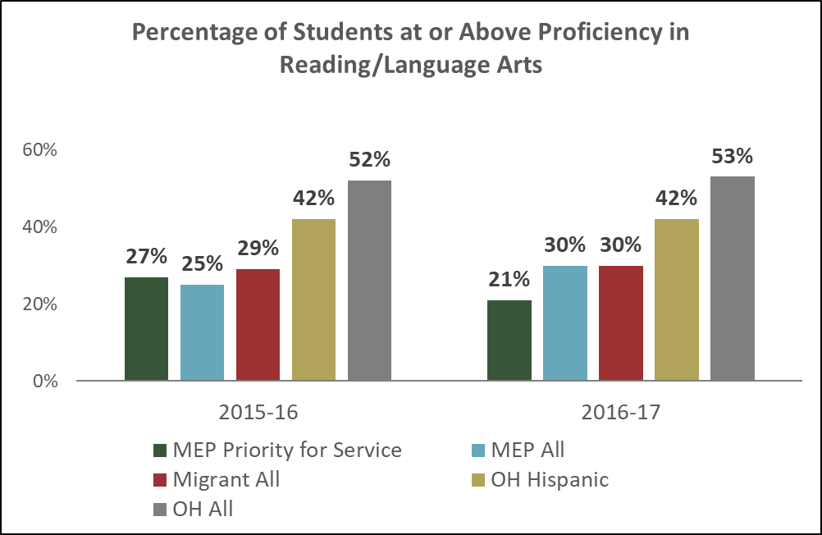
Source: Ohio Migrant Education Center, Ohio Migrant Student Information System & Ohio Department of Education Report Card Database

Analysis of proficiency data is limited because most migrant students are not here to take Ohio’s State Tests, thus few are tested. While there were 751 students in the Migrant Education Program summer or fall programs in 2016-2017, only 90 Migrant Education Program students and 19 Migrant Education Program Priority for Service students took the reading and language arts state test.
Here are the resulting needs statements:
- The reading and language arts proficiency rate for Migrant Education Program students needs to increase by at least 23 percentage points to be on par with all Ohio students. (See Table 6.)
- Migrant Education Program participants, including those not tested by Ohio, need to demonstrate improvements in the reading and language arts areas in which they receive Migrant Education Program services.

Table 6: Ohio Reading Language Arts Proficiency Data and Need.
Need Indicator | Current Status for Migrant Education Program Students | Current Status for Comparison Group | FY26 ESSA Target (if applicable) | Gap/ Need Statement
Ohio Reading Language Arts State Test | 30 percent of tested Migrant Education Program students are proficient in reading and language arts. | 53 percent of tested Ohio students are proficient in reading and language arts. | 80 percent of all tested Ohio students are proficient in reading and language arts. | The reading and language arts proficiency rate for Migrant Education Program students needs to increase by at least 23 percent to be on par with all Ohio students.

Math
One out of three Migrant Education Program students tested in 2016-2017 were at or above proficiency in math on Ohio’s State Tests. This is a decrease of seven percentage points from 2015-2016. However, the percentage of Priority for Service Migrant Education Program students tested who were at or above proficiency in math remained stable between the two years, with 37 percent at or above proficiency in 2016-2017. The percentage of Migrant Education Program students and migrant students overall that achieve proficiency in math is significantly below the rate for all Ohio students and all Ohio Hispanic students. See Figure 6.
Figure 6:Percentage of Students at or Above Proficiency in Math.
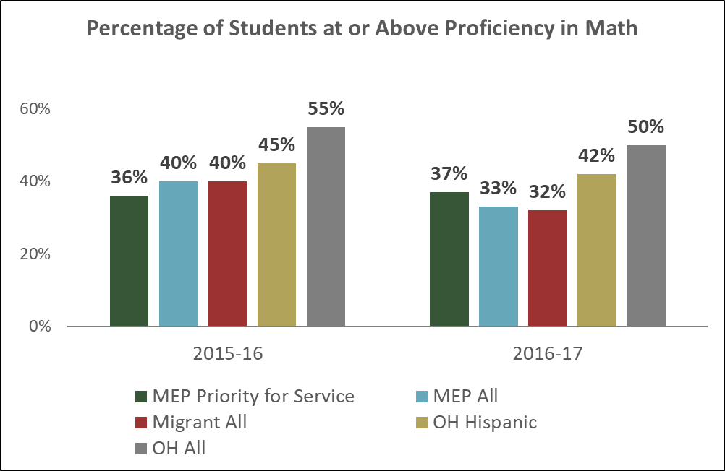
Source: Ohio Migrant Education Center, Ohio Migrant Student Information System & Ohio Department of Education Report Card Database

Again, a caveat to the proficiency data is that only 100 of 751 Migrant Education Program students and 27 Migrant Education Program Priority for Service students were tested.
The need statements based on the information available are:
- The math proficiency among Migrant Education Program students needs to increase by at least 17 percentage points to be on par with all Ohio students. (See Table 7.)
- Migrant Education Program participants, including those not assessed by Ohio’s State Tests, need to demonstrate improvements in math domains in which they receive Migrant Education Program services.

Table 7: Ohio Math Proficiency Data and Needs.
Need Indicator | Current Status for Migrant Education Program Students | Current Status for Comparison Group | FY26 ESSA Target (if applicable) | Gap/ Need Statement
Ohio State Test in math | 33 percent of tested Migrant Education Program students are proficient in math | 50 percent of tested Ohio students are proficient in math. | 80 percent of all tested Ohio students are proficient in math. | The math proficiency rate for Migrant Education Program students needs to increase by at least 17 percentage points to be on par with all Ohio students.

English Language Acquisition
In future years, the needs assessment and program evaluation may look at data related to the Ohio English Language Proficiency Assessment to compare the performance of Migrant Education Program English learners and other English learner students in Ohio. While a breakout for Migrant Education Program students is not available, 16.6 percent of Ohio English learner students have emergent fluency and 68.4 percent have progressing fluency in 2017. Therefore, a broader needs statement is articulated:
- Progression in English fluency for Migrant Education Program English learners needs to be the same or greater than all Ohio English learners. (See Table 8.)

Table 8: Ohio English Language Proficiency Assessment Data and Needs.
Need Indicator | Current Status for Migrant Education Program Students | Current Status for Comparison Group | FY26 ESSA Target (if applicable) | Gap/ Need Statement
Ohio English Language Proficiency Assessment | TBD | 16.6 percent of Ohio English learners have emergent fluency, 68.4 percent are progressing, 15 percent are proficient in 2017. | 75 percent of all English learners will make annual progress toward English language proficiency. | Progression in English fluency for Migrant Education Program English learners needs to be the same or greater than all Ohio English learners.

In the meantime, the consultants examined reading and English language arts proficiency rates among Migrant Education Program students with Limited English Proficiency (LEP) in Figure 7. Of the Migrant Education Program students with limited English proficiency who were tested on the Ohio reading state test, 23 percent scored proficient in 2016-2017 and 22 percent were proficient in 2015-2016. As a reference point, only 29 percent of the tested Migrant Education Program students had limited English proficiency in 2016-2017 compared to 44 percent in the previous period.

Figure 7: Proficiency and Representation of Migrant Education Program Students with LEP Designation for the Ohio Reading and Language Arts Assessment.

Source: Ohio Migrant Education Center, Ohio Migrant Student Information System

Health and Social Needs
Figure 8 below shows the total number of Migrant Education Program children and adults who received vision services including screening, referral and treatment.

Figure 8. Proportion of Migrant Children and Adults who Received Different Levels of Vision Health Services.

Source: Ohio Migrant Education Center
Figure 9 shows this same information for dental services. For dental services, 83 percent of the people referred received eventual dental treatment. However, 87 percent of the students who had poor dental health according to the screening did not receive treatment, predominantly because there were no vouchers available to refer the students to treatment. For a comparison, 25 percent of 5-19-year-olds in U.S. low-income families have untreated tooth decay.

For both health domains, many screenings were delivered but may not have resulted in referrals because there was no need or referral vouchers were not available. Of the individuals referred for additional vision services, 66 percent received vision treatment, which may have included eyeglasses and other remedies to aid in participation in school and homework.

Figure 9. Proportion of Migrant Children and Adults who Received Different Levels of Dental Health Services.

Source: Ohio Migrant Education Center

The committee did not identify a need indicator for tracking social needs and barriers to education for migrant students. The committee discussed looking at chronic absenteeism as a potential indicator, but the chronic absenteeism figure seemed to be too indirect related to health and social needs. The chronic absentee data would be limited for Migrant Education Program students, although it is available for all Ohio migrant students.

The resulting need statements, including items highlighted in Table 9, were:
- The percentage of migrant students experiencing health and/or a social needs who are directed to support services must increase.
- The percentage of children identified as having untreated, poor health conditions must decrease by 62 percentage points.
- The number Migrant Education Program students receiving needed vision care must be increased.

Table 9: Health Data and Needs.
Need Indicator | Current Status for Migrant Education Program Students | Current Status for Comparison Group | Gap/ Need Statement
Health fair screenings, referrals, treatments | Of the 24 parents and children referred for treatment, 20 were treated. However, of the students with poor dental health, 87 percent were not recorded as receiving treatment. | 25 percent of 5-19- year-olds in U.S. low-income families have untreated tooth decay (CDC, 2012). | The percentage of children identified as having untreated poor dental health needs to decrease by 62 percentage points.
Health fair screenings, referrals, treatments | 66 percent of the referred individuals received treatment. | TBD | The number of students receiving needed vision care must be maximized for Migrant Education Program students.

High School Students
The Ohio Migrant Education Center verified that six Migrant Education Program students graduated from high school, and no grade 9-12 students dropped out of school in 2016-2017. Analysis of graduation data is limited because current data collection systems require students to return to Ohio for their outcomes to be tracked. Data currently are not available to determine if those students graduated in other states.
Figure 10 shows complementary data that combines promotion and graduation data for seventh- through 12th-graders. Districts promoted Migrant Education Program students to the next grade levels or graduated them at a rate of 91 percent. This is the same rate as all Hispanic students but lower than the rate for all students in Ohio.
Figure 10: Percentage of Students Who Were Enrolled in Grades 7-12 and Graduated or Were Promoted to the Next Grade Level (School Year 2016-2017).
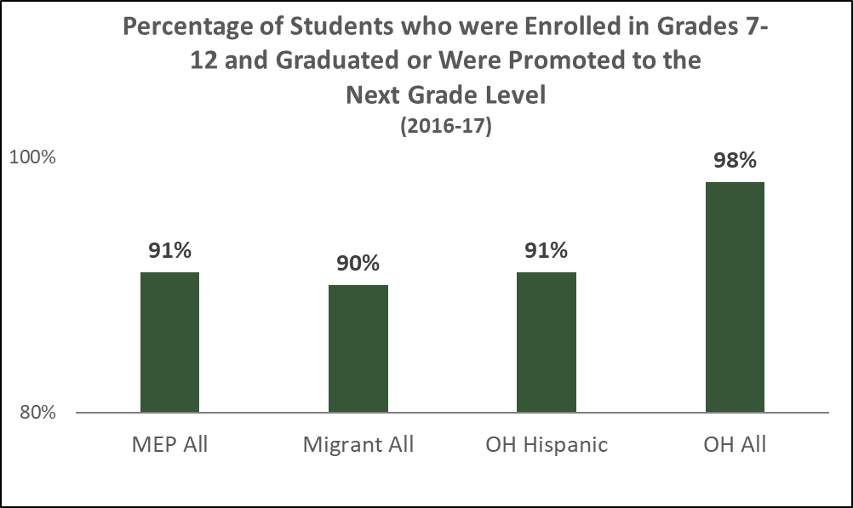
Source: Ohio Migrant Education Center, Ohio Migrant Student Information System & Ohio Department of Education

A contributing metric to graduation, monitored by the U.S. Department of Education, is the percentage of students who have earned Algebra I credit or its equivalent by the time they enter 11th grade.

Figure 11 shows these data for Migrant Education Program students, Ohio Hispanic students and all Ohio students.

Two of three Migrant Education Program students who entered 11th grade had received full credit for Algebra I or were enrolled in a non-remedial math courses that required Algebra I as a prerequisite.

Figure 11: Percentage of Students Who Entered 11th Grade and Received Full Credit for Algebra I or Who Were Enrolled in Non-remedial Math Courses for Which Algebra I Was a Prerequisite. (School Year 2015-2016).
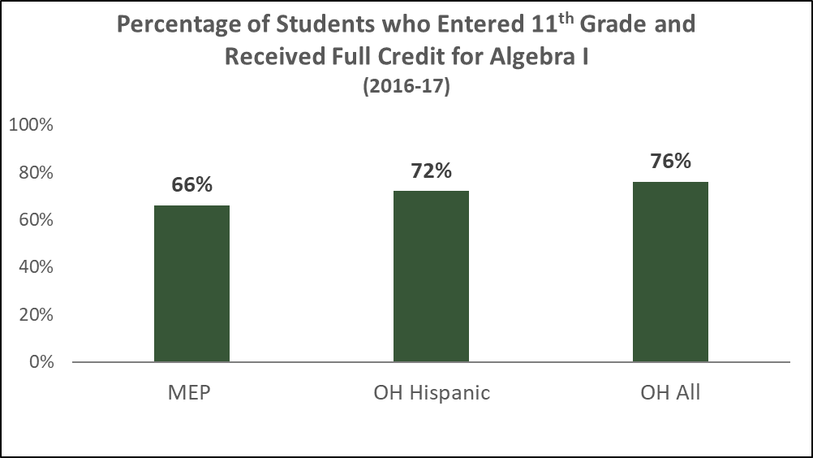
Source: Ohio Migrant Education Center, Ohio Migrant Student Information System & Ohio Department of Education

Analysis of Algebra I credit for Migrant Education Program students is limited due to the data collection process available to the Ohio Center for Migrant Education. The center does not have access to full transcript records for all students served by the Ohio Migrant Education Program. The center could verify data for 81 of the 122 grade 9-12 students who could have earned Algebra I credit. Of that 81, 80 (99 percent) earned Algebra I credit. It is possible that some of the remaining 41 students for whom they could not verify credit did, in fact, earn Algebra I credit. If they did, it would increase the percentage of Migrant Education Program students who earned Algebra I credit.

In addition, stakeholders have been concerned with the participation rate of migrant students of working age.

Table 10 shows the identified needs statements for migrant high school students:
- The graduation rate among Migrant Education Program 12th-graders needs to meet or exceed the ESSA target of 93 percent.
- The percentage of Migrant Education Program students entering 11th grade with a full credit of Algebra I needs to increase by 10 percentage points.

Table 10: High School Performance Data and Needs.
Need Indicator | Current Status for Migrant Education Program Students | Current Status for Comparison Group | FY26 ESSA Target (if applicable) | Gap/Need Statement
Graduation rate | Incomplete record | 95 percent of all Ohio 12th-graders graduated. | 93 percent four-year cohort graduation rate | The graduation rate among Migrant Education Program 12th-graders needs to meet or exceed the ESSA target of 93 percent.
Algebra I credit received by 11th grade | 66 percent of Migrant Education Program students for whom data were available entered 11th grade with a full credit of Algebra I. | 76 percent of Ohio students entering 11th grade with a full credit of Algebra I. |  | The percentage of Migrant Education Program students entering 11th grade with a full credit of Algebra I needs to increase by 10 percentage points.
Migrant Education Program participation | 61 percent for 10th grade, 58 percent for 11th grade, and 45 percent for 12th grade participation rates in Ohio Migrant Education Program instructional services | 79 percent for 10th grade, 79 percent for 11th grade, and 83 percent for 12th grade participation rates in Indiana instructional services |  | Participation rates among 10th-12th graders should increase to be comparable to or higher than participation rates of migrant programs in neighboring states.

Out-of-School Youth
Figure 12 shows the current count of out-of-school youth identified and how many are accessing Migrant Education Program services. About 40 percent of out-of-school youth are accessing Ohio Migrant Education Program services that may include assessment, preparation for the GED or an alternative test, or career-technical education.

Figure 12. Out-of-School Youth Identified and Served.

Source: Ohio Migrant Education Center

The Ohio Migrant Education Program’s objective is that more out-of-school youth successfully transition into careers, either by completing a high school equivalency diploma or gaining career-technical skills. The Migrant Education Program does not have data on these indicators, but some comparison data exists.

The Ohio Department of Higher Education published the percentage of students who pass the high school equivalent diploma test who are engaged in the Department’s adult basic literacy and education program, ASPIRE. Among FY11 and FY17 participants, 73.4 percent of high school equivalent diploma test-takers passed the test.

To understand a potential gap in the general population relating to career-technical education, Ohio reviewed performance data for its career-technical planning districts. In 2016-2017, 41.7 percent of students earned industry credentials of any type before completing high school or within six months of leaving high school.

Based on this information, Table 11 outlines the need statements focused on out-of-school youth:

- The percentage of out-of-school youth receiving high school equivalency services who receive a high school equivalency credential, for example, a GED, must meet or exceed 73 percent;
- The percentage of out-of-school youth receiving career-technical training who then receive industry or institutional career-technical credentials must meet or exceed 42 percent.

One caveat to the use of the metric “percent of students earning an industry or institutional credential” in a need statement is that some out-of-school students are undocumented, but most industry credentials cannot be awarded to students without proper legal documentation. The result of this gap is that some students will be unable to receive industry credentials even though they complete all other requirements. Therefore, the committee suggests that credentials for completing the program, awarded by an educational institution such as a career-technical center or traditional school district, be included in monitoring this result. This challenge should be addressed in a district’s service delivery plan.

Table 11: Out-of-School Youth Participation Data and Need.
Need Indicator | Current Status for Migrant Education Program Students | Current Status for Comparison Group | Gap/ Need Statement
Out-of-school youth completing high school equivalency | Data not available | 73.4 percent of students engaged in Ohio ASPIRE who take a high school equivalency exam pass the test. | The percentage of out-of-school youth receiving higher secondary education services who pass the high school equivalency test needs to meet or exceed 73 percent.
Out-of-school youth receiving career-technical training who receive career-technical credentials | Data not available | 41.7 percent of career-technical planning district students earned industry credentials before leaving high school or within six months of leaving. | The percentage of out-of-school youth receiving career-technical training who then receive either industry or institutional career-technical credentials needs to meet or exceed 42 percent.

School Readiness
Nationally, it is becoming a priority to educate the youngest migrant students to make sure they are ready for school. A key measure of school readiness in Ohio is the kindergarten Readiness Assessment; 40.6 percent Ohio kindergarteners demonstrate readiness on this assessment. The Ohio Migrant Education Program historically has not tracked school readiness scores program wide, but it can look at this measure in the future for kindergartners who received early learning services through the program. Table 12 lists the needs statement:
- At least 41 percent of kindergartners who receive Migrant Education Program services before kindergarten should demonstrate kindergarten readiness.

Table 12: Early Learning Data and Need.
Need Indicator | Current Status for Migrant Education Program Students | Current Status for Comparison Group | Gap/ Need Statement
KRA scores of kindergarten students who received Migrant Education Program preschool services | TBD | 40.6 percent of Ohio kindergartners demonstrate readiness on the kindergarten Readiness Assessment | At least 41 percent of kindergartners who receive Migrant Education Program services before kindergarten demonstrate kindergarten readiness.

Educational Supports at Home
The Ohio Migrant Education Center conducted a parent survey in 2017 that asked what additional supports parents needed at home. The center posed two open-ended questions in the survey. Figures 13 and 14 show responses to the questions in support categories coded by the research team. Tables 13 and 14 show examples of responses.

Figure 13: What Additional Resources do you [as a Parent] Believe Schools Should Provide?

Table 13: Themes and Quotes Regarding What Migrant Education Program Parents Thought Schools Should Provide.
Themes | Quotes
None | "NONE"
Instructional support, such as student/teacher ratio or special ed | "AGE APPROPRIATE WORKSHOPS"  "MORE THERAPY, HELP FOR AUTISTIC STUDENTS"
Language support | "BILINGUAL TEACHER"  "SEND NOTES AND PAPERWORK TRANSLATED INTO SPANISH"
Technology | "LAPTOP"  "MINI TABLETS WOULD BE A GOOD IDEA"
Books | "BOOKS FOR HOMEWORK"
Transportation | "BUSSES"  "GETTING FROM SCHOOL SOONER"
Clothing | "CLOTHING"  "BOOKBAGS AND SUPPLIES"

Figure 14: What Needs do you [as a Parent] Have for Assisting your Child Educationally at Home?

Table 14: Themes and Quotes about what Migrant Education Program Parents Wanted for Additional Educational Support at Home.
Themes | Quotes
None | "NONE"
Books | "BOOKS, THEY LOVE TO READ BUT CANNOT GET TO THE LIBRARY"  "SEND SOME BOOKS TO READ, HE STRUGGLES A LOT IN READING"
Learning aids | "IT WOULD BE GOOD IF SOMEONE VISITED THE HOUSE" "VISUAL AIDS" "MORE MATH KNOWLEDGE"
Technology | "COMPUTER, INTERNET" "INTERNET IS ONLY ON CELL PHONE"
Needs related to being a bilingual family | "SPANISH BOOKS TO READ AT HOME" "ENGLISH BARRIER"

While many parents did not articulate a specific need, others did express specific needs related to bilingual supports, reading materials, technology and social support. Later in the SWOT analysis, the needs assessment committee identified needs that may not have been expressed in the survey because parents may have lacked knowledge about education options. Based on the data available, the need statement regarding educational supports from Table 15 is:
- The Ohio Migrant Education Program should increase its educational supports to parents based on the needs and requests made by parents.

Table 15: Parent Survey Data and Needs.
Need Indicator | Current Status | Gap/ Need Statement
Parent Survey | 41 percent of parents identified additional resources they would like from schools.  45 percent of parents identified a need for additional educational supports at home. | The Migrant Education Program should increase its educational supports to parents based on the needs and requests made by parents.

Strengths, Weaknesses, Opportunities, Threats Analysis
The following analysis summarizes insights from quantitative and qualitative data to shape the needs assessment.

Strengths
- Focus on student needs and local flexibility: A National Summer Learning Association report and surveys of the needs assessment committee pointed out that programs were student-focused and sought creative ways to address student needs. With each Migrant Education Program site having flexibility in how it delivers services, each customizes the program to meet the migratory needs unique to its setting.

- Online curriculum to enhance personalization: Some stakeholders highlighted the strengths of online, self-paced curricula, such as iReady and Odysseyware, in allowing each student to focus on the academic domains in which they needed greater development. The National Summer Learning Association report also referenced the value of the online curriculum in building math and literacy skills.

- Ability to leverage existing district curriculum and resources: Many sites based in traditional districts can use their own district reading and math curricula for summer direct instruction. This allows them to achieve greater education continuity between students’ summer and regular school year experiences. It also lessens the burden on Migrant Education Program sites to identify, acquire and train teachers in new resources for instruction. The expertise of staff who may be using the curricula year-round also is a benefit, although summer assignments for teachers may not be the same as those teachers have during the school year.

- Incorporation of math and literacy skill building in multiple settings: From evidence in interviews and the National Summer Learning Association report, Migrant Education Program sites were adept at incorporating academic skill building in multiple settings. The association cited several observations, including using a dice-rolling game to explore a probability unit and working on a salary and personal budget as a component of writing a report on careers.

- Caring staff and positive environment: A survey of Migrant Education Program directors and other members of the needs assessment committee consistently highlighted caring and committed staff as a strength in their responses to an open-ended question. The National Summer Learning Association report on the summer 2017 program also said the Ohio Migrant Education Program was strong in providing emotional safety and a warm welcome. The report noted the program climate was mostly positive. The study also stated, “Teachers also showed a genuine interest in youth by asking about their home lives and the whereabouts of youth that may have been absent from the program for the day.”

- Coordinated health services and access: In surveys and interviews, Ohio Migrant Education Program site-level staff reiterated that coordinating its programs with health services and support is enhancing students' participation in academics. Many staff members were happy with the design and level of attention provided through health fairs. Of the individuals referred for additional vision services, 66 percent received treatment, which may have included eyeglasses and other remedies to help them take part in school and do homework. Of the 24 parents and children referred for dental treatment, 20 received treatment.

- College and career exploration: Several program leaders expressed excitement about growing opportunities for their students to get college and career exposure related to the Ohio’s learning standards. These activities often were career-technical education experiences ranging from project-based learning to career-technical school visits. Some programs also referred to the value of visits for employers when students are exposed to many options and allowed to see real-world applications of their learning. Regarding college exposure, some noted that certain students did not understand options for college, including the ability to live on campus until they take part in Migrant Education Program activities. According to National Summer Learning Association, at least one program was using a college application as a writing exercise.

- Extended summer program: Interviews with leaders revealed the value they see in the extended summer program at Old Fort Local School District. The district offers its summer instructional services for a longer period because it uses a building that does not host traditional school year operations. Migrant students who participated in other district summer programs can transition to the Old Fort program after the initial summer session. Anecdotally, these transitions and extended experiences were operating smoothly.

- Services to Priority for Service: More Priority for Service students received services last year, especially through IMAGE. The proportion of Priority for Service students receiving IMAGE to all IMAGE students increased from 3 of 99 students in Performance Period 2015 to 42 of 82 students in Performance Period 2017. In addition, the gaps in performance between Priority for Service students and non- Priority for Service students are small. For example, 75 percent of Migrant Education Program Priority for Service students and 79 percent of all migratory students served by the Migrant Education Program received Algebra I credit.

- Organized program flow: The National Summer Learning Association also praised the Ohio Migrant Education Program for “program flow,” saying: “All sites operated with program schedules that included consistent routines and assured that youth had the appropriate time needed for activities.”

Weaknesses/Areas for Improvement
- Attendance among high school students: The 2017 evaluation report, subsequent interviews and surveys of stakeholders all identified this issue. Many high school students stop attending the summer program at harvest time to work in the fields. Some programs were trying to accommodate high school students with online learning modules during that time but had mixed results with students taking advantage of the materials outside traditional school hours.

- Engagement of out-of-school youth: Out-of-school youth have taken advantage of the program in small percentages. In Performance Period 2017, only 33 of 83 out-of-school youth who were eligible for services participated in them.

- Supporting English language acquisition. One comment in the 2017 parent survey regarded the need for more English language supports, including more bilingual teachers. One site representative commented that site has increased the number of bilingual teachers from 1 to 4 in the last few years. Parents also wanted more translated materials sent home. One Migrant Education Program professional cautioned that, to support English language acquisition, centers should not wait for English fluency to flourish before building reading and language arts skills with young children. Instead, they should find ways to address both needs instructionally. The desire for more professional development in English language acquisition was noted at various points.

- Staffing: In the open survey questions, multiple site staff members mentioned local staffing as a weakness. Challenges included staffing turnover, the skill or licensure suitability of staff and the evolving profile and academic needs of students each year.

- Timely professional development: The adeptness in addressing this issue seemed to vary by site based on self-reports. Directors mentioned looking for ways to identify what the teachers believe they need quickly to best serve students and provide training or supplemental resources to do so. Needs may range from cultural awareness with populations new to the migrant community, to better supports for English language acquisition, to instructional techniques for a short timeframe, to providing personalized instruction in a domain for which the teacher may have less experience. Some programs that have all Migrant Education Program teachers from one district may have greater flexibility in what existing professional development and professional resources and curriculum they can use.

- Parent engagement: When surveyed, most needs assessment committee members saw a need to increase parent engagement efforts. Interviews with parents also reflected their desire for greater participation.

- Recruitment statewide: The Migrant Education Program has been challenged in recruiting eligible migratory students outside subgrantee’s traditional service areas. Committee members see identifying, enrolling and serving students in less concentrated pockets as increasingly important because Ohio’s Migrant Education program does not serve slightly more than a third of Ohio’s migratory students. The staff recruitment model of the Migrant Education Program is shifting, with a redesign of recruitment areas and subgrantee’s now hiring and managing identification and recruitment professionals with continued support from Ohio Migrant Education Center staff.

- Youth-to-youth team-building and leadership: Based on the National Summer Learning Association assessment domains, the Ohio Migrant Education Program needs to create intentional opportunities for students to get to know each another, instead of relying on inherent connections among migrant students to create a collaborative learning environment. Sites also may be challenged to find opportunities for students to work as teams and build leadership skills because of the need to focus on individualized instruction.

- Student planning/choice: The National Summer Learning Association hoped to see more students directing their own learning. Association staff also anticipated value in offering more opportunities for students to reflect on their work and give feedback on activities.

Opportunities
- Serving more 3- to 5-year-olds: Many of the site programs are considering whether it is appropriate to offer preschool services in their communities, based on what services may already exist for the youngest migrant children. Some sites have experience working with rising kindergartners, but they are exploring how to work with even younger students. One of the challenges is getting parent permission to evaluate students’ needs, particularly for a disability, during the period they are in Ohio.

- Changes in arrival patterns. Some migrant families are arriving earlier, and programs are exploring the opportunity to provide services in the spring, especially for high school students, which may accelerate their academic progress.

- More diverse migrant population: There is an increase in the number of migrant children with family origins in Guatemala and the Marshall Islands. The culture and language needs of these populations may be different from the predominant Mexican American migrant population in Ohio, and the Migrant Education Program can develop competencies to help these new stakeholders.

- Increased focus and support for out-of-school youth services: Nationally, more attention is being given to engaging out-of-school youth in migrant education services. The Migrant Education Program has access to the resources for graduation and outcomes for success for out-of-school youth.

Threats
- Constraints in resources: A few stakeholders mentioned challenges in finding resources or appropriately allocating money for observed needs. Some mentioned a need for funding to provide food for after-school programs, address summer wear and tear on school buildings and better support parent engagement. Some also expressed a desire to make sure all stakeholders understand the connection between field trips and excursions and academic standards, feeling this would assure that those experiential and applied learning activities qualified for Migrant Education Program funds.

- Perceptions and realities of federal immigration policy: Some students or their parents might have refused to be identified because they were concerned their undocumented status may jeopardize their ability to stay in the United States. In addition, farmers and contractors with workers on H-2A visas were not permitting agencies to bring services to the job site, and this limited recruitment efforts.

- Access to dental vouchers: Of the students with poor dental health, 87 percent were not recorded as receiving treatment. This large percentage is due to the lack of service vouchers, which limits the financial resources available to sponsor dental treatment.

These data highlight what efforts are primed to continue and areas that may need new solutions in future service delivery.

Making Decisions
Proposed Solutions
The needs assessment committee proposed solutions in an initial April meeting. In the second meeting, it reviewed proposed solutions from the first meeting, as well as additional research to yield the recommendations in Table 16. See that research referenced in the Supporting Research and Promising Practices section of this report. Committee members also were asked to determine which strategies they thought needed less, the same, slightly more or significantly more effort. The items needing significantly more effort and attention are in bold. Items listed with superscript roman numerals have strategies listed in multiple areas of concern.

Table 16: Proposed Solutions for Needs Statements.
Need Statement | Solutions
Reading & English Language Arts and Mathematics Instructional Strategies
1.1 Proficiency in reading language arts for Ohio Migrant Education Program participants needs to increase by at least 23 percent on Ohio’s State Test in reading to be on par with all Ohio students.  1.2 Migrant Education Program participants, including those not assessed by Ohio’s State Tests, need to demonstrate improvements in reading and language arts domains in which they receive Migrant Education Program services.  2.1 Proficiency in math for Ohio Migrant Education Program participants needs to increase by at least 17 percent to be on par with all Ohio students.  2.2 Migrant Education Program participants, including those not assessed by Ohio’s State Tests, need to demonstrate improvements in math domains in which they receive Migrant Education Program services. | 1-2a. Provide intensive academic support focused on the individual literacy and math competency needs of students during the summer program.  1-2b. Arrange small-group intervention activities during the regular school year with paraprofessional supplemental services.  1-2c. Expedite personalized and quality instruction with blended learning curricula (such as iReady) and use of 1:1 devices where available.  1-2d. Use district-adopted curricula, technology and systems during summer programs to support education continuity with school year programs.  1-2e. Offer multiple kinds of exercises for students to learn and demonstrate competencies in multiple forms and consider flexible learning environment design, such as Universal Design Learning principles.  1-2f. Empower students through student-led, project-based learning.  1-2g. Offer field experiences and off-site experiential learning in summer tied to the academic standards and skill areas students need.  1-2h. Reinforce communication and sharing of data about students’ academic experiences between summer and regular school year instructors to enhance academic continuity. This may happen through staff meetings of instructors at the start of the year; sharing iReady scores and report cards; and 1:1 meetings between summer and regular school year instructors.  1-2i. Implement peer or volunteer tutoring strategies built on positive relationships to promote students’ persistence in academics, potentially in summer and during the school year. This may include peer-assisted learning strategies, high school students working with elementary students or engaging volunteers from local colleges and the community.^{i}  1-2j. Build students’ connections to external reading resources such as the public library, summer reading programs, book mobiles.  1-2k. Use the San Diego Quick Assessment in the identification process to provide data on current reading proficiency, then align services.  1-2l. Provide in-home instruction for IMAGE students and ensure they have access to computers for instructional work.  1-2m. Identify a contact person in each sending state to expedite recovery of a student’s record, for example, grades or an individualized education program, to align instructional services to student’s needs. Consider a routine for communicating with partner states.^{ii}
English Language Proficiency
3.1 Progression in English fluency for Ohio Migrant Education Program English language learns is the same or greater than all Ohio English learners. | 3a. Focus language acquisition supports on academic reading and writing, particularly on fluency, vocabulary and comprehension.  3b. Provide consistent, continuous professional development for Migrant Education Program instructors and supplemental school-year staff on English Language Proficiency standards and language acquisition strategies.  3c. Engage more bilingual professionals, including teachers and paraprofessionals, who are fluent in English and the first languages of Migrant Education Program students and parents.  3d. Refine English fluency assessments to appropriately identify student needs and align to other Ohio fluency assessments, such as the Ohio English Language Proficiency Assessment, if possible.  3e. Implement bilingual peer or volunteer tutoring and mentoring strategies that capitalize on positive relationships to support students’ academic persistence. This may include peer-assisted learning strategies, high school students working with elementary students or engaging volunteers from local colleges and the community.^{i}
Health and Social Needs
4.1 The percentage of migrant students experiencing a health and/or a social need who are directed to support services increases.  4.2 The percentage of children identified as having untreated, poor health conditions needs to decrease by 62 percentage points.  4.3 The number of students receiving needed vision care must be increased for Migrant Education Program students. | 4a. Continue coordination with dental and vision screening and referral services; identify additional external resources such as community health centers and clinics to pay for and provide necessary treatments for students.  4b. Connect Migrant Education Program participants to mental and physical health resources when needed.  4c. Work with district absenteeism teams to provide supports to all migrant students during the school year to maintain good attendance until they have a qualifying move.  4d. Inform parents about health and nutritional objectives to help students learn using routine outreach items, such as information bags or kits.^{iv}
High School Students
5.1 The graduation rate among Migrant Education Program 12th graders needs to meet or exceed the ESSA target of 93 percent.  5.2 The percentage of Migrant Education Program students entering 11th grade with a full credit of Algebra I needs to increase by 10 percentage points.  5.3 Participation rates among 10th -12th graders should increase to be comparable to or higher than participation rates of migrant programs in neighboring states. | 5a. Provide more parent education and engagement in opportunities to recover credit and allow flexible schedules for students to learn and work.  5b. Offer credit accrual and recovery options that meet Ohio’s Learning Standards, can be accepted for credit at the high school that will award a student’s diploma and has an online curriculum the student can access beyond the summer program term.  5c. Offer teacher instructional support as a complement to online curricula.  5d. Capitalize on Flex Credit options for students.  5e. Deploy career-tech educational experiences to increase student engagement and credit acquisition and improve academic competencies.^{iii}  5f. Closely monitor math performance for students in Pre-Algebra and Algebra I courses; provide summer instruction and school year supplemental services for students in these math courses.  5g. Incorporate academic guidance services so counselors can review students’ transcripts and course selections to graduate from high school.  5h. Offer after-school tutoring during the school year.  5i. Create advising support for students for making postsecondary choices, particularly for college-bound students.  5j. Engage students in credit recovery when they arrive in late spring before summer sessions start.  5k. Consider 9th grade transition strategies focused on monitoring and improving attendance, grade point averages and course completion.  5l. Identify a contact person in each sending state to expedite the transfer of a student’s records, such as transcripts, grades or an individualized education program, so the receiving school can provide instruction in necessary high school courses.^{ii}
Out-of-School Youth
6.1 The percentage of out-of-school youth receiving higher secondary education services who pass the high school equivalency test (for example, GED) needs to meet or exceed 73 percent.  6.2 The percentage of out-of-school youth receiving career-technical training who then receive a career-technical credential needs to meet or exceed 42 percent. | 6a. Build partnership with farm management and businesses to get access to camps to provide instruction and show value to employers, particularly if providing career-technical education skills.  6b. Offer career-technical experiences that tie both to work duties and academic standards.^{iii}  6c. Implement English language acquisitions strategies for out-of-school youth.  6d. Have out-of-school youth identify their specific education needs and provide services based on their preferences.  6e. Consider connections to apprenticeship programs.
School Readiness
7.1 At least 40 percent of kindergartners who received Migrant Education Program services prior to kindergarten demonstrate kindergarten readiness. | 7a. Create preschool programs at Migrant Education Program sites where other migrant preschool services are not available for the community.  7b. Where transfer model curriculum sites are available, explore partnerships to provide consistent educational supports to students to promote kindergarten readiness.
Educational Supports at Home
8.1 The Ohio Migrant Education Program should increase its educational supports to parents based on parents’ needs and requests. | 8a. Provide more parent education on Migrant Education Program services, especially for working-age children, potentially through parent-to-parent conversation and engagement.  8b. Guide parents in navigating education system resources, including access to services for children with special needs.  8c. Provide more bilingual communication to parents and access to bilingual learning materials, including books and online materials.  8d. Provide access to mobile learning devices; identify community resources that enable free internet access, including public library and library hotspot checkouts.  8e. Support parents in participating in the decision-making process for their children’s college and career choices. This may include involvement in business or college visits or distributing information about application processes.  8f. Inform parents about education activities and student progress through routine outreach bags or kits that may include resources for educational learning, health and nutritional objectives and other items that will gain the attention of families and serve an educational purpose.^{iv}

The Ohio Migrant Education Program’s service delivery plan will explore and further prioritize these solutions. The service delivery plan will incorporate strategies in its services descriptions, professional development section, parent involvement component, and identification and recruitment plan. The measurable program outcomes and evaluation section will also align to the services.

Suggestions for measurable program outcome metrics
Based on input from the needs assessment committee and suggestions from the research, options for measurable program outcomes metrics are listed below. The measurable program outcomes are intended to track program progress annually for progress toward Migrant Education Program goals. Development of the service delivery plan will further narrow this list, and plan developers will choose the final metrics and specific annual targets for the measurable program outcomes. Unselected metrics may be useful for investigating specific evaluation questions related to the service delivery plan strategies.

Table 17: Proposed Measurable Program Outcomes for Monitoring Progress in the Key Areas.
Key Areas | Potential Implementation Metrics | Potential Outcome Metrics
Literacy and Mathematics | - Degree of fidelity in implementing standards-based curriculum at summer sites as observed by Ohio Migrant Education Center and documented in records  - Student usage time of iReady online modules  - Student completion rates of iReady modules on targeted domains  - Teacher survey item on perceived student engagement  - Access to student records and data about learning needs among academic terms  - Percentage of migrant student transcripts/records received in a given timeframe after identification  - Number of Migrant Education Program sites implementing intervention and the number of students participating  - Number of identified students who are assessed with San Diego Quick Assessment | - Gains on curriculum-based pre- and post- assessments (summer and regular-school year)
English Learners | - Degree of implementation of professional development strategies  - Percentage of staff completing English language professional development and/or receiving related credentials  - Number of bilingual professionals on staff  - Number of bilingual volunteers engaged  - Teacher survey on perceived growth in their ability to support English language acquisition  - Number of Migrant Education Program sites that have refined their English fluency assessment deployment | - Progression on English language assessments  - Gains on curriculum-based pre- and post- assessments (summer and regular-school year)
Health and Social Needs | - Number and percentage of students screened for dental or vision needs  - Number and percentage of students needing dental, vision, medical, or mental health services who were referred to services  - Number of partnerships developed  - Number of dollars in in-kind or donations supporting health and social needs  - Number of Migrant Education Program sites utilizing routine outreach items, and the number of families receiving them | - Number of students receiving treatment  - Percentage of children with untreated poor health conditions
High School Students | - Percentage of high school migrant student transcripts received in each timeframe after identification  - High school student participation and attendance rates in instructional or support services  - Number of parents receiving outreach about credit recovery | - Number of students receiving Algebra I credit  - Number and percentage of high school students who obtain credits during the summer program that count toward high school graduation requirements  - Number of high school students receiving a career-technical industry credential  - Number of high school students who applied to college or received permanent job offer during school year  - Number of first time 9th graders matriculating with a passing GPA  - Graduation rate among Migrant Education Program 12th graders
Out-of-School Youth | - out-of-school youth participation rates in instructional services  - Number of partnerships or joint activities with farms/employers | - out-of-school youth students receiving a career-technical certificate or credential or GED  - Progression on English language assessments
School Readiness | - Percentage of migrant children age 3 to 5 enrolled in early learning programs  - Number of partnerships with transfer model curriculum sites | - Percentage of students showing expected progress on Early Learning Assessments during program.
Educational Supports | - Percentage of parents participating in family night.  - Percentage of parents participating in other parent-activities  - Percentage of parent communications (written or oral translations) available in-home languages of migrants, such as Spanish and the indigenous Mayan languages of Guatemala  - Number of Migrant Education Program sites utilizing routine outreach items, and the number of families receiving them | - Parents reporting knowledge of services in parent program survey  - Parents reporting increased ability to help students achieve educational goals in parent program survey

See Appendix D for a comprehensive table showing alignment between all Needs Statements, Solutions, Potential Implementation Metrics and Potential Outcome Metrics.

Supporting Research and Promising Practices
Many of the needs and solutions identified in this document are informed by research and promising practices. Following is a list of the resources that were used or may be referenced as the needs assessment is considered in creating the service delivery plan.

Some resources that apply across domains include:
- The Migrant Education Program Resource Library, https://results.ed.gov/resources
- The What Works Clearinghouse, https://ies.ed.gov/ncee/wwc/FWW
- Free, J, Kriz, K. Konecnik, J. (2014). Harvesting Hardships: Educators’ Views on the Challenges of Migrant Students and Their Consequences on Education. Children and Youth Services Review. Vol. 47, pp. 187-197.

Additional resources are listed by domain or topic area.

Literacy and Mathematics
- Ohio Vendor Approved Assessments: https://education.ohio.gov/getattachment/Topics/Common-Application-for-Requests-for-Qualifications/Approved-Assessment-List.pdf.aspx?lang=en-US
- United States Government Accountability Office. (November 2010). K-12 Education. Many Challenges Arise in Educating Students Who Change Schools Frequently. Accessed at https://www.gao.gov/new.items/d1140.pdf
- What Works Clearinghouse Peer-Assisted Learning Strategies, https://ies.ed.gov/ncee/wwc/Intervention/7

English Learners
- Colorín Colorado: http://www.colorincolorado.org/
- Center for Applied Linguistics, http://www.cal.org/siop/
- Ohio Department of Education- English Learners, http://education.ohio.gov/Topics/Other-Resources/English-Learners
- What Works Clearinghouse Intervention Report on Sheltered Instruction Observation Protocol, https://ies.ed.gov/ncee/wwc/Docs/InterventionReports/wwc_siop_022013.pdf
- What Works Clearinghouse Peer Tutoring and Response Groups, https://ies.ed.gov/ncee/wwc/Docs/InterventionReports/WWC_Peer_Tutoring_070907.pdf
- Huebner, Tracy A. (2009) “What Research Says about… Small Group Intervention for ELLs”, Educational Leadership: Supporting English Language Learners Vol.66. No.7, Available: http://www.ascd.org/publications/educational_leadership/apr09/vol66/num07/Small-Group_Intervention_for_ELLs.aspx
- Francis, D., Rivera, M., Lesaux, N., Kieffer, M., & Rivera, H. (2006). Practical guidelines for the education of English language learners: Research-based recommendations for instruction and academic interventions. Portsmouth, NH: RMC Research Corporation, Center on Instruction. Available: www.centeroninstruction.org/files/ELL1-Interventions.pdf
- Gersten, R., Baker, S. K., Shanahan, T., Linan-Thompson, S., Collins, P., & Scarcella, R. (2007). Effective literacy and English language instruction for English learners in the elementary grades: A practice guide (NCEE 2007-4011). Washington, DC: Institute of Education Sciences, U.S. Department of Education. Available: http://ies.ed.gov/ncee/wwc/pdf/practiceguides/20074011.pdf
- Gwynne, J., Stitiziel Pareja, A., Ehrlich, A.S., Allensworth, E. (2012) “What Maters for Staying on Track and Graduating in Chicago Public Schools: A Focus on English Language Learners.” Chicago, Il: University of Chicago. Available: https://consortium.uchicago.edu/publications/what-matters-staying-track-and-graduating-chicago-public-schools-focus-english-language

Health and Social Needs
- Center for Disease Control and Prevention, Children’s Oral Health https://www.cdc.gov/oralhealth/children_adults/child.htm#1
- Center for Disease Control and Prevention, Migrant Farmworker Health, https://www.cdc.gov/minorityhealth/migrantfarmworkers/
- Romanowski, M. (September/October 2003). Meeting the Unique Needs of the Children of Migrant Farm Workers. The Clearinghouse. Vol. 77, No. 1. pp. 27-33.

High School Students
- Ohio Department of Education Credit Flexibility, http://education.ohio.gov/Topics/Quality-School-Choice/Credit-Flexibility-Plan
- Ohio Department of Education Career Tech, http://education.ohio.gov/Topics/Career-Tech
- Gibson, M. (July 2003). Improving Graduation Outcomes for Migrant Students. ERIC Digest. Accessed at https://eric.ed.gov/?id=ED478061

Out-of-School Youth
- Graduation and Outcomes for Success for Out of School Youth, http://www.osymigrant.org/
- Bridgeland, J., Milano, J., (2012). Opportunity road: The Promise and Challenge of America’s Forgotten Youth. A report by Civic Enterprises & America’s Promise Alliance. Accessed at https://assets.aspeninstitute.org/content/uploads/files/content/docs/resources/Opportunity_Road_Report.pdf

School Readiness
- Ohio Department of Education Early Learning, http://education.ohio.gov/Topics/Early-Learning
- Heckman, J., Elango, S., Garcia, J., Hojman, A. (November 2015). Early Childhood Education. Prepared for Means-Tested Transfer Programs in the United States, Volume II, edited by Robert A. Moffitt. Accessed at https://heckmanequation.org/assets/2017/01/FINALMoffitt-ECE-Paper2015.pdf.

Educational Supports
- Ohio Coalition for the Education of Children with Disabilities http://www.ocecd.org/
- Gibson, M. (July 2003). Improving Graduation Outcomes for Migrant Students. ERIC Digest. Accessed at https://eric.ed.gov/?id=ED478061
- McHatton, P., Zalaquett, C., Cranson-Gingras, A. (Spring 2006). Achieving Success: Perceptions of Students from Migrant Farmwork Families. American Secondary Education. Vol. 34, No. 2, pp. 25-39. Accessed at http://www.jstor.org/stable/41064570?seq=1#page_scan_tab_contents
- Romanowski, M. (September/October 2003). Meeting the Unique Needs of the Children of Migrant Farm Workers. The Clearinghouse. Vol. 77, No. 1. pp. 27-33.

Conclusion

In addition to concerns that have historically been a priority, the 2018 needs assessment addressed subpopulations that are becoming a higher priority, including out-of-school youth and students ages 3- 5. This year’s process also specified in greater detail the educational support needs at home that will provide greater information for the service delivery plan, especially the parent involvement section.

The SWOT analysis highlighted strengths on which to build, weaknesses to address, opportunities on which to capitalize and threats to mitigate. Through capacity building, service design, stakeholder engagement (including staff, parents and students) and professional development, the items in the SWOT can be tackled to meet migrant students’ needs.

The needs assessment committee was extensive in thinking about solutions to address migrant students in the Migrant Education Program. More than 40 strategies were proposed for further development in the service delivery plan. With initial indicators and potential metrics to use for future measurable program outcomes, the Ohio Migrant Education Program is well positioned to create the 2018-2019 service delivery plan. The Migrant Education Program can consequently update its data reporting structures and requests for more robust and accurate data.

This comprehensive needs assessment, once approved in its final status by the needs assessment committee and Ohio Department of Education, may be disseminated in the following ways:
- Email copies sent to all Migrant Education Program staff and all LEAs that serve migrant students;
- Discussed at director, data clerk and recruiter meetings;
- Shared at Ohio Department of Education Federal Programs meeting;
- Posted on the state and local Migrant Education Program websites.

Special presentations of this needs assessment may be created for targeted audiences. A translation of key components of the needs assessment and service delivery plan into Spanish also may be developed to share with parents and other stakeholders.

The needs assessment process was designed to be comprehensive in its look at various aspects of the needs for migrant children. However, the Migrant Education Program implementers should continue to be mindful of changes in needs they see every day and bring that information into the continuous improvement process. The Migrant Education Program may consider a formal local needs assessment at each district subgrantee that will feed into the next comprehensive needs assessment two to three years from now. Staff also may continue to reference state and national resources listed in the assessment as they develop and implement services.

Appendix A

Definitions Used in the Needs Assessment Process
Source: Comprehensive Needs Assessment Toolkit, ED Office of Migrant Education, 2012

Concern Statements: Clear and consistent interpretations of the points that the needs assessment committee discussed that should be used to guide the work in developing the comprehensive needs assessment. Concern Statements identify areas that require special attention for migrant students.

Measurable program outcomes (measurable program outcomes): Outcomes (i.e., objectives) that a State’s migrant education program will produce to meet the identified unique needs of migratory children and help migratory children achieve the State’s performance targets.

Need: The difference between “what is” and “what should be.” Needs Assessment Committee (needs assessment committee): A broad-based committee of stakeholders that provide input and direction throughout the comprehensive needs assessment process.

Need Indicator: A measure that can be used to verify that a gap or discrepancy exists for migrant children and sets a parameter to specify the severity of that gap.

OME Seven Areas of Concern: A broad area based on the root causes of the unique characteristics of the target group. The Office of Migrant Education has identified seven areas of concern which are: Educational Continuity, Instructional Time, School Engagement, English Language Development, Educational Support in the Home, Health, and Access to Services.

Priority for Services: Section 1304(d) of the Elementary and Secondary Education Act establishes a Priority for Services (PFS) requirement. In accordance with this requirement, Migrant Education Programs must give Priority for Services to migrant children who are failing, or are most at risk of failing, to meet the state’s content and performance standards and whose education has been interrupted during the regular school year.

Service Delivery Plan: A plan for delivering and evaluating Migrant Education Program. It is based on the results of an up-to-date statewide Comprehensive Needs Assessment and is intended to meet the unique needs of migrant children and their families.

Solution Strategy: A strategy that addresses an identified need.

Appendix B
Needs Assessment Committee Membership List 2017-2018

First name | Last name | Organization | Role
Gloria | Altamirano | Ohio Migrant Education Center | State Transfer Record Coordinator
Ray | Draghi | Ohio Department of Education | Office of Improvement and Innovation
Lisa | Florez | Ohio Migrant Education Center | Health Fair Coordinator
Noemi | Fouty | Northwest Ohio ESC | Summer Migrant Education Program Director
Fareal | Gause | Woodmore Local Schools | Summer Migrant Education Program Director
Kerri | Gearhart | Northwest Ohio ESC | Superintendent
Michael | Groholy | Marlington | Summer Migrant Education Program Director
Malena | Gutierrez | Ohio Migrant Education Center | State ID&R Coordinator
Gary | Herman | Putnam County ESC | Odysseyware Coordinator
Rasha | Hetata | Ohio Department of Education Staff | Office of Federal Programs
Jeff | Lynch | Bettsville Local Schools | Summer Migrant Education Program Director
Josefina | Martinez | Ohio Migrant Education Center | Recruiter
Lynn | McKahan | Ohio State Support Team -Region 1 | Director, IDEA Compliance and Monitoring
Juanita | Megger | Willard City Schools | Summer Migrant Education Program Director
Jan | Osborn | Putnam County ESC | Summer Migrant Education Program Director & ESC Superintendent
Sherry | Panizo | Ohio Department of Education Staff | Policy Staff
Mark | Papenhausen | META Associates | Database Developer
Lonny | Rivera | North Point ESC | Director of Innovation
Erika | Salinas |  | Parent
José | Salinas | Ohio Migrant Education Center | Director
Jenni | Smith | Willard City Schools | Curriculum Coordinator
Page | Warner | Fremont City School | Student Services Coordinator
Bonnie | Weaver | Fremont City School | Summer Migrant Education Program Director
Dana | Weber | Stark County ESC | ELL
Susan | Wile | Tecumseh Local Schools | Summer Migrant Education Program Director

Appendix C
Monthly Qualifying Arrival Trends by Site

Source: Ohio Migrant Education Center

Appendix D
Alignment of Needs Statements, Solutions, Potential Implementation Metrics and Potential Outcome Metrics
Area of Concern |  | Needs Statement (NS)
Reading & English Language Arts and Mathematics Instructional Strategies |  | 1.1 Proficiency in reading language arts for Ohio Migrant Education Program participants needs to increase by at least 23 percentage points on Ohio’s State Test for reading to be on par with all Ohio students.  1.2 Migrant Education Program participants, including those not assessed by Ohio’s State Tests, need to demonstrate improvements in reading and language arts domains in which they receive Migrant Education Program services.  2.1 Proficiency in math for Ohio Migrant Education Program participants needs to increase by at least 17 percentage points to be on par with all Ohio students.  2.2 Migrant Education Program participants, including those not assessed by Ohio’s State Tests, need to demonstrate improvements in math domains in which they receive Migrant Education Program services.
Solutions | NS | Implementation Metrics | Outcome Metrics
1-2a. Provide intensive academic support focused on the individual literacy and math competency needs of students during the summer program. | 1.1, 1.2, 2.1, 2.2 | - Degree of fidelity in implementing standards-based curriculum at summer sites as observed by Ohio Migrant Education Center and documented in records  - Student usage time of iReady online modules  - Student completion rates of iReady modules on targeted domains | Gains on curriculum-based pre- and post-assessments (summer and regular-school year)
1-2b. Arrange small-group intervention activities during the regular school year with paraprofessional supplemental services. | 1.1, 1.2, 2.1, 2.2 | Number of Migrant Education Program sites implementing intervention and the number of students participating | Gains on curriculum-based pre- and post-assessments (summer and regular-school year)
1-2c. Facilitate personalized and quality instruction with blended learning curricula (such as iReady) and use of 1:1 devices where available. | 1.1, 1.2, 2.1, 2.2 | - Student usage time of iReady online modules  - Student completion rates of iReady modules on targeted domains | Gains on curriculum-based pre- and post-assessments (summer and regular-school year)
1-2. d. Use district-adopted curricula, technology and systems during summer program to support education continuity with the school year programming. | 1.1, 1.2, 2.1, 2.2 | Degree of fidelity in implementing standards-based curriculum at summer sites as observed by Ohio Migrant Education Center and documented in records | Gains on curriculum-based pre- and post-assessments (summer and regular-school year)
1-2e. Offer multi-modal learning exercises for students to learn and demonstrate competencies in multiple forms and consider flexible learning environment design (e.g. Universal Design Learning principles). | 1.1, 1.2, 2.1, 2.2 | Number of Migrant Education Program sites implementing intervention and number of students participating | Gains on curriculum-based pre- and post-assessments (summer and regular-school year)
1-2f. Empower students through student-led, project-based learning. | 1.1, 1.2, 2.1, 2.2 | Teacher survey item on perceived student engagement | Gains on curriculum-based pre- and post-assessments (summer and regular-school year)
1-2g. Offer field experiences and off-site experiential learning in summer tied to the academic standards and skill areas needed for students. | 1.1, 1.2, 2.1, 2.2 | Teacher survey item on perceived student engagement | Gains on curriculum-based pre- and post-assessments (summer and regular-school year)
1-2h. Reinforce communication and sharing of data about students’ academic experiences between summer and regular school year instructors to enhance academic continuity. Communication may be facilitated by staff meetings of instructors at the start of the year; sharing iReady scores and report cards; 1:1 meetings between summer and regular school year instructors. | 1.1, 1.2, 2.1, 2.2 | Access to student records and data about learning needs among academic terms | Gains on curriculum-based pre- and post-assessments (summer and regular-school year)
1-2i. Implement peer or volunteer tutoring strategies that leverage positive relationships in support of academic persistence, potentially in summer and during the school year. This may include peer-assisted learning strategies, high school students working with elementary students or engaging volunteers from local colleges and the community.^{i} | 1.1, 1.2, 2.1, 2.2 | Number of Migrant Education Program sites implementing intervention and the number of students participating | Gains on curriculum-based pre- and post-assessments (summer and regular-school year)
1-2j. Facilitate connection to external reading resources such as the public library, summer reading programs, book mobiles. | 1.1, 1.2 | Number of Migrant Education Program sites implementing intervention and the number of students participating | Gains on curriculum-based pre- and post-assessments (summer and regular-school year)
1-2k. Use San Diego Quick Assessment in the identification process to provide data on current reading proficiency and align services. | 1.1, 1.2 | Number of students identified who are assessed | Gains on curriculum-based pre- and post-assessments (summer and regular-school year)
1-2l. Provide in-home instruction for IMAGE students and connect them with access to computers for instructional work. | 1.1, 1.2, 2.1, 2.2 | - Student usage time of iReady online modules  - Student completion rates of iReady modules on targeted domains | Gains on curriculum-based pre- and post-assessments (summer and regular-school year)
1-2m. Identify a contact person in each sending state to facilitate and expedite student record (i.e. grades, individualized education program) recovery to align instructional services to student’s needs. Consider a routine for communication to partner states. ^{ii} | 1.1, 1.2, 2.1, 2.2 | Percentage of migrant student transcripts/records received in each timeframe after identification | Gains on curriculum-based pre- and post-assessments (summer and regular-school year)
 |  |  | €
Area of Concern |  | Needs Statement (NS)
English Language Proficiency |  | 3.1 Progression in English fluency for Migrant Education Program English learners is the same or greater than all Ohio E learners.
Solutions | NS | Implementation Metrics | Outcome Metrics
3a. Focus language acquisition supports on academic reading and writing, particularly on fluency, vocabulary and comprehension. | 3.1 | Percentage of staff completing English language professional development and/or receiving related credentials | - Progression on English language assessments  - Gains on curriculum-based pre- and post-assessments (summer and regular school year)
3b. Provide consistent and continuous professional development for Migrant Education Program instructors and supplemental school year staff on English Language Proficiency standards and language acquisition strategies. | 3.1 | - Degree of implementation of professional development strategies  - Percentage of staff completing English language professional development and/or receiving related credentials  - Teacher survey on perceived growth in their ability to support English language acquisition | - Progression on English language assessments  - Gains on curriculum-based pre- and post-assessments (summer and regular-school year)
3c. Engage more bilingual professionals, including teachers and paraprofessionals, who are fluent in English and the first languages of Migrant Education Program students and parents. | 3.1 | Number of bilingual professionals on staff | - Progression on English language assessments  - Gains on curriculum-based pre- and post-assessments (summer and regular-school year)
3d. Refine the deployment of assessments of English fluency to appropriately identify student needs and align to other Ohio assessments of fluency such as the OELPA if possible. | 3.1 | Number of Migrant Education Program sites that have refined their English fluency assessment deployment | - Progression on English language assessments  - Gains on curriculum-based pre- and post-assessments (summer and regular-school year)
3e. Implement bilingual peer or volunteer tutoring and mentoring strategies that leverage positive relationships in support of academic persistence. This may include peer-assisted learning strategies, high school students working with elementary students or engaging volunteers from local colleges and the community.^{i} | 3.1 | Number of bilingual volunteers engaged | - Progression on English language assessments  - Gains on curriculum-based pre- and post-assessments (summer and regular-school year)
Area of Concern |  | Needs Statement (NS)
Health and Social Needs |  | 4.1 The percentage of migrant students experiencing health and/or a social needs who are directed to support services increases.  4.2 The percentage of children identified as having untreated, poor health conditions needs to decrease by 62 percentage points.  4.3 The number of students receiving needed vision care must be maximized for Migrant Education Program students.
Solutions | NS | Implementation Metrics | Outcome Metrics
4a. Continue coordination with dental and vision screening and referral services; identify additional external resources, such as community health centers and clinics to pay for and provide necessary treatments for students. | 4.1, 4.2, 4.3 | - Number and percentage of students screened for dental or vision needs  - Number of partnerships developed  - Number of dollars in in-kind or donated funds leveraged for health and social needs | - Number of students receiving treatment  - Percentage of children with untreated poor health conditions
4b. Connect Migrant Education Program participants to mental and physical health resources when needed. | 4.1, 4.2, 4.3 | Number and percentage of students needing dental, vision, medical or mental health services who were referred to services | - Number of students receiving treatment  - Percentage of children with untreated poor health conditions
4c. Work with district absenteeism teams to provide supports to all migrant students during the school year to maintain good attendance until they have qualifying moves. | 4.1, 4.2, 4.3 | Number of partnerships developed | - Number of students receiving treatment  - Percentage of children with untreated poor health conditions
4d. Inform parents about health and nutritional objectives to help students learn through routine outreach items, such as information bags or kits.^{iv} | 4.1, 4.2, 4.3 | Number of Migrant Education Program sites utilizing routine outreach items and the number of families receiving them | - Number of students receiving treatment  - Percentage of children with untreated poor health conditions
Area of Concern |  | Needs Statement (NS)
High School Students |  | 5.1 The graduation rate among Migrant Education Program 12th-graders needs to meet or exceed the ESSA target of 93 percent.  5.2 The percentage of Migrant Education Program students entering 11th grade with a full credit of Algebra I needs to increase by 10 percentage points.  5.3 Participation rates among 10th-12th-graders should increase to be comparable to or higher than participation rates of migrant programs in neighboring states.
Solutions | NS | Implementation Metrics | Outcome Metrics
5a. Provide more parent education and engagement about opportunities to recover credit and allow flexible schedules for students to learn and work. | 5.1, 5.2, 5.3 | Number of parents receiving outreach about credit recovery | Number and percentage of high school students who obtain credits during the Migrant Education Program programming that count toward high school graduation requirements
5b. Offer credit accrual and recovery options that meet Ohio academic standards, can be accepted for credit at the student’s high school that will award a diploma, and has an online curriculum that can be accessed beyond terms of the summer program. | 5.1, 5.2, 5.3 | High school student participation and attendance rates in instructional or support services | Number and percentage of high school students who obtain credits during the Migrant Education Program programming that count toward high school graduation requirements
5c. Connect teacher instructional support as a complement to online curricula. | 5.1, 5.2, 5.3 | High school student participation and attendance rates in instructional or support services | Graduation rate among Migrant Education Program 12th-graders
5d. Capitalize on Flex Credit options for students. | 5.1, 5.2, 5.3 | High school student participation and attendance rates in instructional or support services | Number and percentage of high school students who obtain credits during the Migrant Education Program programming that count toward high school graduation requirements
5e. Deploy career-tech educational experiences to increase student engagement, credit acquisition and improve academic competencies.^{iii} | 5.1, 5.2, 5.3 | High school student participation and attendance rates in instructional or support services | Number of high school students receiving a career-technical industry credential
5f. Monitor closely math performance for students in Pre-Algebra and Algebra I courses; provide summer instruction and school year supplemental services for students in these math courses. | 5.1, 5.2, 5.3 | High school student participation and attendance rates in instructional or support services | - Number and percentage of high school students who obtain credits during the Migrant Education Program programming that count toward high school graduation requirements  - Number of students receiving Algebra I credit
5g. Incorporate academic guidance services to review transcripts and course selections to graduate from high school. | 5.1, 5.2, 5.3 | High school student participation and attendance rates in instructional or support services | Graduation rate among Migrant Education Program 12th-graders
5h. Offer after-school tutoring during the school year. | 5.1, 5.2, 5.3 | High school student participation and attendance rates in instructional or support services | Graduation rate among Migrant Education Program 12th-graders
5i. Create advising support for making postsecondary choices, particularly for college-bound students. | 5.1, 5.2, 5.3 | High school student participation and attendance rates in instructional or support services | Number of high school students who applied to college or received permanent job offers during school year
5j. Engage students in credit recovery when they arrive in late spring before summer sessions start. | 5.1, 5.2, 5.3 | High school student participation and attendance rates in instructional or support services | Number and percentage of high school students who obtain credits during the Migrant Education Program programming that count toward high school graduation requirements
5k. Consider 9th grade transition strategies focused on monitoring and improving attendance, GPA and course completion. | 5.1, 5.2, 5.3 | High school student participation and attendance rates in instructional or support services | Number of first time 9th-graders matriculating with a passing GPA
5l. Identify a contact person in each sending state to facilitate and expedite student record (i.e., transcripts, grades, individualized education program) recovery to provide instruction in necessary high school courses. ^{ii} | 5.1, 5.2, 5.3 | Percentage of high school migrant student transcripts received in each timeframe after identification | Graduation rate among Migrant Education Program 12th-graders
Area of Concern |  | Needs Statement (NS)
Out-of-School Youth |  | 6.1 The percentage of out-of-school youth receiving HSE services who pass the high school equivalency (e.g., GED) test needs to meet or exceed 73 percent.  6.2 The percentage of out-of-school youth receiving career-technical training who then receive an industry or institutional career-technical credential needs to meet or exceed 42 percent.
Solutions | NS | Implementation Metrics | Outcome Metrics
6a. Build partnerships with farm management and businesses to get access to camps to provide instruction and show value to employers, particularly if providing career-technical education skills. | 6.1, 6.2 | Number of partnerships or joint activities with farms/employers | Out-of-school youth students receiving career-technical credentials or GEDs.
6b. Offer career-technical experiences that tie both to work duties and academic standards.^{iii} | 6.1, 6.2 | Out-of-school youth participation rates in instructional services | Out-of-school youth students receiving career-technical industry or institutional credentials.
6c. Deploy English language acquisitions strategies for out-of-school youth. | 6.1, 6.2 | Out-of-school youth participation rates in instructional services | Progression on English language assessments
6d. Have out-of-school youth identify their specific education needs and provide services based on out-of-school youth preferences and choice. | 6.1, 6.2 | Out-of-school youth participation rates in instructional services | Out-of-school youth students receiving career-technical credentials or GEDs
6e. Consider connections to apprenticeship programs. | 6.1, 6.2 | Number of partnerships or joint activities with farms/employers | Out-of-school youth students receiving career-technical industry or institutional credentials
Area of Concern |  | Needs Statement (NS)
School Readiness |  | 7.1 At least 40 percent of kindergartners who received Migrant Education Program services prior to grade K demonstrate kindergarten readiness.
Solutions | NS | Implementation Metrics | Outcome Metrics
7a. Create preschool programs at Migrant Education Program sites where other migrant preschool services, such as transfer model curriculum, are not available for the community. | 7.1 | Percentage of migrant children ages 3 to 5 enrolled in early learning programs | Percentage of students showing expected progress on Early Learning Assessments during program.
7b. Where transfer model curriculum sites are available, explore partnerships to provide consistent educational supports to students to promote kindergarten readiness. | 7.1 | - Percentage of migrant children ages 3 to 5 enrolled in early learning programs  - Number of partnerships with transfer model curriculum sites | Percentage of students showing expected progress on Early Learning Assessments during program.
Area of Concern |  | Needs Statement (NS)
Educational Supports at Home |  | 8.1 Migrant Education Program should increase its educational supports to parents based on the needs and requests made by parents.
Solutions | NS | Implementation Metrics | Outcome Metrics
8a. Provide more parent education on Migrant Education Program services, especially for working-age children, potentially utilizing parent-to-parent conversation and engagement. | 8.1 | - Percentage of parents participating in family night.  - Percentage of parents participating in other parent-\ activities | Parents reporting knowledge of services in parent program survey
8b. Guide parents in navigating education system resources, including access to services for children with special needs. | 8.1 | - Percentage of parents participating in family night.  - Percentage of parents participating in other parent activities | Parents reporting knowledge of services in parent program survey
8c. Provide more bilingual communication to parents and access to bilingual learning materials including books and online materials. | 8.1 | Percentage of parent communications (written or oral translations) available in home languages of migrants, such as Spanish and the indigenous Mayan languages of Guatemala | Parents reporting knowledge of services in parent program survey
8d. Provide access to mobile learning devices; Identify community resources to free Internet access, including public library and library hot spot checkouts. | 8.1 | Percentage of parents participating in other parent activities | Parents reporting increased abilities to help students achieve educational goals in parent program survey
8e. Support parents in participating in the decision-making processes for their children’s college and career choices. This may include involvement in business or college visits or information about application processes. | 8.1 | - Percentage of parents participating in family night.  - Percentage of parents participating in other parent activities | Parents reporting increased abilities to help students achieve educational goals in parent program survey
8f. Inform parents about education activities and student progress through routine outreach bags or kits that may include resources tied to educational learning, health and nutritional objectives, and other items that will gain the attention of families and serve an educational purpose.^{iv} | 8.1 | Number of Migrant Education Program sites utilizing routine outreach items and number of families receiving them | Parents reporting knowledge of services in parent program survey

Appendix A to Ohio’s Consolidated State Plan, http://education.ohio.gov/getattachment/Topics/Every-Student-Succeeds-Act-ESSA/ESSA-Appendix-A.pdf.aspx
Annual progress for English language learning is determined by the number of English learners who meet or exceed their annual improvement targets. The annual improvement target is assigned to each student individually by using the student’s grade level when identified as an English learner and the summed score on their initial OELPA assessment. For more information, reference the ELP Improvement Measure Technical Documentation, July 12, 2018. http://education.ohio.gov/getattachment/Topics/Data/Report-Card-Resources/Gap-Closing-Component/ELP-Improvement-Measure_Technical-Documentation.PDF.aspx?lang=en-US
Ohio Migrant Education Center Ohio Migrant Student Information System is used for the migrant population because the data reported in the Ohio Department of Education Report Card Database reports only on students who are enrolled during the academic fall and spring semesters. Migrant students who are enrolled only during the summer program are not counted in the “All Students in Ohio” count.
Priority for Service students are migrant students who have been determined to be both at-risk of academic failure and have experienced interruption in their education during the regular school year.
Disability data reported to Ohio Migrant Education Center are currently collected during the recruitment process and not recorded when a student enrolls in a program site. Thus, data are not available at the program level. Ohio Migrant Education Center is changing its processes to collect this data at the site level going forward.
United States Government Accountability Office. (November 2010). K-12 Education. Many Challenges Arise in Educating Students Who Change Schools Frequently. Accessed at https://www.gao.gov/new.items/d1140.pdf
Free, J, Kriz, K. Konecnik, J. (2014). Harvesting Hardships: Educators’ Views on the Challenges of Migrant Students and Their Consequences on Education. Children and Youth Services Review. Vol. 47, pp. 187-197.
Romanowski, M. (September/October 2003). Meeting the Unique Needs of the Children of Migrant Farm Workers. The Clearinghouse. Vol. 77, No. 1. pp. 27-33.
Free, J, Kriz, K. Konecnik, J. (2014). Harvesting Hardships: Educators’ Views on the Challenges of Migrant Students and Their Consequences on Education. Children and Youth Services Review. Vol. 47, pp. 187-197.
Gibson McHatton, P., Zalaquett, C., Cranson-Gingras, A. (Spring 2006). Achieving Success: Perceptions of Students from Migrant Farmwork Families. American Secondary Education. Vol. 34, No. 2, pp. 25-39. Accessed at http://www.jstor.org/stable/41064570?seq=1#page_scan_tab_contents.
Dye BA, Xianfen L, Beltrán-Aguilar ED. Selected Oral Health Indicators in the United States 2005–2008. NCHS Data Brief, no. 96. Hyattsville, MD: National Center for Health Statistics, Centers for Disease Control and Prevention; 2012.
Ohio Migrant Education Center is exploring ways to survey students who remain out of state to collect more robust data in future years.
Ohio Department of Higher Education Attainment project tool, https://www.ohiohighered.org/sites/ohiohighered.org/files/uploads/attainment/OhioAttainmentGapModel.html

