Early Learning Assessment Bridge Document
Teacher Paper and Pencil Directions

FALL/SPRING Data Collections
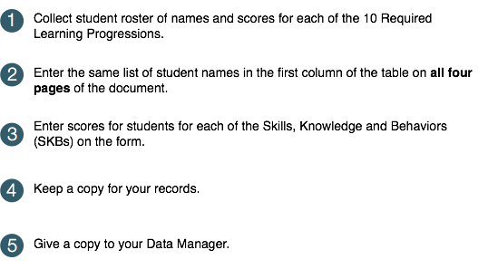
Write Same Student Names on Page 2 -4 | Emotional Identification | Response to Distressed Peer | Separation from Familiar Adults | Seeking Emotional Support | Play/ Work with Peers | Social Behaviors

Copy Student Names From Page 2 | Rhyming Words | Syllables/ Onsets and Rimes/ Phonemes | Initial / Final / Medial Sounds | Adding/ Deleting/ Substituting Sounds | Purposes and Situations | Word Meanings | Word Relationships

Copy Student Names From Page 2 |  | Number Words |  | Object Counting |  | Number Concepts |  | Subitizing |  | Numeral Identification /Writing
Copy Student Names From Page 2 | Tool and Object Manipulation |  | Writing Tool Grasp |  | Safe and Unsafe Behaviors |  | Safety Rules |  | Ways Adults Help Keep Children Safe |  | Personal Care and Basic Health

