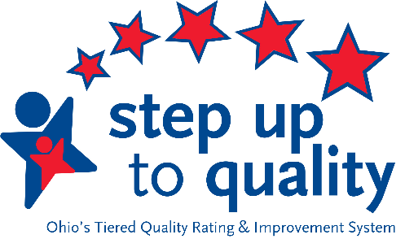
Step Up To Quality Professional Development Guidance
Revised 9/9/19 - Important
This document provides important information regarding professional development requirements for programs participating in Step Up To Quality (SUTQ) in programs licensed by the Ohio Department of Education (ODE).

Professional Development through an LPDC no longer accepted
Beginning in the 2019-2020 school year, ODE will no longer accept the LPDC form for Ohio Approved professional development hours for SUTQ obtained through the ODE created LPDC process.

LPDC forms will be accepted by the Ohio Professional Registry (OPR) if the approved training was completed between July 1, 2019 and December 1, 2019. Any training completed through the LPDC process after December 1, 2019 will not be accepted.

In keeping in line with the intent and integrity of the SUTQ standards for professional development there are multiple options for obtaining Ohio Approved trainings. It is recommended that each school district or professional development organization create their own Training Organization in the OPR. This will provide ease of use for teaching staff to receive Ohio Approved hours and for those to be verified more quickly through the OPR.

The administrator of a Training Organization can set permissions on who can submit training for Ohio Approved credit and manage or schedule the training. Potential trainers must apply to be an Ohio Approved Instructor in order to submit training for Ohio Approved credit. Submissions should be done in the district’s dashboard in the OPR. Once a person is approved as an instructor, they can submit as many trainings they want for approval.

There are user guides available to assist school district personnel to set up a Training Organization and to submit training and instructors on the OPR website: https://occrra.org/our-resources-page/. Click on Training and Instructor Approvals on the left menu bar. There you will find User Guides and a video tutorial outlining the Instructor Approval process.

There are also numerous Ohio Approved trainings (both face-to-face and online options) listed in the Ohio OPR under “Find Training”.

If you have questions about professional development, please submit them to the SUTQ mailbox at SUTQ@education.ohio.gov
Ohio Professional Registry

The Ohio Professional Registry (OPR) is a centralized information system for individuals in Ohio who are employed in the field of early childhood education, including ODE preschool programs. Individuals use the OPR to track education, on-going professional development and employment information. The OPR is also used to register for Ohio Approved professional development.

All professionals must create and maintain a professional profile in the Ohio Professional Registry. Instructions on how to create a profile for ODE professionals are available at https://occrra.org/our-resources-page/.

In the SUTQ rules the word Professional refers to all individuals who are required to obtain and maintain professional development hours. This includes the following person in SUTQ-rated programs:

- Named Onsite Administrator for SUTQ
- Lead teachers
- Assistant teachers (this is the title recognized in the OPR for assistants, aides, and paraprofessionals)
Each program must have one named OPR Administrator who verifies other program professionals registered in the OPR. This can be the same person who serves as the SUTQ onsite Director or Lead Teacher. Instructions for this profess are located on the Resources pages referenced in the link above.

SUTQ Professional Development Requirements and Certificate
Professionals in Step Up To Quality rated programs are required to complete 20 hours of Ohio Approved professional development every biennium (the two year period running from July 1 of an odd numbered years – June 30 of the following odd numbered year – example: July 1, 2019 – June 30, 2021).

At the end of the biennium a Step Up To Quality Professional Development Certificate (SUTQ PDC) is displayed in each individual’s Registry Profile. If an individual completes more than the required 20 hours of Ohio Approved professional development, the additional hours may be used to calculate points towards achieving a four- or five-star rating.

Required Online Courses for SUTQ
Professionals working a star rated programs are required to complete two online training modules, Ohio’s Approach to Quality and Ohio’s Overview of Child Development. The modules are available on the Ohio Professional Registry. The trainings are required to be completed within 30 days of hire. To access the courses, logon to your OPR profile on the OPR website and click on “Find Training”. Click on the module title in the announcement box at the top of the page to register and follow the directions provided to begin each course.

Course Descriptions:

Ohio’s Approach to Quality (2 hours): This course explains the basics of the SUTQ system and what it means for program staff. It allows participants to better understand the purpose behind Ohio’s quality rating and improvement system and how their roles affect the quality outcome.

Ohio’s Overview of Child Development (3 hours): This course explores the basic concepts in Child Development and how that knowledge is linked to providing quality care for children.

Information about exemption from the Child Development course can be found on the Resources page referenced above under SUTQ Professional Development.

