The results are in. We have a winner in the 2014 State of Ohio School Bus Driver Safety Road-E-O.

Lori Robertson a driver from Lakota Schools near Cincinnati, Ohio by a slim margin of 1 point, defeated Lois Humberger of Genoa Area Local schools to take the title. Driving a Transit bus, Robertson scored 698 points out of a possible 725 to be the 2014 State Champion.

The state finals were held at Licking Heights High School in Pataskala, Ohio, in cold temperatures, overcast skies, and moderate windy conditions. Notwithstanding, all 48 competitors representing 8 regions gave it their best efforts.

Once again, the North Region team garnered top team score honors and narrowly defeated the Northwest Region (2nd) and the Southwest Region (3rd).

The top six finalist were:

Lori Robertson, Lakota Petermann in the Transit division, with a score of 698
Lois Humberger, Genoa Area Local driving a conventional, with a score of 697
Linda Schmidt, Archbold, Transit division with a score of 663
Deborah Hill, Findlay City Schools, Transit division and a score of 656
Lori Stulz, Loveland City Schools, Conventional division, 655
Steve Rucker, South-Western City Schools, Conventional division, 643

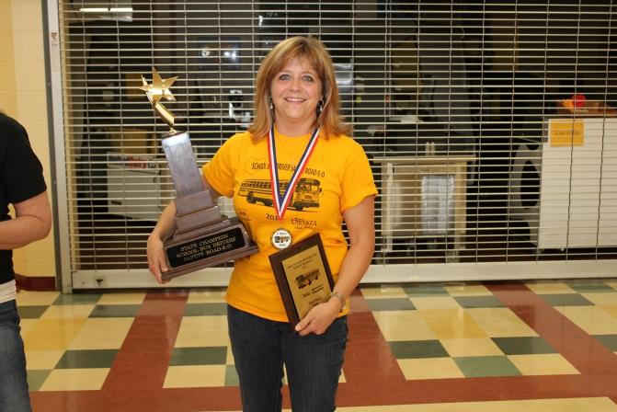 FIRST PLACE LORI ROBERTSON, LAKOTA PETERMANN

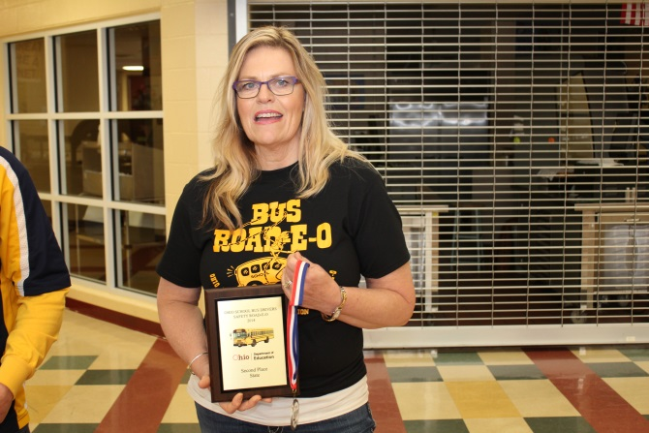 SECOND PLACE LOIS HUMBERGER, GENOA AREA LOCAL

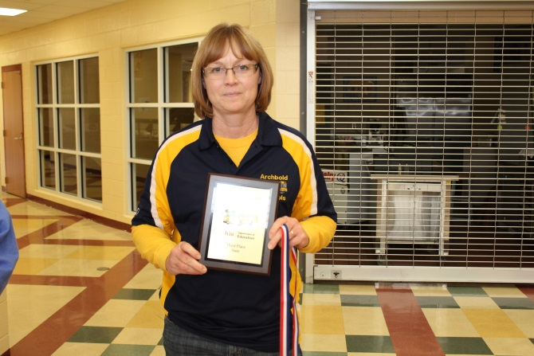 THIRD PLACE LINDA SCHMIDT, ARCHBOLD CITY

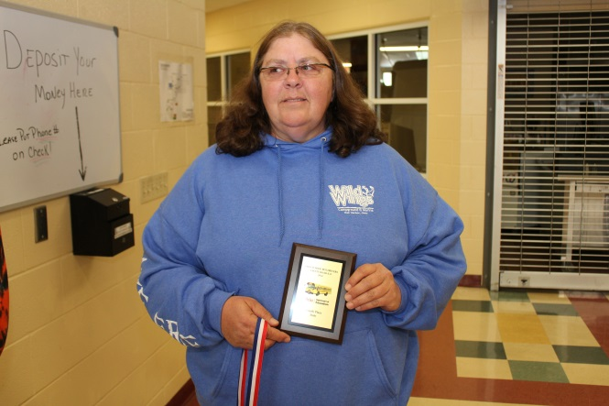 FOURTH PLACE DEBORAH HILL, FINDLAY CITY SCHOOLS

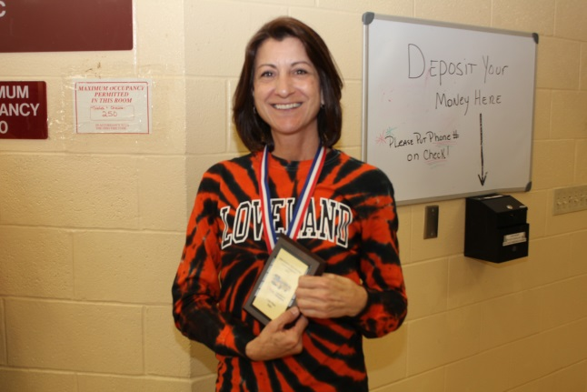 FIFTH PLACE LORI STULZ, LOVELAND CITY SCHOOLS

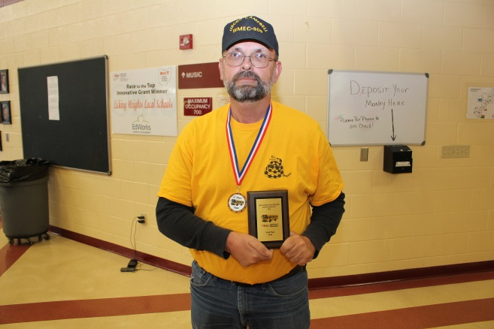 SIXTH PLACE STEVE RUCKER, SOUTH-WESTERN CITY

