INTERCULTURAL PLANNING TEMPLATE

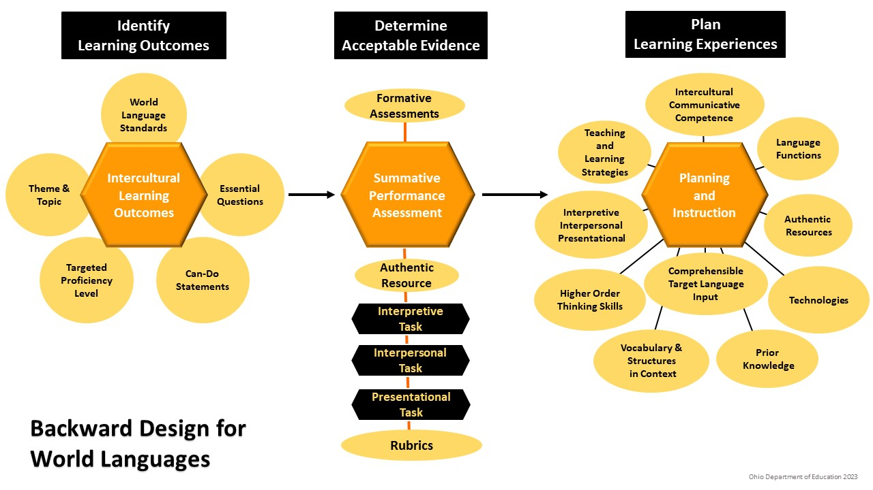

Theme/Topic: Essential Question(s):
Targeted Proficiency Level

INTERCULTURAL OUTCOMES  INVESTIGATE and INTERACT:  In my own and other cultures I can | COMMUNICATION OUTCOMES  INTERPRETIVE: I can  INTERPERSONAL: I can  PRESENTATIONAL: I can

Summative Assessment Tasks Overview
Authentic
Resources
Interpretive Tasks | ACTFL Template
Presentational Tasks
Interpersonal Tasks
Intercultural Reflection Questions (See NCSSFL-ACTFL Reflection Tool to develop pre/post questions in the target language in class, and/or in English outside of class).

CONTENT (What your students need to do and to know to meet the learning outcomes for this unit)

Language Functions  What students need to be able to do  with language, such as compare, summarize, etc. | Language Forms  What students need to know, such as content, vocabulary or structures

Formative Assessments (Design activities for learning checks throughout the unit, aligned to the intercultural and communication outcomes)

