This sample intercultural unit shows the detailed step-by-step process for Backward Design planning. For each step of the process, the left column provides an explanation and links to relevant resources from the Ohio World Languages and Cultures Model Curriculum. All curricula will be developed at the local level.
Note that Backward Design is an integrated, non-linear process. Moving backward and forward throughout the template is expected. Most important is that there are strong intercultural and communicative learning outcomes, and that assessments and activities build reliably toward those outcomes.
Download this unit template and a variety of other planning and assessment templates on the World Languages and Cultures Unit Samples webpage.
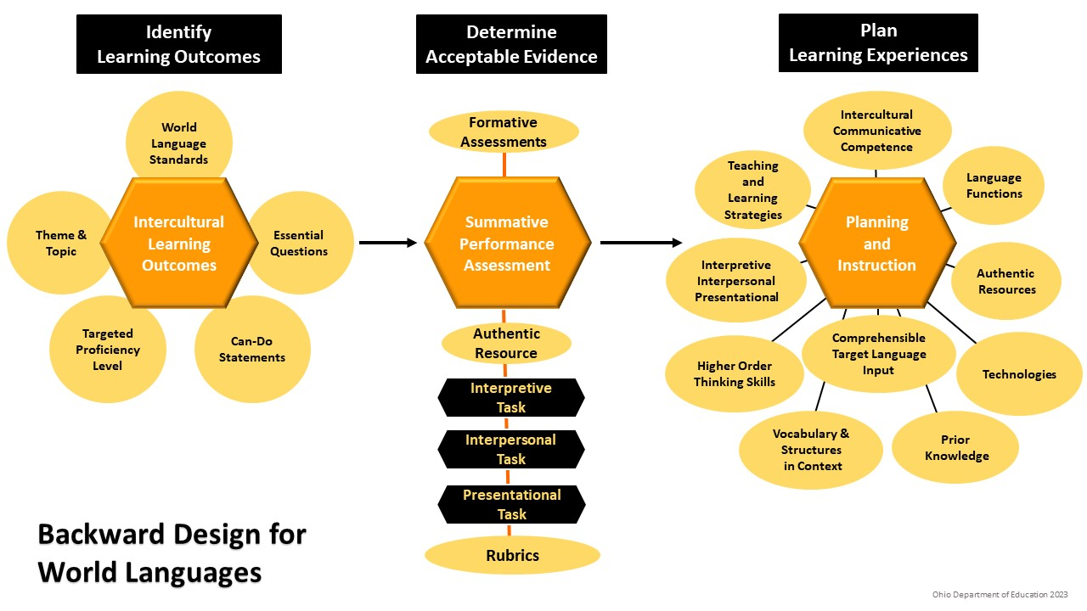
Explanations for each step of the unit plan, with links to the relevant resources from the World Languages and Cultures Model Curriculum | Step 1: IDENTIFY LEARNING OUTCOMES  Learn more about Backward Design
Targeted Proficiency Level  Choose the proficiency level that this unit is targeting.  - View proficiency targets based on the difficulty of the target language.  - Refer to the Ohio World Languages and Cultures Learning Standards for descriptors of Novice Low – Advanced Low language learners.  - Novice learners use a mixture of practiced or memorized words, phrases, simple sentences and questions to talk about very familiar topics. Learners understand the general topic and basic information in simple texts or media.  - Intermediate learners create original questions and series of connected sentences to talk about familiar or personal interest topics and negotiate meaning in conversations. Learners understand the main idea and related information in texts or media.  - Advanced learners use various time frames and paragraphs to talk about and discuss familiar and unfamiliar or researched topics. Learners understand the main message and supporting details in complex texts. | Targeted Proficiency Level(s)
Unit Overview  Choose the theme, topic and essential question(s) that will guide the learning process and outcomes for the targeted proficiency levels.  - Essential questions are open-ended and have no singular right answer. These questions provide a context for intercultural content, stimulate long-term inquiry and help learners increase their critical thinking skills. Find more essential questions for world languages here and here. | Unit Overview  Theme:  Topic:  Essential Question(s):
Intercultural Learning Outcomes  Choose the intercultural communication goals for this unit. Sample intercultural progress indicators for each proficiency level can be found in both the Ohio World Languages and Cultures Learning Standards and in the NCSSFL-ACTFL Intercultural Can-Do Statements  - Intercultural learning outcomes focus on investigation of products, practices and perspectives in the learner’s native culture and the target culture(s), as well as interactions using culturally appropriate language and behavior.  - Using intercultural outcomes to drive communication will help the teacher focus on the relevant content, vocabulary and structures that learners need to know to be successful.  - Learn more about building intercultural competence. | Intercultural Learning Outcomes  - I can…

Explanations for each step of the unit plan, with links to the relevant resources from the World Languages and Cultures Model Curriculum | Step 1: IDENTIFY LEARNING OUTCOMES  Learn more about Backward Design
Standards  Indicate the standards for intercultural communication and literacy that are being targeted from the Ohio World Languages and Cultures Learning Standards.  - Interpretive Standards: Learners comprehend the main idea and relevant details in a variety of culturally authentic and age-appropriate oral, written or signed texts, both nonfictional and fictional, as well as overheard, observed or written conversations. Learners derive meaning using listening, viewing and reading strategies.  - Interpersonal Standards: Learners initiate and sustain spontaneous meaningful spoken, written or signed communication by providing and obtaining information, expressing feelings and emotions and exchanging opinions in culturally appropriate ways. Learners actively negotiate meaning across languages and cultures to ensure their messages are understood and they can understand others.  - Presentational Standards: Learners present prepared or spontaneous information, narratives and viewpoints on a variety of topics to audiences of listeners, readers or viewers for varied purposes. Learners use their understanding of culture to convey messages in a manner that facilitates interpretation by others where no direct opportunity for the active negotiation of meaning exists. | Targeted Standards  Interpretive Intercultural Communication and Literacy:  Interpersonal Intercultural Communication and Literacy:  Presentational Intercultural Communication and Literacy:
Explanations for each step of the unit plan, with links to the relevant resources from the World Languages and Cultures Model Curriculum | Step 2: DETERMINE ACCEPTABLE EVIDENCE  Learn more about Backward Design
Summative Assessment  Design a holistic performance assessment where learners can demonstrate how well they have mastered the learning goals of this unit. The assessment should use authentic cultural resources and be scored using performance or proficiency rubrics. The assessment could be given at the end of the unit, or different components could be given throughout the unit.  - A summative performance assessment will not test discrete content, grammar or vocabulary. Rather, it will allow learners to apply what they know and can do in a meaningful context and will help the teacher determine whether the learners have performed at the targeted proficiency level.  - Summative assessments might include individual or group projects, interpretive assessments, performance assessment, presentations, portfolios, exhibits, reports, writing topics, videos, interviews, role plays, conversations, discussions, etc. | Summative Assessment Tasks - Overview  Authentic Resource(s):  Interpretive Task(s): (see ACTFL template for help with Interpretive task design and rubric)  Interpersonal Task(s):  Presentational Task(s):
Formative Assessment  Create formal or informal tasks to guide instruction by checking for understanding throughout the unit. This will inform the teacher and the learner how to close the gap between where the learner currently is and where they need to be, based on a targeted standard, outcome or proficiency level.  Examples of formative assessments might include:  - non-verbal response (whiteboards, five-finger fist, red/green cards)  - short quizzes over specific vocabulary or structures  - role plays, Think-pair-share, peer editing, partner chats  - exit slips, KWL charts, questions and answers  - kinesthetic activities, polling, surveys, informal observations | Formative Assessments

Explanations for each step of the unit plan, with links to the relevant resources from the World Languages and Cultures Model Curriculum | Step 3: PLAN LEARNING EXPERIENCES  Learn more about Backward Design
Prior Knowledge or Pre-Assessment  Activating prior knowledge before teaching a new concept helps learners see connections to previous learning or personal experiences and build on this knowledge. Learners can show what they already know and give the teacher insight into areas of strength or focus throughout the unit.  Prior knowledge activities might include:  surveys, checklists or brainstorming  short quizzes  drawing or games  graphic organizers or concept maps  interactive technology tools  personal, reflective or content questions | Prior Knowledge or Pre-Assessment Activities
Language Functions/Forms and Vocabulary  Determine the language functions and forms learners will need to meet the learning outcomes of this unit.  - Language functions refer to what students do with language, such as compare/contrast, express opinions or make predictions. Language forms refer to grammatical structures, such as adjectives or verb forms.  - Present grammar in a meaningful context as chunks of language or as a concept in order to impact language acquisition. Focus on meaning before form. Learn about the PACE model for contextualized grammar.  Determine the essential vocabulary for this unit and present it in a meaningful context, such as with images or stories. Learn more about [ i+1] and how to contextualize target language at all proficiency levels to make it more comprehensible. | Language Functions  Language Forms/Structures  Vocabulary
Instructional Strategies  Create learning experiences related to the unit outcomes that will reach a wide range of diverse learners, using strategies based on Universal Design for Learning principles (i.e., a variety of ways for engagement, practice and demonstration of learning).  Integrate a variety of activities that focus on:  - intercultural competence and knowledge  - interpretive, interpersonal, presentational skills  - literacy skills  - relevant vocabulary and structures  - technology integration  - real-life or future life connections  - native or heritage speakers  - learners with disabilities  - gifted learners | Instructional Strategies  Interpretive Reading and Listening/Viewing Activities:  (see ACTFL template for help with Interpretive task design)  Interpersonal Activities  Presentational Writing and Speaking or Signing Activities:  Contextualized Vocabulary and Grammar Activities:  Technology Integration:  Strategies or Scaffolds for Native/Heritage Speakers  Strategies or Scaffolds for Learners with Disabilities  Strategies for Scaffolds for Gifted Learners
Student Engagement  Help learners determine the relevance of this unit to their current life or future pathways. Why and how is this content or learning useful to them?  - Ohio’s World Language Career Connections has lessons, videos, activities and ideas for making world language content relevant for learners future goals. | Student Engagement: Life, College or Career Connections:
Intercultural Reflection  Encourage learners to engage in deeper reflection on the cultural content of the unit, either in class in the target language, or outside of class in English.  - Use the NCSSFL-ACTFL Reflection Tool With Sample Questions for ideas on creating deeper reflection questions in English outside of class and target language activities in class:  - “Learners’ awareness and understanding of their own and others’ cultures grow with each new intercultural encounter. It takes reflection, however, to process a depth of understanding that develops openness and promotes an examination of values and attitudes.  The primary focus of language education is to develop language proficiency; however, deep reflection normally occurs in one’s native language. For this reason, reflection activities are designed with maximum use of the target language during instructional time and an option for use of English at home for deeper reflection.” (NCSSFL-ACTFL Reflection Tool, 2017). | Intercultural Reflection Questions or Activities  - [Create target language questions or activities at the appropriate proficiency level for IN CLASS.]  - [Create deeper level reflection questions or activities to be done in English/native language OUTSIDE OF CLASS. See the NCSSFL-ACTFL template for examples.]  [The following questions could be used as the final reflection questions]:  - What new insights about yourself and others have you gained from thinking about this topic?  - What have you learned that is new, interesting or might change the way you think about things?

