INTERCULTURAL
REFLECTION ACTIVITIES
FOR LEARNERS

NCSSFL-ACTFL
Intercultural Can-Do Statements
2017
Reflection
Intercultural Communicative Competence
Introduction
Cultures Goal: Interact with Cultural Competence and Understanding.
Standard: Learners use the language to investigate, explain and reflect on the relationship between Practices and Perspectives of the cultures studied.
Standard: Learners use the language to investigate, explain and reflect on the relationship between Products and Perspectives of the cultures studied.
World Readiness Standards
Using the Can-Do Statements for Intercultural Communication for self-assessment, goal setting, and planning for learning is only a first step on the journey to developing Intercultural Communicative Competence (ICC). Another crucial step is reflection.
Learners’ awareness and understanding of their own and others’ cultures grow with each new intercultural encounter. They begin to experience how language proficiency can limit or enhance their comfort level or success in these encounters. It takes reflection, however, to process a depth of understanding that develops openness and promotes an examination of values and attitudes, which Byram (1997, 2002), Deardorff (2006) and Fantini (2006) state, that along with knowledge and skills, are the foundation of intercultural competence. Learning to examine and understand behaviors provides a factual base from which stereotypes and misconceptions can be explained and dispelled. To help develop a habit of self-reflection, it is important for learners to pause and withhold judgment when learning about, analyzing, and interpreting cultural products, practices and perspectives.
The primary focus of language education is to develop language proficiency, however, deep reflection normally occurs in one’s native language. For this reason, the reflective activities are designed with maximum use of the target language during instructional time and an option for use of English at home for deeper reflection. The framework for reflective activities involves:
- an introductory in-class component in the target language;
- a deeper reflection outside of class in English, or, if the learner’s proficiency level allows, in the target language; and
- a follow-up in-class target language component.
It is worth noting that the lack of sufficient language proficiency does not prevent the internalization of cultural perspectives, it only hinders the ability to communicate them in the target language. Learners internalize perspectives by reflecting on them and expressing them in their native language, before they express those perspectives in the target language. In the early stages of learning a language, learners develop an understanding of products and practices, while internalizing the perspectives associated with them. Later, as their language proficiency grows, learners are able to express and apply their knowledge of perspectives in intercultural contexts.
The development of cognitive and affective skills is a factor in intercultural reflection and growth. Young learners need guided experience and can benefit from parental or caregiver involvement at home. Observing, noticing, discovering, comparing, considering, thinking, and higher level skills such as recommending, planning, hypothesizing and creating, are among the cognitive acts associated with reflection and are vital to the evolution of attitudes. Affective components such as receiving, feeling, imagining, valuing, appreciating, and preferring need to be taken into account, as they, too, play an important role in the reflective process.
The accumulation of individual experiences and the quality of reflection on those experiences pave the path to growth in Intercultural Communicative Competence. The world language classroom provides a prime environment for nurturing these dispositions and skills, crucial to whole child development. However, it should not be the sole responsibility of language teachers to develop a learner’s ICC. Educators across content areas can collaborate and partner with outside organizations to build a more extensive and integrated schoolwide ICC program.

Note: Blank templates can be found at the end of this document.
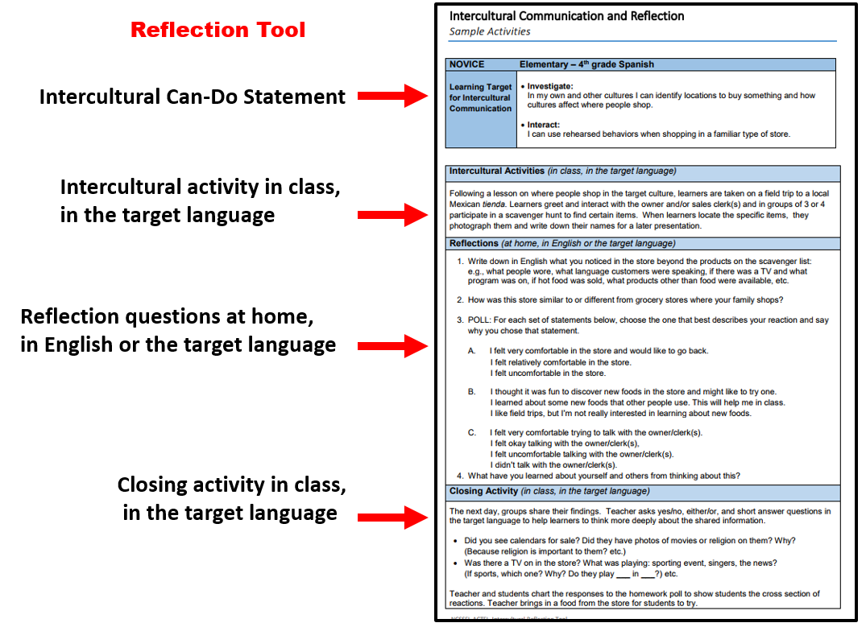

Intercultural Communication and Reflection

Sample Activities
NOVICE Early Learners, K-1-2
Learning Target for Intercultural Communication | - Investigate:  In my own and other cultures I can identify social practices such as greetings, introductions, leave-taking and thanking people.  - Interact:  I can greet and take leave from someone using polite rehearsed behaviors.

Intercultural Activities (in class, in the target language)
- Learners watch video clips of various people meeting one another in different contexts – family members, friends, business associates.

- Ask learners to repeat what was said in the various interactions.
- Make a chart on the board, with columns for family members, friends, and business associates.
- Review the videos and ask the learners to guess which interactions were among family members, friends, and business associates.
- Point out that in some interactions, the people kiss the cheek of the person they are meeting (“Faire la bise”).
- Have learners take note that some people do 2 kisses, whereas some do 3 and some do 4. Show a map of France and show Paris. State that in Provence it is 3 kisses and that in southern France it is 4 kisses. The rest of France uses 2 kisses. State that in Paris people do 2 or 4 kisses.
- Give situations and ask learners what would they say. Would they “faire la bise?”
- Ask for volunteers to use puppets or stuffed animals to demonstrate how people in the target culture greet/say good-bye to friends, family and teachers, based on what they saw in the videos.

- Learners think about how comfortable they would feel using the appropriate greeting in the target culture. As the teacher points to /says each line of the chart, learners give Thumbs UP, Thumbs SIDEWAYS, or Thumbs DOWN.

Reflections (at home, in English or the target language)
Interactive Journal. Parents will interview their child and record responses in their journal.
- How do French kids greet their family members? Do you greet your family in this way?
- How do French kids greet their friends? Do you greet your friends in this way?
- How do French adults meet their friends? Do your parents greet their friends in this way?
- How do French adults meet their business associates? Do your parents greet their business associates in this way?
- Would you feel comfortable greeting your family members with a bise? What about your friends?
F. If you were to travel to France, would you think it is important to greet people with a bise? Why or why not?
Closing Activity (in the target language)
Teacher will respond in writing to learners’ journal entries. Parents will share responses with their child.

Intercultural Communication and Reflection
Sample Activities

NOVICE Elementary – 4th grade Spanish
Learning Target for Intercultural Communication | - Investigate:  In my own and other cultures I can identify locations to buy something and how cultures affect where people shop.  - Interact:  I can use rehearsed behaviors when shopping in a familiar type of store.

Intercultural Activities (in class, in the target language)
Following a lesson on where people shop in the target culture, learners are taken on a field trip to a local Mexican tienda. Learners greet and interact with the owner and/or sales clerk(s) and in groups of 3 or 4 participate in a scavenger hunt to find certain items. When learners locate the specific items, they photograph them and write down their names for a later presentation.

Reflections (at home, in English or the target language)
- Write down in English what you noticed in the store beyond the products on the scavenger list:
e.g., what people wore, what language customers were speaking, if there was a TV and what program was on, if hot food was sold, what products other than food were available, etc.
- How was this store similar to or different from grocery stores where your family shops?

- POLL: For each set of statements below, choose the one that best describes your reaction and say why you chose that statement.

A. I felt very comfortable in the store and would like to go back.
I felt relatively comfortable in the store.
I felt uncomfortable in the store.
B. I thought it was fun to discover new foods in the store and might like to try one.
I learned about some new foods that other people use. This will help me in class.
I like field trips, but I’m not really interested in learning about new foods.
C. I felt very comfortable trying to talk with the owner/clerk(s).
I felt okay talking with the owner/clerk(s),
I felt uncomfortable talking with the owner/clerk(s).
I didn’t talk with the owner/clerk(s).
4. What have you learned about yourself and others from thinking about this?
Closing Activity (in class, in the target language)
The next day, groups share their findings. Teacher asks yes/no, either/or, and short answer questions in the target language to help learners to think more deeply about the shared information.
- Did you see calendars for sale? Did they have photos of movies or religion on them? Why?
(Because religion is important to them? etc.)
- Was there a TV on in the store? What was playing: sporting event, singers, the news?
(If sports, which one? Why? Do they play ___ in ___?) etc.

Teacher and students chart the responses to the homework poll to show students the cross section of reactions. Teacher brings in a food from the store for students to try.

Intercultural Communication and Reflection

Sample Activities
NOVICE Middle / High School
Learning Target for Intercultural Communication | - Investigate:  In my own and other cultures I can identify locations to buy something and how culture affects where people shop.  - Interact:  I can use rehearsed behaviors when shopping in a familiar type of store.

Intercultural Activities (in class, in the target language)
- Learners view a video clip of a family grocery shopping for the week, in a target language country.
It may include shopping in a supermarket; shopping in a supermarket and in some specialty shops; or shopping exclusively in specialty shops.

- In small groups, learners complete a T-chart in which they compare the shopping experience in the video with their own family’s grocery shopping experience.

 | Video Observations | How My Family Shops
List the store(s) where they shopped:

List what they bought:

List how much they bought of each item:

Categorize what was bought:

- The teacher facilitates a class summary in the target language as the groups share their results.

Reflections (at home, in English or the target language)
Interactive Journal. Learners will reflect on/answer the following questions in their journal.
- Describe how a family shops in <target country>.
- How does this compare to the way your family shops?
- What do you think accounts for some of the differences? Why do you think the family in <target country> bought certain groceries and not others?
- What groceries will they have to buy before the next week’s shopping trip?
- Name some specialty food shops in our city. Who shops at specialty food shops?
- How practical would it be for your family to shop like the family in <target country>?
- What new insights about yourself and others have you gained from thinking about this?

Closing Activity (in class, in the target language)
The teachers facilitates the completion of a class Venn diagram to summarize the similarities and differences of grocery shopping in < target culture>. Learners then role play shopping in various specialty shops in <target country>.

Intercultural Communication and Reflection

Sample Activities
NOVICE Middle / High School
Learning Target for Intercultural Communication | - Investigate:  In my own and other cultures I can identify social practices such as greetings, introductions, leave-taking and thanking people.  - Interact:  I can greet and take leave from someone using polite rehearsed behaviors.

Intercultural Activities (in class, in the target language)
- Draw the following T-chart on the board. Modify as needed for your target culture.
GREETINGS / GOOD-BYE
 | United States | Target Country/Culture
With friends
With family
With teachers

- Ask for volunteers to demonstrate how they greet/say good-bye to their friends; to their family members; to their teachers. The teacher will fill out the USA column, with simple language or images, using the target language to summarize what the learners did (e.g., high five, fist bump, hug).

- Ask for volunteers to demonstrate how they think people in the target culture greet/say good-bye to friends, family and teachers. The teacher fills out the second column, with simple target language or images, summarizing what the learners did.
- Show snippets of videos with native speakers greeting or saying good-bye to friends, family and teachers. The teacher and learners then edit the second column together, based on the videos.
- Ask learners to think about how comfortable they would feel using the appropriate greeting in the target culture. As the teacher points to /says each line of the chart, have learners give Thumbs Up, Thumbs Down, Thumbs Sideways, to indicate their comfort level.
Reflections (at home, in English or the target language)
Interactive Journal. Learners will reflect on/answer the following questions in their journal.

1. Describe how students in <target culture> greet family, friends and teachers.
2. How is this similar and/or different from your way of greeting?
3. How comfortable or uncomfortable would you be using the appropriate greetings/good-byes in the target culture, with friends, family and teachers? Why do you think you would react this way?
4. How important would it be for you to adjust your behavior to fit in with teens in the target culture?
5. What do you think a <target culture> teen would think about the way American students greet their friends, family and teachers? Do you think it would be hard for them to adjust their behavior?
6. What new insights about yourself and others have you gained from thinking about this?
Closing Activity (in the target language)
Teacher responds in writing to the students’ journal reflections.
Intercultural Communication and Reflection
Sample Activities

INTERMEDIATE Middle / High School
Learning Target for Intercultural Communication | - Investigate:  In my own and other cultures I can describe how attitudes toward informality and formality in relationships affect behavior and language.  - Interact:  I can use appropriate greeting and leave taking gestures and behaviors in familiar informal and formal situations.

Intercultural Activities (in class, in the target language)
Learner Discussion:
- How does the level of formality between students and teachers in the USA compare to that of the target culture?
- What might be some reasons for similarities or differences in formality in both cultures?
- How much formality do you prefer with teachers? Why?
- How do people use behavior and language to show their attitude toward another person in the USA? And in the target culture?

Reflections (at home, in English or the target language)
1. Describe how formal or informal are you with people in your life (parents, friends, teachers).
How does your language or behavior change when interacting with these people?
2. How is this similar or different to teens in <target culture>?
3. Why do you think there are these similarities or differences?
4. How do you know what level of formality someone else expects?
5. Do you think American parents are too informal with their children?
6. Do you think teachers in the USA are too informal with their students?
7. What are the advantages and drawbacks to an informal teacher-student or parent-child relationship? 8. How does the level of formality between the student and teacher affect the classroom environment?
9. How does the level of formality between the parent and child affect the home environment?
10. What new insights about yourself and others have you gained from thinking about this?

Closing Activity (in class, in the target language)
Essay topic: Pick one of the following topics:

a) Choose one of your classes in which the teacher is either very formal with students or very informal with the students. Tell how this affects the atmosphere of the class, teacher-student interactions, and the behavior and language in the class. How does this level of formality affect your experience in the class? How might this be similar or different to a class in <target culture>?
b) Write from the point-of-view of an exchange student from <target culture> staying in the USA for a year. What might surprise her/him regarding the level of formality between American teens and their parents/teachers/other adults? How might s/he have to adjust her/his own behavior and language?

Intercultural Communication and Reflection

Sample Activities
INTERMEDIATE High School
Learning Target for Intercultural Communication | - Investigate:  In my own and other cultures I can identify and compare the values expressed by the way people celebrate holidays or festivals.  - Interact:  I can adjust the way I dress to make it appropriate for a celebration or event.

Reflections (at home, in English or the target language)
Learners journal about the 4th of July, answering the questions:
- Why does your family celebrate this holiday?
- What are a few of the traditions associated with its celebration in your family?
- Does everyone in your town celebrate this holiday and if so, do they celebrate it in the same way? Why or why not?
- What underlying values does this holiday represent for you?
- What is a similar holiday that exists in <target culture>?
- How does <target culture> celebrate this holiday?
- How is this similar to the way you celebrate?

Intercultural Activities (in class, in the target language)
- The teacher:
a. Skypes with a personal friend from the target culture;
b. has learners Skype or correspond with a peer class in the target country; or
c. invites a target language speaker or native-speaking ESL or exchange student to the class, to tell about how s/he/they celebrate their national holiday.

- Learners ask prepared and impromptu questions about why and how the holiday is celebrated and what the holiday represents. Additional questions could be asked to find out what the native speaker’s knowledge and impression are about the celebration of July 4th in the U.S.

- Learners create a Venn diagram that illustrates the holidays’ celebrations and their values.

Reflections (at home, in English or the target language)
Learners write about insights they have gained about themself and others, regarding the celebration of national holidays and people’s values.

Intercultural Communication and Reflection
Sample Activities

ADVANCED High School
Learning Target for Intercultural Communication | - Investigate:  In my own and other cultures I can explain how the role of personal space and topics of conversation influence social interaction.  - Interact:  I can greet and take leave from someone using appropriate behaviors in most situations and change an incorrect behavior.

Intercultural Activities (in class, in the target language)
Learner discussion:
- How does personal space differ, based on the person with whom you are talking?
- How do you react when someone stands/sits too close or too far away from you?
- How do you know what is the “appropriate” distance between yourself and another person?
- How does personal space differ between your culture and the target culture?

- How does your topic of conversation differ, based on the person with whom you are talking?
- How do you react when someone brings up a topic that might be considered inappropriate for the social situation?
- How do you know what is an “appropriate” topic of conversation?
- How do conversation topics differ in your culture as compared to the target culture?

Reflections (at home, in English or the target language)
1. What is the appropriate amount of personal space in the USA for various social situations?
2. Research the appropriate amount of personal space in the target culture for various social
situations.
3. How can one overcome feelings of discomfort brought on by another person being too close
(or too far), based on cultural norms? How can one react or adjust without offending the other?
4. How do your topics of conversation differ, based on your social interactions?
5. Research what topics of conversation are appropriate in the target culture, based on the social
situation.
6. How can one control strong reactions or emotions that might be brought on by a controversial
topic of conversation?
7. What are some possible ways to repair a “faux pas” or an incorrect behavior in your own or
another culture?
8. What new insights about yourself and others have you gained from thinking about this?

Closing Activity (in class, in the target language)
Scenarios
Learners brainstorm scenarios that would make a person from another culture uncomfortable (either an American in the target culture, or a foreign visitor to the USA). These could involve personal space, controversial topics, socially unacceptable behavior or language, etc.). Learners then discuss appropriate ways to react in these scenarios. Finally, learners role play the scenarios spontaneously with a peer.

Intercultural Communication and Reflection

Activities (see NCSSFL-ACTFL Can-Do Statements for Intercultural Communication)
NOVICE
Learning Target for Intercultural Communication | - Investigate:  In my own and other cultures I can  - Interact:  I can

Intercultural Activities (in class, in the target language)
Reflection Questions (at home, in English or the target language)
- What have you learned about yourself and others from thinking about this?
- What might change in you from thinking about this?
Closing Activity (in the target language)

Intercultural Communication and Reflection
Activities (see NCSSFL-ACTFL Can-Do Statements for Intercultural Communication)
INTERMEDIATE
Learning Target for Intercultural Communication | - Investigate:  In my own and other cultures I can  - Interact:  I can

Intercultural Activities (in class, in the target language)
Reflections Questions (at home, in English or the target language)
- What new insights about yourself and others have you gained from thinking about this?
- What might change in you from thinking about this?

Closing Activity (in class, in the target language)
Intercultural Communication and Reflection
Activities (see NCSSFL-ACTFL Can-Do Statements for Intercultural Communication)

ADVANCED
Learning Target for Intercultural Communication | - Investigate:  In my own and other cultures I can  - Interact:  I can

Intercultural Activities (in class, in the target language)
Reflection Questions (at home, in English or the target language)
- What new insights about yourself and others have you gained from thinking about this?
- What might change in you from thinking about this?

Closing Activity (in class, in the target language)

