Ohio Physical Education Assessments
Standard  1 | Demonstrates competency in motor skills and movement patterns needed to perform a variety of physical activities.
Benchmark  A | Combines locomotor and non-locomotor skills into movement patterns.
Grade Band: 3-5

Task: Performance of a creative movement pattern – in a movement setting, observe student as he or she individually practices and performs a sequence of locomotor and non-locomotor movements.

Options: Choose one or more of the following options:
1. | Jump Rope
2. | Gymnastics
3. | Dance
*Scoring for the benchmark will be comprised of the average of options assessed. For example, if only one is assessed that will be the Benchmark score; if all three are assessed, then it will be the overall average of the three options.

Option 1: Jump Rope
Skills: Routine should consist of at least five or more movements. Skills in the routine can include
various difficulties – at least two challenging skills must be present to score advanced. Student score is based on the performance of skills within routine. See Standard 1 A Template.

Challenging skills include: footwork, arm action, and combined footwork and arm action skills.

Level | Jump Rope - Criteria
Advanced  3 | A minimum of five jump rope skills, including at least two challenging jump rope skills (e.g., combined footwork skills and arm action skills and/or tricks) are performed correctly in the routine. Routine has smooth transitions between skills and has an identifiable beginning and ending points.
Proficient  2 | At least three jump rope skills are performed correctly and combined with smooth transitions. Routine has identifiable beginning and ending points. *Could be three basic skills or a combination of basic and challenging (two basic, one challenging)
Limited  1 | Jump rope skills are not performed correctly. Routine lacks smooth transitions or there is not an identifiable beginning and/or ending point.

Option 2: Gymnastics
Skills: Balances, rolls, travel skills and jumps. The delineation from basic to advanced skills should be determined by the physical education teacher with the consideration of level of difficulty (e.g., inverted balancing is much more challenging than upright balancing). See Standard 1 A Template

Level | Gymnastics - Criteria
Advanced  3 | A minimum of five educational gymnastics skills, including at least two challenging skills are performed correctly in the routine. The skills are combined with smooth transitions and identifiable beginning and ending points in a routine.
Proficient  2 | At least three educational gymnastics skills are performed with correct technique. The skills are combined with smooth transitions and identifiable beginning and ending points in a routine.
Limited  1 | Educational gymnastic skills are not performed with correct technique. The routine lacks smooth transitions and/or the routine is missing an identifiable beginning and/or ending point.

Option 3: Dance
Skills: The delineation from basic to advanced dance movements should be determined by the physical education teacher with the consideration of level of difficulty.
Level | Dance - Criteria
Advanced  3 | Basic and advanced dance movements are performed with correct technique in time to a beat or with a rhythm.
Proficient  2 | Basic dance movements are performed with correct technique in time to a beat or with a rhythm.
Limited  1 | Has difficulty demonstrating dance movements with proper technique or moving in time to a beat or with a rhythm.

Standard 1 A Template
Routine skills could be selected and filled out by the teacher or student.

Remember, you will need to have at least five skills. If you want to earn Advanced, at least two skills must be advanced.
Routine |  | Basic | Advanced
Beginning
1
2
3
4
5
6
End
See excel sheets for data collection.

Level | Average Rating
Advanced | Average score 3.0 – 2.75
Proficient | Average score 2.74 – 1.75
Limited | Average score 1.74 - 0

Ohio Physical Education Assessments
Standard  1 | Demonstrates competency in motor skills and movement patterns needed to perform a variety of physical activities.
Benchmark  B | Apply the critical elements of fundamental manipulative skills in a variety of physical activities.
Grade Band: 3-5

Overall Task: All skills must be assessed and will then be combined to identify the student’s overall competency.

Skill and Task: Throwing – Observe multiple repetitions of your students throwing balls (tennis ball size) overhand (from approximately 25 feet away) at a target (approximately 6 feet by 6 feet).

Level | Throwing - Criteria
Advanced  3 | Demonstrates correct technique of the overhand throw. The ball travels with sufficient force and accuracy to hit the target consistently.
Proficient  2 | Demonstrates correct technique of the overhand throw (side to target, step with opposite foot, trunk rotation, elbow bend in L-shape at shoulder level and follow through).
Limited  1 | Demonstrates incorrect overhand throwing technique.

Skill and Task: Catching with an implement (e.g., glove or scoop) – Observe multiple repetitions of your students catching a thrown ball (baseball or softball size) with an implement.

Level | Catching with an implement - Criteria
Advanced  3 | Consistently catches using an implement thrown from varying heights and locations (e.g., to the right, left, high, middle, low).
Proficient  2 | Catches using an implement with correct technique (eyes on the ball, moves into line with the ball, implement presented to the ball, force absorption) in a practice setting.
Limited  1 | Demonstrates incorrect catching technique when using an implement.

Skill and Task: Striking – Observe multiple repetitions of your students striking moving balls with implements in practice and game-like situations (e.g., softball, badminton, paddle tennis, floor hockey). It is quite possible for the teacher to have multiple practices/games in progress concurrently, with the teacher observing and assessing over a broad field of vision.

Level | Striking - Criteria
Advanced  3 | Demonstrates correct striking technique with accuracy and control of force to be successful in game settings.
Proficient  2 | Demonstrates correct striking technique (eyes on the ball, bat or stick goes back, step into the swing, trunk rotation, follow through) with accuracy and control of force to be successful in practice settings.
Limited  1 | Demonstrates incorrect striking technique.

Skill and Task: Receive/dribble/pass with the feet – Observe multiple repetitions of your students in a soccer practice setting. This can be done in pairs with one student acting as the “feeder” who rolls the ball to the “performer.” The performer receives the ball with the foot, dribbles 20-30 feet to a designated line and then passes the ball to a target (about 10 feet wide) from a distance of 15-20 feet.

Level | Receive/Dribble/Pass with the Feet - Criteria
Advanced | Demonstrates correct receiving technique, dribbles with speed and passes with power and accuracy to the target.
Proficient | Demonstrates correct receiving, dribbling and passing technique (moves into line with the ball, uses the receiving foot to steer the ball in the required direction of dribble, keeps the ball close in the dribble, passes with the inside or laces of the foot to the target).
Limited | Demonstrates incorrect receiving, dribbling and passing technique.

Skill and Task: Dribbling a basketball, hockey puck or ball – Observe multiple repetitions of your students dribbling to avoid stationary objects in open space. This can probably be done as a class activity. Then, observe them dribbling in game or game-like (competitive drill) situations.

Level | Dribbling a Basketball, Hockey Puck or Ball - Criteria
Advanced  3 | Dribbles with correct technique and control with both hands while avoiding stationary or moving objects in a practice situation.
Proficient  2 | Dribbles with correct technique (use of appropriate surfaces, eyes up, ball/puck is kept under control) while avoiding stationary objects in practice situations.
Limited  1 | Dribbles with incorrect technique and inability to avoid stationary objects in practice situations.
See excel sheets for data collection.

Level | Average Rating
Advanced | Average score 3.0 – 2.75
Proficient | Average score 2.74 – 1.75
Limited | Average score 1.74 - 0

Ohio Physical Education Assessments
Standard  2 | Applies knowledge of concepts, principles, strategies and tactics related to movement and performance.
Benchmark  A | Demonstrates and applies basic tactics and principles of movement.
Grade Band: 3-5

Task: Game performance observation of students playing in small-sided games – Observe students on multiple occasions in game performance settings. These settings should be small-sided to allow for student involvement in game play and opportunities for the teacher to observe students’ performances. Focus specifically on the level of understanding students show in terms of positioning and skill selection. Use the criteria below to evaluate student performance.
Level | Criteria
Component Observed | Positioning | Decision-Making –  Skill Selection
Advanced  3 | Consistently:  - Moves to help teammates with the ball.  - Moves to defend space.  - Returns to correct base position for the game played. | Consistently selects the appropriate skills required to perform within the context of the game (e.g., shoots, passes or dribbles when appropriate, throws to the correct base).
Proficient  2 | Usually, but not always:  - Moves to help teammates with the ball.  - Moves to defend space.  - Returns to correct base position for the game played. | Usually, but not always, selects the appropriate skills required to perform within the context of the game (e.g., shoots, passes or dribbles when appropriate, throws to the correct base).
Limited  1 | Rarely:  - Moves to help teammates with the ball.  - Moves to defend space.  - Returns to correct base position for the game played. | Rarely selects the appropriate skills required to perform within the context of the game (e.g., shoots, passes or dribbles when appropriate, throws to the correct base).
Benchmark A score = Average of Positioning and Decision-Making score.
See excel sheets for data collection.

Level | Average Rating
Advanced | Average score 3.0 – 2.75
Proficient | Average score 2.74 – 1.75
Limited | Average score 1.74 - 0

Ohio Physical Education Assessments
Standard  2 | Applies knowledge of concepts, principles, strategies and tactics related to movement and performance.
Benchmark  B | Demonstrates knowledge of critical elements for more complex motor skills.
Grade Band: 3-5

Task: The teacher would provide a demonstration of a skill (but not demonstrating advanced technique), so that all students are observing and analyzing the same performance. Students will then analyze the following:
- A list of the performer’s performance strengths. What does the performer do well?
- A list of the performer’s performance weaknesses. What can the performer practice to improve (e.g., the main skills needing improvement)?
- A plan to improve performance including drills, cues or activities to help the performer achieve advanced-level performance of the skill.
A task sheet, like that on the next page, can be developed for students to use. To accommodate students with writing difficulties, reports could be audiotaped or submitted verbally by interview with the teacher.

Level | Criteria
Advanced  3 | The report contains an accurate comprehensive list of strengths and weaknesses applying critical elements of the skill. Provides with specific and appropriate suggestions regarding how the performer could improve performance.
Proficient  2 | The report lists at least one of the performer’s strengths and weaknesses accurately using critical elements. Provides an appropriate suggestion to improve performance.
Limited  1 | The report is vague about strengths and weaknesses and the practice plan does not identify specific elements of focus. Goals are either not stated or are broad.

See excel sheets for data collection.

Level | Average Rating
Advanced | Average score 3.0 – 2.75
Proficient | Average score 2.74 – 1.75
Limited | Average score 1.74 - 0

Name:_____________

Task: Watch a sport skill performance (the skill will be one in which the performer is not advanced and needs to improve). Watch the performer many times and then complete the worksheet below.

- List the performer’s performance strengths. What does he or she do well?

- List the performer’s performance weaknesses, and describe what he or she can practice to get better (e.g., the main things needing attention).

- Tell the performer what to do to improve. This could be specific drills to practice, games to play, exercises or cues to remember how to perform a critical element.

Ohio Physical Education Assessments
Standard  3 | Demonstrates the knowledge and skills to achieve and maintain a health-enhancing level of physical activity and fitness.
Benchmark  A | Describes current level of physical activity and identifies additional physical activity opportunities to create calorie balance.
Grade Band: 3-5
Task: The student will demonstrate a basic understanding of tracking and identifying opportunities for physical activity and the relationship of eating healthy and being physically active by completing the following questions. The questions do not have to be administered during one test; they can be administered throughout the course of multiple units.
Level | Physical Activity Tracking and Opportunities | Healthy Choices in Relation to Physical Activity
Advanced  3 | Student identifies two physical activity opportunities for each: school, home and community, and the student tracks physical activity minutes accurately over a one-day span. | Student identifies a food choice for each category of MyPlate and identifies the benefit of both eating properly and being physically active.
Proficient  2 | Student identifies a physical activity opportunity for each: school, home and community, and the student tracks physical activity. | Student identifies a food choice for four out of the five categories of MyPlate and identifies the benefit of both eating properly and being physically active.
Limited  1 | Student has difficulty identifying physical activity opportunities and/or tracking physical activity minutes. | Student has difficulty identifying food choices in the categories of MyPlate and/or cannot identify the benefit of eating healthy and being physically active.

*Scoring will be an average of the two rubrics.

Level | Average Rating
Advanced | Average score 3.0-2.75
Proficient | Average score 2.74-1.75
Limited | Average score 1.74-0

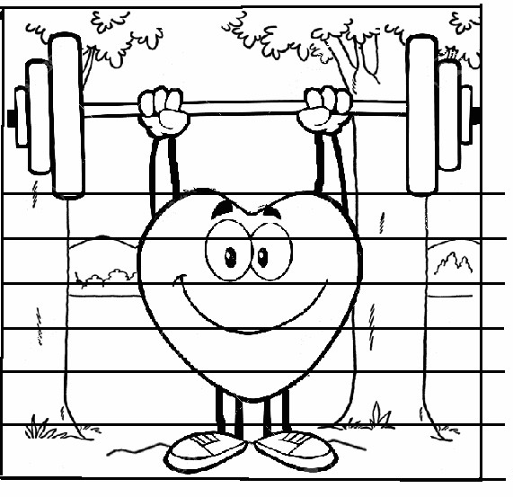
Below: List any physical activity that you did yesterday and color in the picture for every 10 minutes of activity you did.
Physical Activities I did on___/___/_____:
0
10 Minutes
20 Minutes
30 Minutes
40 Minutes
60 Minutes
50 Minutes
Example: If I did 40 minutes of physical activity total, I would color up to the 40-minute line.
List two or more physical activities that you either did or could do at home:

List two or more physical activities you either did or could do at school:

List two or more physical activities you either did or could do in your community:
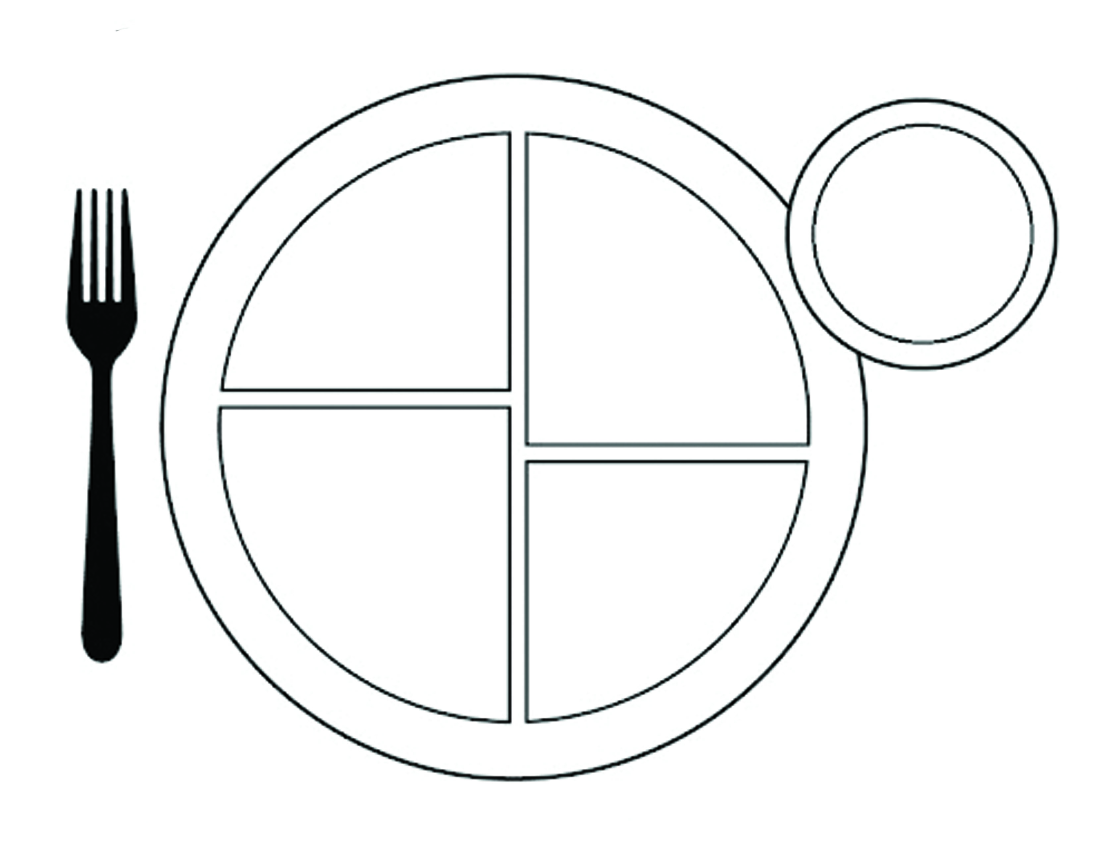
Fruits
Vegetables
Proteins
Grains
Dairy

Word Bank
corn
rice
chicken
white bread
milk
apples
potato chips
candy
chocolate
broccoli
cheese
tomatoes
beef
strawberries
grapes
whole wheat
carrots
cucumbers
eggs
yogurt

May choose words from the word bank or select your own.

Select the two letters that apply.
In order to maintain a healthy body weight, I need to______________ and ____________:
A. Go to sleep really late B. Eat fast food C. Play a video game D. Read about sports
E. Eat healthy F. Be physically active G. Watch TV H. Sit still

Identify a healthy food choice for each category and write each in the proper category.

Ohio Physical Education Assessments
Standard  3 | Demonstrates the knowledge and skills to achieve and maintain a health-enhancing level of physical activity and fitness.
Benchmark  B | Understands the principles, components and practices of health-related physical fitness to maintain or improve one’s level of fitness.
Grade Band: 3-5

Task: The student will demonstrate a basic understanding of analyzing fitness results and health-related fitness principles and practices by completing the following questions. The questions do not have to be administered during one test; they can be administered throughout the course of the 3-5 grade band. It would be appropriate to implement the fitness components during one session and analyze and identify activities for the student’s fitness in separate sessions.

Level | Benchmark B  Analyze fitness results and identify activities for improvement | Benchmark B  FITT Principles
Advanced  3 | Student analyzes all of the results of his or her fitness assessment and identifies multiple activities that could improve each health-related fitness component. | Student links all components of the FITT principle with the appropriate description.
Proficient  2 | Student analyzes the results of his or her fitness assessment and identifies one activity that could improve each health-related fitness component. | Student links three of the four components of the FITT principles with the appropriate description.
Limited  1 | Student has difficulty analyzing the results of his or her fitness assessment and/or identifying specific activities that could improve each health-related fitness component. | Student demonstrates a limited understanding of the FITT principle.

Level | Average Rating
Advanced | Average score 3.0-2.75
Proficient | Average score 2.74-1.75
Limited | Average score 1.74-0

Fitness Recording Sheet - Standard 3B Grades 3-5
Name: Birthdate: month ____ day____ year____ Age: _____ Grade/Teacher:
 | Cardiovascular Endurance | Muscular Strength and Endurance |  | Flexibility
Analyze fitness results | Results:  __________  Are you in the  Healthy Fitness Zone?  Yes or No  Maintain or Improve | Results:  __________  Are you in the Healthy Fitness Zone?  Yes or No  Maintain or Improve | Results:  __________  Are you in the Healthy Fitness Zone?  Yes or No  Maintain or Improve | Results:  __________  Are you in the Healthy Fitness Zone?  Yes or No  Maintain or Improve
 | Activities to improve | Activities to improve |  | Activities to improve
Identify activities to help improve or maintain | 1.  2. | 1.  2. |  | 1.  2.
Please match the concepts of the FITT Principles with the appropriate definition (not all definitions will match up):

Frequency -
Intensity -
Time -
Type –

- Length of activity
- Working out your heart
- How often one is exercising
- Kind of exercise
- Using your muscles
- How hard one is exercising

Standard 3 Benchmark B - Answer Key

Cardiovascular Endurance Activities – Answers vary. (These activities should be something that has vigorous continuous physical activity.)

Muscular Strength and/or Endurance Activities – Answers vary. (These activities should be something that highly engages or fatigues the muscles.)

Flexibility Activity – Answers vary. (These activities should be something that stretches the muscles.)

Frequency – How often one is exercising.

Intensity – How hard one is exercising.

Time – Length of activity.

Type – Kind of exercise.

Ohio Physical Education Assessments
Standard  4 | Exhibits responsible personal behavior and social behavior that respects self and others in physical activity settings.
Benchmark  A | Understands the purpose of and applies appropriate rules, procedures and safe practices in physical activity settings.
Benchmark  B | Interacts and communicates positively with others.
Grade Band: 3-5

Task: The following rubric can be used as a formative assessment over the course of a number of different games or contexts. If assessed in multiple settings or times throughout the grade band, determine an average rating for each benchmark.

Directions: Observe student behavior in an activity that would allow the students to demonstrate the categories listed in the rubric. Provide one rating for each category. Calculate an average for each category for a score for each benchmark. (Note: A student’s responsibility for proper attire during physical education class is not included in the standards or this assessment.)

Level | Average Rating
Advanced | Average score 3.0 – 2.75
Proficient | Average score 2.74 – 1.75
Limited | Average score 1.74 - 0

Level | Criteria
 | 4A Personal |  | 4B Social
 | Safe | Self-direction | Cooperate | Respect Others | Resolving Conflict and  Fair Play
Advanced  3 | - Consistently follows all rules and safe practices in class activities. | - Effort given throughout and student challenges self to be successful at his or her level.  - Tries his or her best without prompts or encouragements from others for all activities.  - Takes responsibility and accepts consequences for actions. | - Consistently engages in appropriate cooperative behaviors in partnerships and/or groups, including: leading, following and supporting group members to improve play in cooperative and competitive settings.  - Evaluates personal behaviors and refines behavior to ensure positive effects on others without prompts. | - Consistently respects the rights and feelings of those who may be of different backgrounds or skill levels by encouraging others or other behaviors to include all students.  - Provides frequent, positive comments to classmates without prompts. Never uses put-downs or comments that are hurtful. | - Respects judgments of others.  - Consistently demonstrates cooperation with others when resolving conflict in games without prompts or support from teacher.  - Consistently demonstrates good winner/loser behaviors without prompts or direction (e.g., shaking hands, complimenting others, letting outcomes go).
Proficient  2 | - Follows safety procedures and activity specific rules to ensure safety of self and others. | - Engages in activities and stays on task with prompts and encouragement from others.  - Completes lesson tasks without constant supervision.  - Takes responsibility for actions. | - Leads, follows and supports group members to improve play in cooperative and competitive settings.  - Personal behavior has positive effects on others and refines behavior with prompts from others. | - Respects the rights and feelings of those who may be of different backgrounds or different skill levels.  - Provides some positive comments to classmates and does not use put-downs or comments that are hurtful. | - Respects judgments of others.  - Demonstrates cooperation with others when resolving conflict in games.  - Demonstrates good winner/loser behaviors (e.g., shaking hands, complimenting others, letting outcomes go) with prompts or directions.
Limited  1 | - Does not follow some rules or must be reminded about rules or safety procedures. | - Engages in activities and stays on task with prompts and encouragement from others.  - Prompts needed to be prepared for success.  - Takes little or no responsibility for actions and their consequences. | - Engages in behaviors that are helpful to others after prompts from the teacher OR does not engage in behaviors that are helpful to others.  - Does not recognize and/or evaluate the effects of personal behavior to ensure positive effects on others. | - Has difficulty in respecting the rights and feelings of those who may be of different backgrounds or different skill levels.  - Sometimes uses put-downs or comments that are hurtful. | - Reactions demonstrate lack of respect for judgments of others.  - Does not successfully demonstrate cooperative behaviors when resolving conflict.  - Inconsistent demonstration of good winner/loser behaviors (e.g., shaking hands, complimenting others, has difficult time letting outcomes go).
See excel sheets for data collection.

Ohio Physical Education Assessments
Standard  5 | Recognizes the value of physical activity for health, enjoyment, challenge, self-expression and/or social interaction.
Benchmark  A | Identifies multiple, specific health benefits as reasons to value physical activity.
Benchmark  B | Expresses multiple, specific reasons (enjoyment, challenge and social) to participate in physical activity.
Grade Band: 3-5

Task: The student will select a physical activity (e.g., sport, game, exercise) and identify specific health benefits from participation in that physical activity, such as physical, emotional and intellectual benefits. The student could write a friendly letter or make a poster, brochure or flyer. The picture or note should illustrate and/or share the student’s selected health benefits. The student also could identify reasons he/she enjoys that physical activity, the social benefits and the challenging aspects of that physical activity to address Benchmark B within the same project or a separate project.

Directions: Provide a rating in both Benchmark A and B using the attached rubric.
Level | Criteria
 | Benchmark 5A -  Health Benefits of Physical Activity | Benchmark 5B -  Reasons to Participate in Physical Activity
Advanced  3 | Identifies two or more specific health benefits from participation in physical activity that includes different dimensions of health: physical, emotional and intellectual. | Identifies two or more specific reasons to participate in physical activity that may include: why he/she enjoys that physical activity, social benefits of participation or challenging aspects of physical activity.
Proficient  2 | Identifies a specific health benefit from participation in physical activity in one of the dimensions of health: physical, emotional and intellectual. | Identifies a specific reason for participation in physical activity.
Limited  1 | Identifies no specific health benefits from participation in physical activity. | Identifies no specific reason to participate in physical activity.
See excel sheets for data collection.

Level | Average Rating
Advanced | Average score 3.0 – 2.75
Proficient | Average score 2.74 – 1.75
Limited | Average score 1.74 - 0

