Ohio English Language Proficiency Screener - Individual Student Report
This report contains your child’s results from the Ohio English Language Proficiency Screener (OELPS). The OELPS measures four areas of English proficiency: reading, listening, writing and speaking. Schools give the OELPS to identify students who could benefit from language assistance to participate more effectively and meaningfully in school.
Each student gets an Overall Proficiency Determination and four Domain Performance Scores. The Overall Proficiency Determination tells whether a child is “Emerging,” “Progressing,” or “Proficient” in English. Your child’s overall proficiency is based on scores from the reading, listening, writing and speaking items. Students get a score from 1 to 5 for each domain, where 1 is the least proficient and 5 is the most proficient. See below to learn more about your child’s results. Descriptions of the Domain Performance Levels by grade or grade-band are on the following pages.
Student Name:
SSID Number: |  | Student Grade Level:
School Year: |  | School Name:
Date Tested: |  | District Name:
Grade Band: | □ Kindergarten □ Grade 1 □ Grades 2-3 □Grades 4-5 □Grades 6-8 □Grades 9-12
Overall Performance on the OELPS
Your Child’s Overall Proficiency Determination |  | Overall Proficiency Level Description
 | Proficient | Students are Proficient when they demonstrate a level of English language skill necessary to independently produce, interpret, collaborate on, and succeed in grade-level academic tasks in English. This is indicated on the OELPS by earning Levels 4 or higher in all domains. Proficient students are not identified as English learners and do not receive English language development services.
 | Progressing | Students are Progressing when, with support, they are approaching a level of English language skill necessary to produce, interpret, and collaborate on grade-level academic tasks in English. This is indicated on the OELPS by scoring at least one domain score above Level 2 and at least one domain score below Level 4. These students are English learners and are eligible for English language development services.
 | Emerging | Students are Emerging when they have not yet reached a level of English language skill necessary to produce, interpret, and collaborate on grade-level content-related academic tasks in English. This is indicated on the OELPS by scoring a Level 1 or Level 2 in listening, reading, writing, and speaking. These students are English learners and are eligible for English language development services.
 | Proficiency Not Determined | Students receive a status of Proficiency Not Demonstrated when testing is stopped due to the student not participating. State policy determines whether a non-participant is eligible for English language development services.
Performance on the OELPS by Domain
Domain | Level 1 | Level 2 | Level 3 | Level 4 | Level 5
Listening
Reading
Writing
Speaking

Performance Level Domain Descriptions

Kindergarten: Performance Level Domain Descriptions
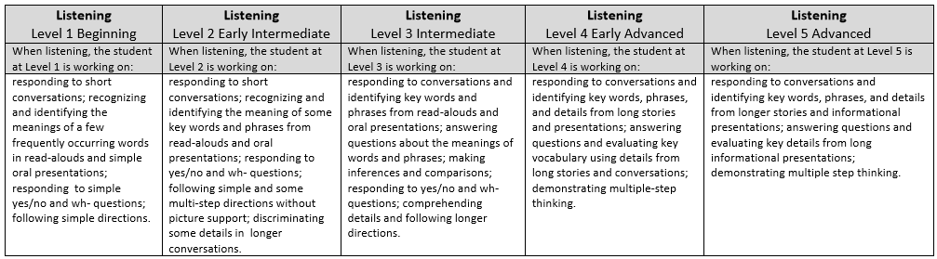
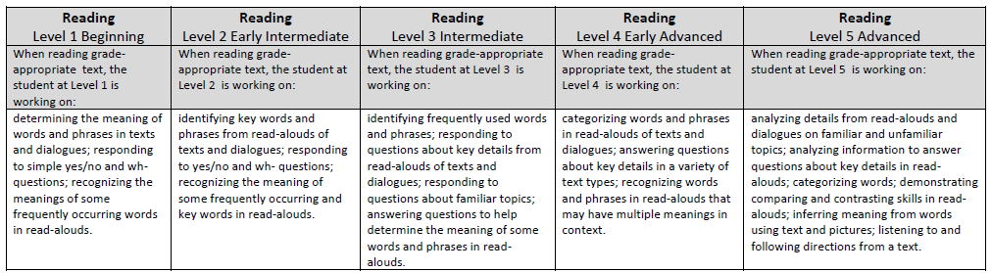
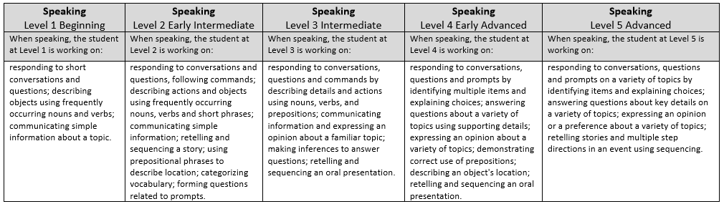
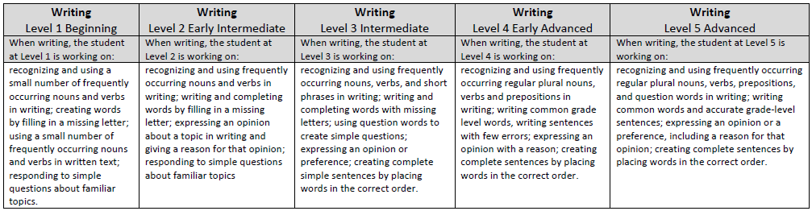

Grade 1: Performance Level Domain Descriptions
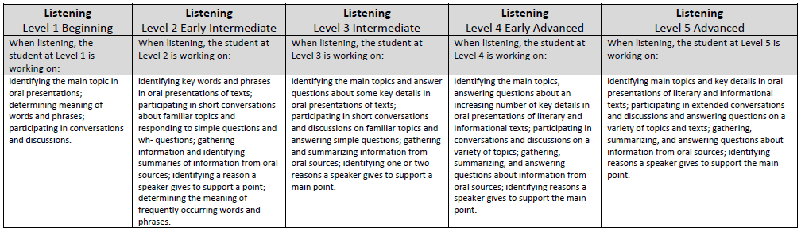
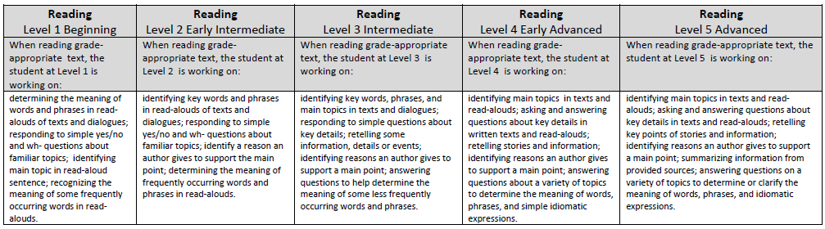
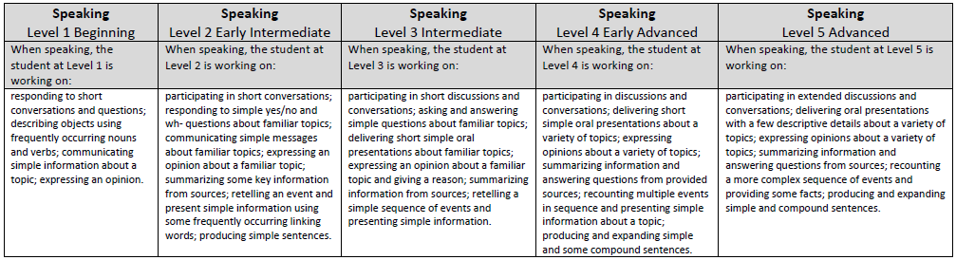
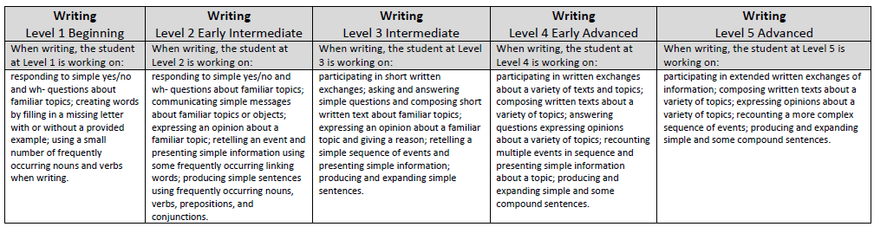

Grades 2-3: Performance Level Domain Descriptions
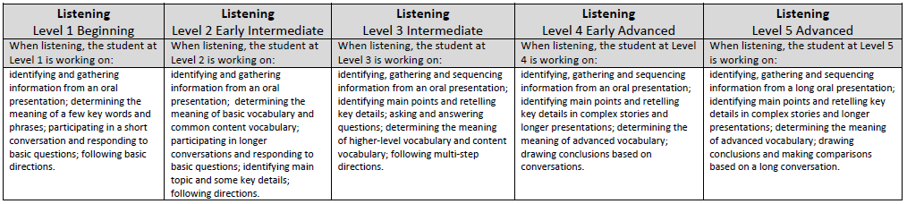
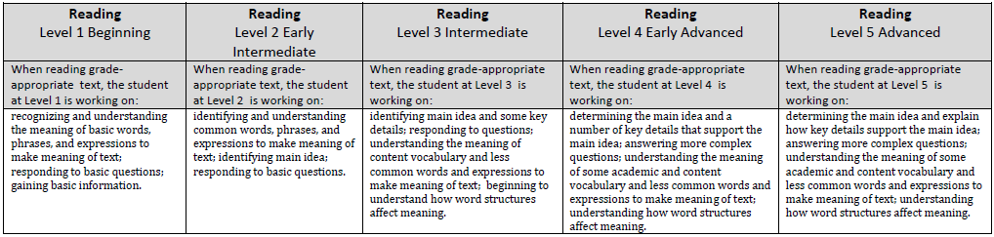
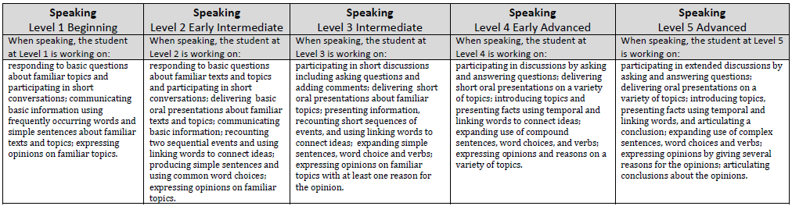
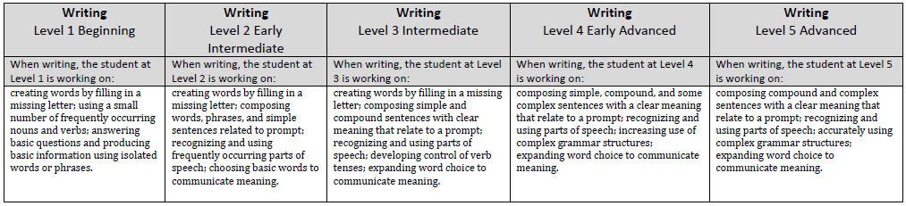

Grades 4-5: Performance Level Domain Descriptions
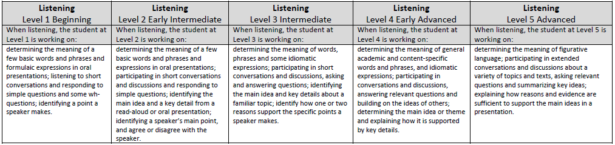
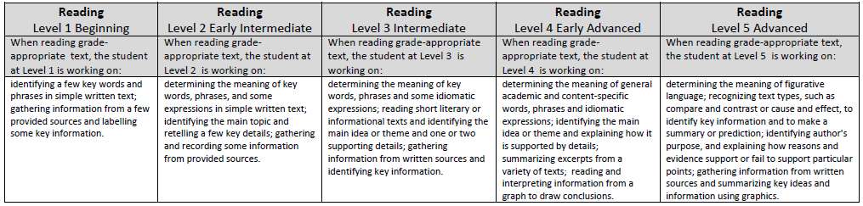
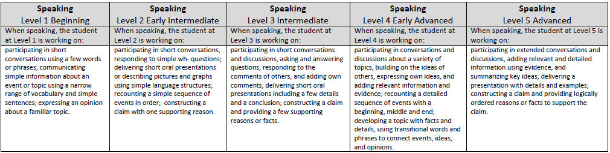
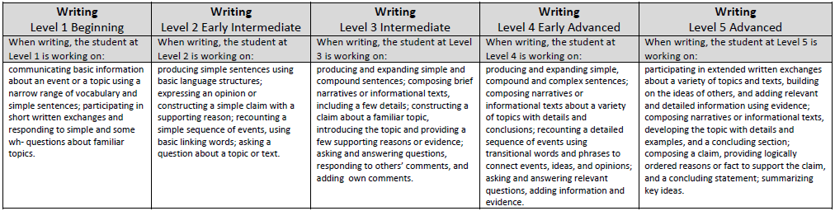

Grades 6-8: Performance Level Domain Descriptions
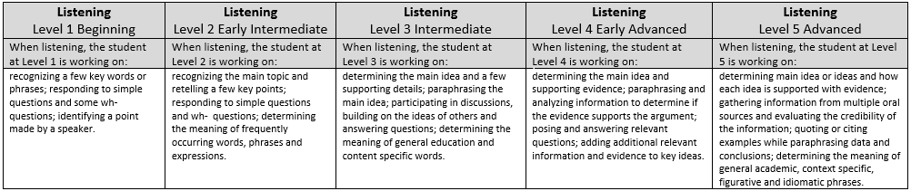
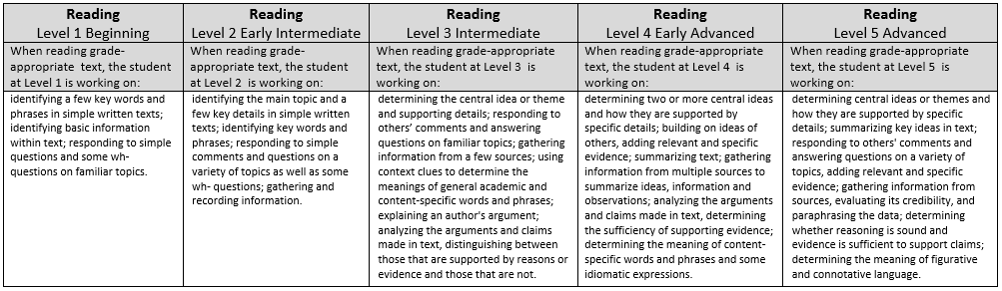
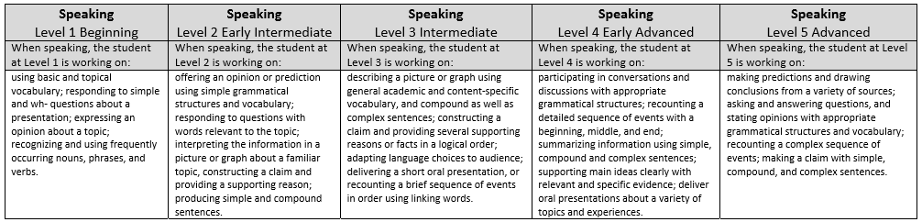
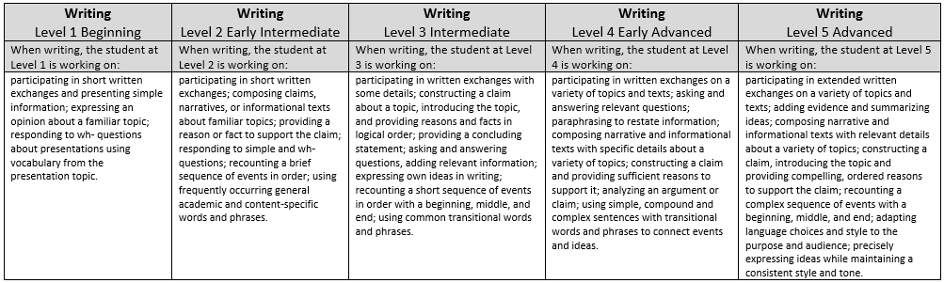

Grades 9-12: Performance Level Domain Descriptions