Quality Program Review Action Plan
CTPD Name |  |  | District Name |  | Pathway | Indicator
School(s) with Pathway |  |  | Names of Local Team |  | Root Cause of Noncompliance
 |  |  | CTPD Representative
 |  |  | Building Admin.
 |  |  | Pathway Teacher |  | Aligned Standard & Indicator from QPR Self-Assessment
 |  |  | Pathway Teacher
 |  |  | Other
SMART Goal for Improvement
Briefly Describe the Strategy for Improvement
Checkpoint | Date | Action(s) |  |  | Responsible Person(s)
1
2
3
4
5
Metric(s) Used to Measure Improvement |  |  |  | Current Performance Rate | Projected Improved Rate |  | Actual Rate after 1 Year

Action Plan Guidance
CTPD Name: Name of the career-technical planning district of the school district.
District Name: Name of the school district
Pathway: Pathway code or name of the non-compliant pathway
Indicator: List the noncompliant indicator for this Action Plan.
School(s) with Pathway: List all schools with this pathway in the district.
Names of Local Team: Each noncompliant pathway should have a team consisting of a CTPD representative, a building leader, pathway teacher(s), and other support staff as needed. List the names of the Local Team.
Root Cause: Briefly describe the root cause of noncompliance for each indicator.
Aligned Standard & Indicator from QPR Self-Assessment: From the Ohio Quality Program Standards in the QPR Self-Assessment, list the standards and the indicators aligned to the root cause of the noncompliant indicator.
Example:
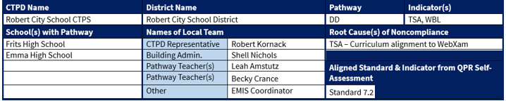
Figure 1: Action Plan Example
SMART Goal for Improvement: Create a SMART Goal for improving the noncompliant standards. Use an appropriate timeframe that could potentially result in meeting the state target for all noncompliant indicators for the pathway.
Example:
Figure 2: Action Plan Example - SMART Goal
Briefly Describe the Strategy for Improvement: Aligned to improving the root cause, provide a narrative plan for actions that will be completed over the timeframe referenced in the SMART Goal that could potentially result in meeting the state target for the noncompliant indicators for the pathway.
Example:
Figure 3: Action Plan Example - Strategy for Improvement
Checkpoints: From the Strategy for Improvement, create a date, action, and responsible person for each checkpoint needed to implement the plan. Each plan may use as many checkpoints as needed.
Example:
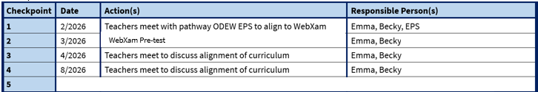
Figure 4: Action Plan Example - Checkpoints for Action
Metric Used to Measure Improvement: The metric used for measuring the improvement of the noncompliant indicator will likely be the reporting of that indicator. However, if a district would like to use another type of metric, they may.
Current Performance Rate: List the current noncompliant rate for the QPR noncompliant indicator.
Projected Improved Rate: List the projected
Actual Rate After 1 Year:
Example:
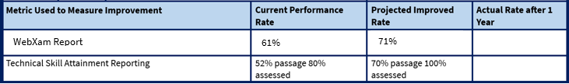
Figure 5: Action Plan Example - Metrics and Performance Rate

