# 2024-2025 Business Advisory Council

# Plan Template

The Ohio Department of Education and Workforce recommends using this template and the optional award addendum for your Business Advisory Council plan. However, feel free to use any extra space for additional initiatives that you list based on how much space is allocated in the template. You can add extra rows to the tables to include more than two initiatives for each quality practice.

Identify the Structure and Name of the Business Advisory Council: (School District, Educational Service Center, Joint Vocational School District or Independent Collaborative)

[JobsOhio Region](https://ohiolmi.com/_docs/Maps/MapJobsOhioNetwork.pdf) in which business advisory council operates:

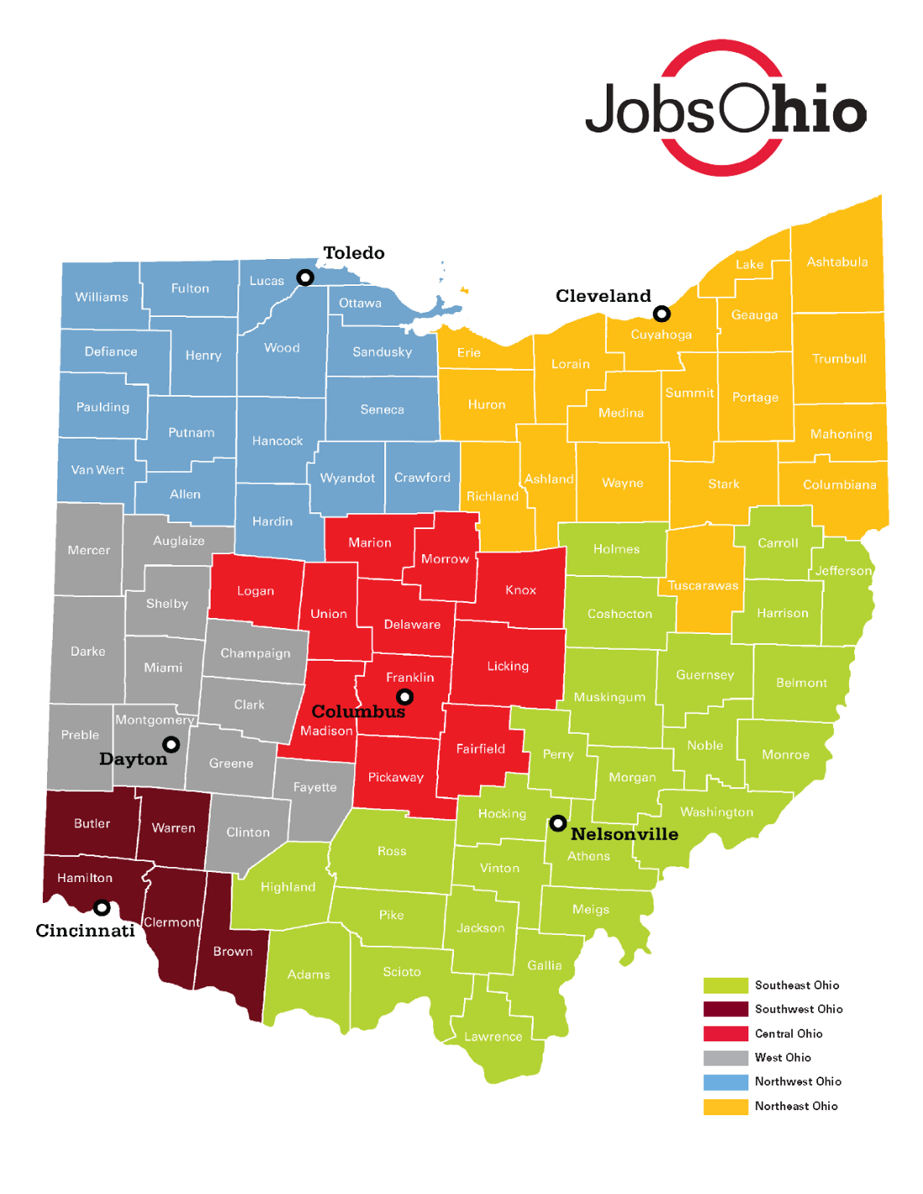

List all member districts Represented by the Business Advisory Council:

|  |  |  |  |  |
| --- | --- | --- | --- | --- |
| District | District Primary Contact and Role | Primary Contact Email | District Secondary Contact and Role | Secondary Contact Email |
|  |  |  |  |  |
|  |  |  |  |  |
|  |  |  |  |  |
|  |  |  |  |  |
|  |  |  |  |  |

*Note: May add cells as needed.*

List business advisory council members (business, higher education, community partners, for example). List industries represented on the business advisory council based on [Ohio’s Top Jobs](https://topjobs.ohio.gov/top-jobs-list) classification. Include workforce boards, economic development, higher education, and community partners.

|  |  |  |  |
| --- | --- | --- | --- |
| Business Advisory Council Member | Title | Email | Industry |
|  |  |  |  |
|  |  |  |  |
|  |  |  |  |
|  |  |  |  |

*Note: May add cells as needed.*

## Schedule of Meetings

Planning meetings for the (Academic Year) school year include:

|  |  |
| --- | --- |
| Quarter 1 Meeting: Month DD, YYYY | Quarter 2 Meeting: Month DD, YYYY |
| Quarter 3 Meeting: Month DD, YYYY | Quarter 4 Meeting: Month DD, YYYY |

Note: Some business advisory councils may choose to meet more frequently; Please include any planned meeting in the schedule.

## Business Advisory Council Mission and Vision

## for the 2024-2025 School Year

Business advisory councils operate under [three quality practices](https://education.ohio.gov/getattachment/Topics/Career-Tech/Career-Connections/Business-Advisory-Councils/BAC-Awards-%E2%80%93-Quality-Practices-Overview.pdf.aspx?lang=en-US): **Develop Professional Skills for Future Careers**, **Build Partnerships**, and **Coordinate Experiences**.

### Develop Professional Skills for Future Careers

Describe how the business advisory council plans to **Develop Professional Skills for Future Careers** for the 2024-2025 school year.

* Describe the plan, including initiatives, projects, or events. Include specific districts impacted by initiative(s), and list all businesses involved.
* Use the template as a guide to list all initiatives, projects, and events used to develop professional skills for future careers (include business input in curriculum alignment with skills needed for in-demand professions, educator engagement and development, employers in classroom involvement, etc.). Be sure to include existing programs and how they will be sustained and scaled.
* When describing initiatives, please tie them to previous initiatives so that the Department can see the progression of the business advisory council from year to year.

|  |
| --- |
| **Initiative 1** |
| Describe in detail the plan associated with implementing this quality practice. What collaborative action steps are required to facilitate achieving outcomes? |
| List all participating school districts. What percentage of students within the BAC will be impacted by this initiative? |
| List all businesses involved. |
| List all related timelines for each phase of plan development and associated deadlines. |
| List the resources needed for implementation (funding, manpower, tools, for example). |
| Identify any challenges that may impact this plan. How will the business advisory council overcome these challenges? |
| Identify existing [data](https://reports.education.ohio.gov/overview) and set measurable outcomes to achieve plan. If data is unavailable, identify steps being taken to acquire this data.  How does this initiative help to develop relevant in-demand skills for students and educators. |
| How does this initiative impact students with disabilities? Please refer to the [State Systemic Improvement Plan](https://education.ohio.gov/Topics/Special-Education/On-Track-for-Graduation). |

|  |
| --- |
| **Initiative 2** |
| Describe in detail the plan associated with implementing this quality practice. What collaborative action steps are required to facilitate achieving outcomes? |
| List all school districts participating. What percentage of students within the BAC will be impacted by this initiative? |
| List all businesses involved. |
| List all related timelines for each phase of plan development and associated deadlines. |
| List the resources needed for implementation (funding, manpower, tools, etc.). |
| Identify any challenges that may impact this plan. How will the business advisory council overcome these challenges? |
| Identify existing [data](https://reports.education.ohio.gov/overview) and set measurable outcomes to achieve plan. If data is unavailable, identify steps being taken to acquire this data.  How does this initiative help to develop relevant in-demand skills for students and educators. |
| How does this initiative impact students with disabilities? Please refer to the [State Systemic Improvement Plan](https://education.ohio.gov/Topics/Special-Education/On-Track-for-Graduation). |

*Note: May add cells as needed.*

### Build Partnerships

Describe how the business advisory council plans to **Build Partnerships** for the for the 2024-2025 school year.

* Describe how the business advisory council will grow partnerships in alignment with in-demand careers in the region with representation from industry, workforce boards, port authority, Ohio Means Jobs Centers, industry sector partnerships, higher education, etc.
* Use the template as a guide to list all initiatives, projects, and events used to build partnerships. Include information on partnership alignment, effectiveness, and initiatives spearheaded by these collaborations. Demonstrate cooperative efforts between districts and partners to benefit students and businesses.
* When describing initiatives, please tie them to previous initiatives so that the Department can see the progression of the business advisory council from year to year.

| **Initiative 1** |
| --- |
| Describe in detail the plan associated with implementing this quality practice. What collaborative action steps are required to facilitate achieving outcomes? |
| List all school districts participating. What percentage of students within the BAC will be impacted by this initiative. |
| List all businesses involved. |
| List all related timelines for each phase of plan development and associated deadlines. |
| List the resources needed for implementation (funding, manpower, tools, for example). |
| Identify any challenges that may impact this plan. How will the business advisory council overcome these challenges? |
| Identify [existing data](https://reports.education.ohio.gov/overview) and set measurable outcomes to achieve plan. If data is unavailable, identify steps being taken to acquire this data.  How does this initiative help to develop relevant in-demand skills for students and educators. |
| How does this initiative impact students with disabilities? Please refer to the [State Systemic Improvement Plan](https://education.ohio.gov/Topics/Special-Education/On-Track-for-Graduation). |

|  |
| --- |
| **Initiative 2** |
| Describe in detail the plan associated with implementing this quality practice. What collaborative action steps are required to facilitate achieving outcomes? |
| List all school districts participating. What percentage of students within the BAC will be impacted by this initiative. |
| List all businesses involved. |
| List all related timelines for each phase of plan development and associated deadlines. |
| List the resources needed for implementation (funding, manpower, tools, for example). |
| Identify any challenges that may impact this plan. How will the business advisory council overcome these challenges? |
| Identify existing [data](https://reports.education.ohio.gov/overview) and set measurable outcomes to achieve plan. If data is unavailable, identify steps being taken to acquire this data.  How does this initiative help to develop relevant in-demand skills for students and educators. |
| How does this initiative impact students with disabilities? Please refer to the [State Systemic Improvement Plan](https://education.ohio.gov/Topics/Special-Education/On-Track-for-Graduation). |

*Note: May add cells as needed.*

### Coordinate Experiences

Describe how the business advisory council plans **Coordinate Experiences** for the 2024-2025 school year.

* Describe how the business advisory council will connect students to experiential learning to show competency of skills learned through hands-on demonstration (for example, internships, problem-based learning, pre-apprenticeships, and apprenticeships).
* When describing initiatives, please tie them to previous initiatives so that the Department can see the progression of the business advisory council from year to year.

| **Initiative 1** |
| --- |
| Describe in detail the plan associated with implementing this quality practice. What collaborative action steps are required to facilitate achieving outcomes? |
| List all school districts participating. What percentage of students within the BAC will be impacted by this initiative. |
| List all businesses involved. |
| List all related timelines for each phase of plan development and associated deadlines. |
| List the resources needed for implementation (funding, manpower, tools, for example). |
| Identify any challenges that may impact this plan. How will the business advisory council overcome these challenges? |
| Identify [existing data](https://reports.education.ohio.gov/overview) and set measurable outcomes to achieve plan. If data is unavailable, identify steps being taken to acquire this data.  How does this initiative help to develop relevant in-demand skills for students and educators. |
| How does this initiative impact students with disabilities? Please refer to the [State Systemic Improvement Plan](https://education.ohio.gov/Topics/Special-Education/On-Track-for-Graduation). |

|  |
| --- |
| **Initiative 2** |
| Describe in detail the plan associated with implementing this quality practice. What collaborative action steps are required to facilitate achieving outcomes? |
| List all school districts participating. What percentage of students within the BAC will be impacted by this initiative. |
| List all businesses involved. |
| List all related timelines for each phase of plan development and associated deadlines. |
| List the resources needed for implementation (funding, manpower, tools, for example). |
| Identify any challenges that may impact this plan. How will the business advisory council overcome these challenges? |
| Identify existing [data](https://reports.education.ohio.gov/overview) and set measurable outcomes to achieve plan. If data is unavailable, identify steps being taken to acquire this data.  How does this initiative help to develop relevant in-demand skills for students and educators. |
| How does this initiative impact students with disabilities? Please refer to the [State Systemic Improvement Plan](https://education.ohio.gov/Topics/Special-Education/On-Track-for-Graduation). |

*Note: May add cells as needed.*

# Ohio Business-Education Leader Awards for Excellent Business Advisory Councils Overview

The Ohio Business-Education Leader Awards for Excellent Business Advisory Councils recognize educators, businesses, business partners, staff, schools, educational service centers, joint vocational school districts, and communities who come together to create dynamic, career-focused learning environments for students. The Ohio Business-Education Leader Awards for Excellent Business Advisory Councils recognize educators, businesses, business partners, staff, schools, educational service centers, joint vocational school districts, and communities who come together to create dynamic, career-focused learning environments for students.

Business advisory councils that demonstrate excellence in ensuring Ohio students are prepared for successful career paths, including college, industry credentials, apprenticeships, military enlistment, or any combination of these. Business advisory councils pursuing this recognition will be considered for awards of excellence and star ratings.

### Selection Criteria

* **Enrollment Eligibility:** Business advisory councils must submit their annual plans, joint statement and required addendum using the approved template from the Department’s from the Department’s Microsoft Forms by **Sept. 30, 2024.**
* **Data Considerations:** Data metrics may include, but are not limited to, trend data on previous school-year graduation cohorts earning the OhioMeansJobs-Readiness Seal, completing work-based learning, and earning industry-recognized credentials.
* **Conditional Selection:** The award is subject to the Department’s review of the accuracy of the business advisory council’s submission. The award review committee will consist of Department staff and business and education leaders.
* **Awards:** In addition to a star rating, state business and education leaders will select one of the following award categories based on the submission materials provided:
  + Excellence in Developing Professional Skill for Future Careers
  + Excellence in Building Partnerships
  + Excellence in Coordinating Experience

### Quality Practices

The business advisory council award is based on the implementation of the following quality practices. During the recognition year, the business advisory council, in consultation with the local governing board, should:

1. **Develop Professional Skills for Future Careers** – Work together to define key professional skills needed for the future job market. Develop a curriculum that instills these skills while advising on changes in the economy and job market.
2. **Build Partnerships** – Develop and increase collaborative relationships among businesses, labor, and education personnel. Partnerships should align with in-demand industries in the region.
3. **Coordinate Experiences** – Create environments that allow students to demonstrate proficiency in critical professional and specialized skills that will aid in future employment.

In addition to the addendum to the Business Advisory Council Plan, the following information is requested from the submitting organization to qualify:

* A link to the previous year’s joint statement or a copy of the joint statement.
* Local data measuring the implementation of the Quality Practices. Data may be obtained from the school counselor, administration, career navigators, etc.
* If the business advisory council represents multiple school districts, specify initiatives and objectives for each district, and provide data for each district served.
* Responses to the following questions:

1. How has the business advisory council helped students prepare and successfully enter the local workforce?
   1. Include any curriculum changes influenced by the business advisory council (state-specific initiatives, outcomes, and data).
   2. Include how the business advisory council is preparing students with both technical and professional skills needed to address local business needs.
2. How has the business advisory council and its members supported students in work-based learning (internships, apprenticeship and pre-apprenticeship) opportunities? **(NOTE: Career exploration activities such as job shadowing, mock interviews, and mentoring should not be included in data.)**
   1. What percentage of students within the BAC have been placed in work-based learning experiences?
   2. What are some examples of high-quality, [work-based learning](https://education.ohio.gov/Topics/Career-Tech/Work-Based-Learning) supported by your business advisory council?
   3. How many of your business partners have accepted students into work-based learning experiences?
   4. How has work-based learning benefited students and employers?
   5. What percentage of students have earned an in-demand, [Industry-Recognized Credential](https://education.ohio.gov/Topics/Ohio-s-Graduation-Requirements/Contacts-and-Resources/Industry-Recognized-Credentials/Industry-Recognized-Credentials-by-Career-Field) because of the work-based learning experience with employers within the BAC?
3. How has the business advisory council supported mentorship programs and/or provided networking opportunities for students and professionals?
   1. What career activities have been influenced by the business advisory council? (Include districts involved and data on students involved in each activity.)
   2. What professional development opportunities are available through the business advisory council for teachers? (Include teacher bootcamps, externships, and tours.)
4. What major decisions has the business advisory council influenced for the member school districts, and how have decisions impacted students, educators, and curriculum?
5. How are the members of the business advisory council representative of the job market of the area you serve? (Specify industries represented on the business advisory council reflective of in-demand occupations in the area.)
6. How is the business advisory council collecting, implementing, and responding to feedback and industry trends in the region in which it operates? Include samples of feedback (business, educator and student)?
7. What barriers has your business advisory council encountered in implementing these quality practices?
   1. How has it overcome these barriers or what needs to occur to overcome these barriers?
8. What additional information would you like to share about how the business advisory council develops professional skills for future careers? Please provide any details on how the work of the business advisory council is shared within the community.
9. What additional information would you like to share on how your business advisory council works collaboratively on initiatives to build partnerships and enhance experiences for students?
10. What additional information would you like to share about how career readiness experiences are coordinated? How have these experiences benefited students and employers?
11. Which business partner has been the most influential on the business advisory council and why?