BUSINESS ADVISORY COUNCILS IN OHIO SCHOOLS
ANNUAL PLAN SUBMISSION GUIDANCE DOCUMENT
Table of Contents
Introduction 3
Accessing the Data Submission Forms Application 3
Creating a new OH|ID 4
Logging in with OH|ID 5
Setting up Department of Education Profile 6
Access to the Data Submission Forms Application 9
Accessing the Business Advisory Council Survey 9
Completing the Business Advisory Council Survey 11
Overview 11
Questions 11
Comments 14
Supporting Documents 15

Introduction

ORC 3313.821 enacted as part of Am. Sub H.B 49 requires all school districts, including joint vocational school districts (JVSDs), and Educational Service Centers (ESCs) to create and submit their business advisory council plans to the Ohio Department of Education (ODE).

Beginning in the 2019 – 2020 (FY20) school year, ODE will coordinate the submission of these plans annually through the Data Submission Forms application located within the OH|ID web portal. The department has requested all annual plans be submitted not later than September 30th.

This guidance document is designed to help districts complete the submission process.

Those districts that have entered into an agreement under section 3313.843 or 3313.845 of the Revised Code to receive any services from a JVSD or an ESC, and have agreed the entity’s business advisory council will represent the business of the district, do not need to upload a separate plan. The JVSD or ESC submission of its plan is sufficient to meet the requirement.

Please note: Although districts supported by a JVSD or an ESC’s business advisory council are not required to upload a separate plan, the Department is asking those districts to answer questions within the Data Submissions Forms application identifying their supporting entity.

Accessing the Data Submission Forms Application

The Ohio Department of Education uses the Data Submission Forms application to complete the Business Advisory Council Plan collection process. Users access the system through the OH|ID web portal.

Users must have one of the following roles in the Ohio Educational Directory System (OEDS), assigned by their district’s OEDS administrator, to complete the required surveys:
- Superintendent
- Superintendent Designee

Note: Users who need to access the system but do not have one of these identified roles must contact their district’s OEDS administrator.

Creating a new OH|ID

1. Log into the Department of Education
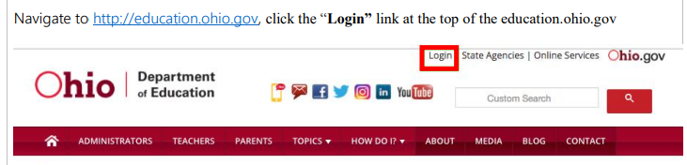

2. Choose all other user options (not ODE employee).
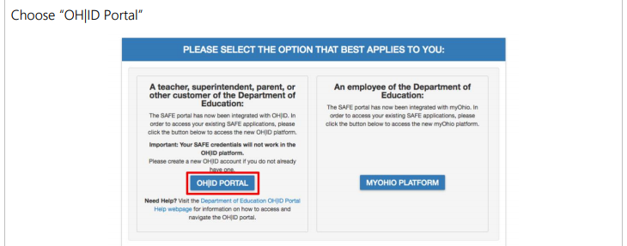

3. If you haven’t previously created a new OH|ID account, do so now.
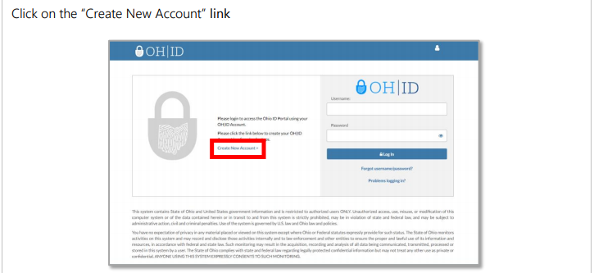

4. After clicking creating a new account, complete the OH|ID Profile and Security Information.

Logging in with OH|ID

1. Log into the Department of Education

2. Choose all other user options (not ODE employee).

3. Login with newly created / or existing OH|ID username and password

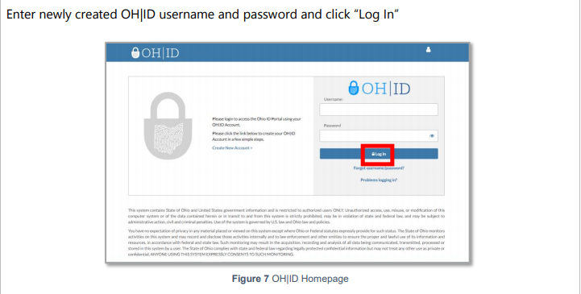

Setting up Department of Education Profile

If you haven’t previously created an ODE profile through the old SAFE process, you will need to do so now by following this process. If you have previously had a SAFE account, this process should automatically link your previous ODE profile.

Note: You must have an ODE profile prior to accessing or attempting to access the Data Submission Forms application.

1. Follow the login process identified under the heading “Logging in with OH|ID”.

2. Select Department of Education Profile Setup button under Available Apps
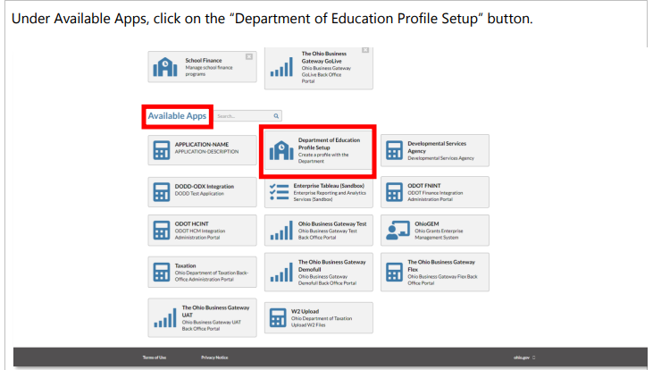

3. Accept Terms and Conditions and Verify SSN; click “Request Access”
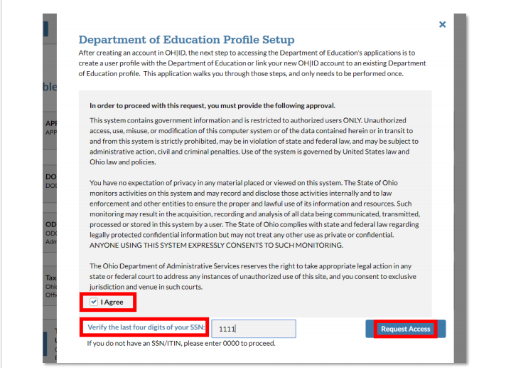

4. After requesting access, you’ll receive a notification. Return to Applications.
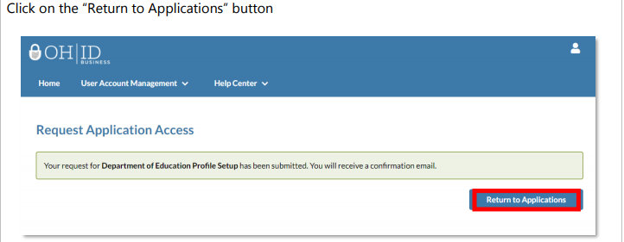

5. Return to Department of Education Profile Setup
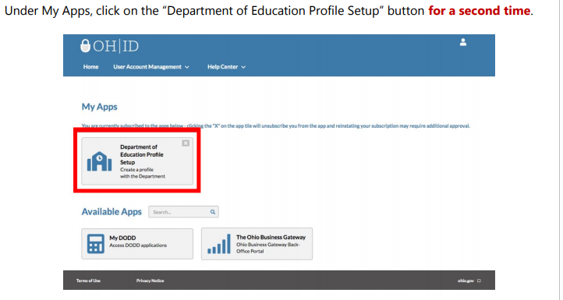

6. If an ODE profile is found, click on “View Applications” to view available ODE applications; skip to step 1 under the Access to ODE applications heading below. If an ODE profile is NOT found go to next step.
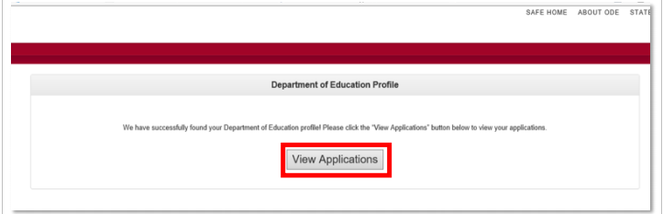

7. If an ODE profile was not found, click on “Create Profile”.
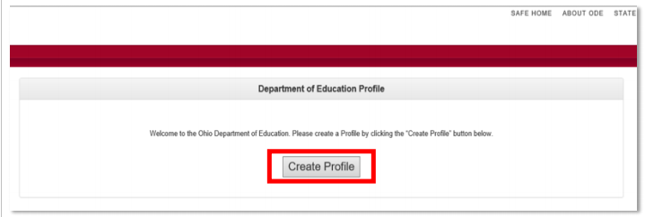

8. Once you select Create a Profile, follow the directions to complete the profile creation process.

9. If all information is entered correctly and verified, approval will be granted.

10. Return to Login and sing in with your Username and Password:
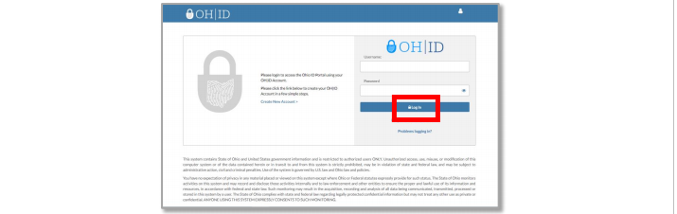

11. If information is entered incorrectly and/or cannot be verified, approval will not be granted. A member of the ODE support team will contact you if information requires verification.
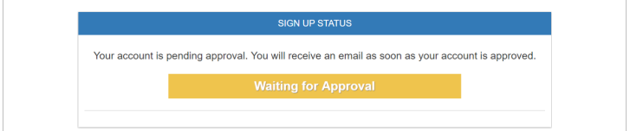

Access to ODE Applications

1. Once logged in with an approved profile, you will see the applications within OH|ID that you have permissions to access. If you previously had access to FORMS through SAFE, the Data Submission Forms tile should appear below. Click it and move to step XXXXXX.
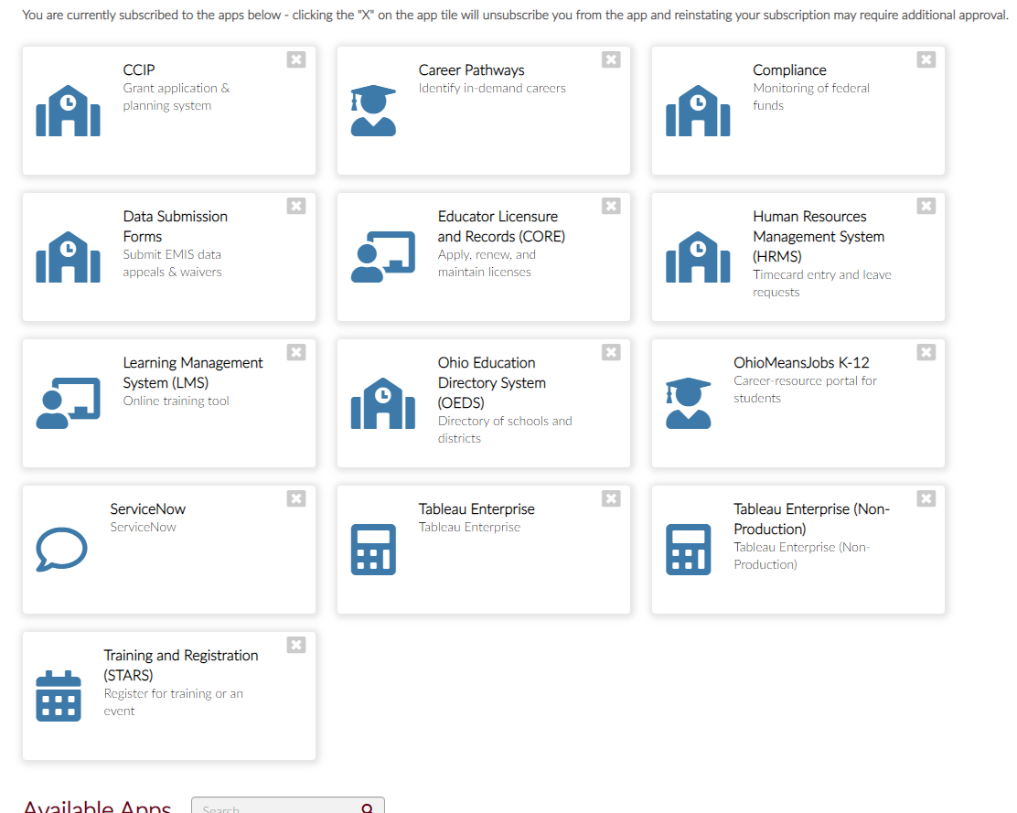

2. Locate the Available Apps section if you have not accessed the Data Submission Forms tile before.
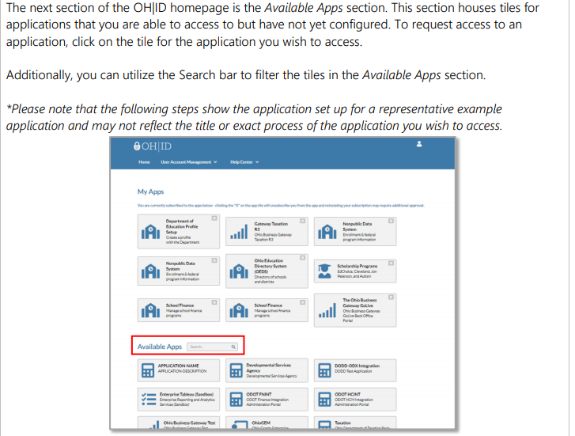

3. Find the tile under the available aps and select it; follow instructions.
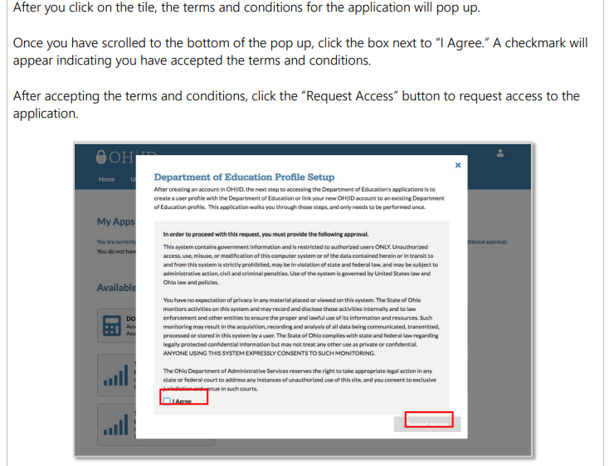

Accessing the Business Advisory Council Survey

- The Forms link will open on the Forms Dashboard. There is a link to a YouTube video in the upper right corner of the screen that provides an overview of the dashboard features.

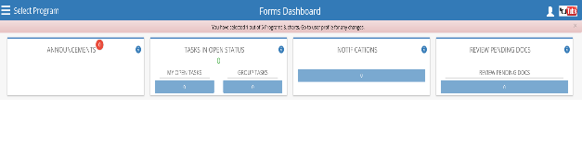

- The Select Program on the upper left side of the screen provides quick access to the programs available based on the user’s OEDS role(s).

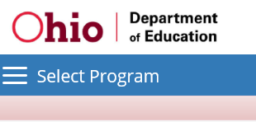

- Click on the Business Advisory Councils link. If you do not see Business Advisory Councils, you likely do not have the proper role assigned within OEDS. Please see your OEDS administrator.

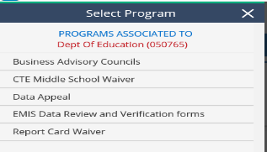

- The User may need to scroll down to the bottom of the screen to see district information. Click on the magnifying glass icon under the Details heading to access the school district’s Business Advisory Council survey.

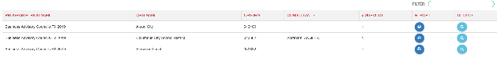

Completing the Business Advisory Council Survey

The following instructions outline how the user will complete the survey. Further guidance and additional support on the use of this tool is available by contacting the Career Connections team at CareerConnections@education.ohio.gov.

Overview

- The home page of the survey is the OVERVIEW. It provides the name of the organization, physical address, mailing address and Superintendent’s contact information. Users can navigate each portion of the survey by navigating the adjacent tabs.

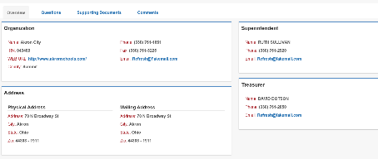

Questions

The QUESTIONS tab displays the completion status, the sections, and questions for the Business Advisory Council survey. This tab is where the user will answer questions regarding the plan and upload into the system.

- On the QUESTIONS tab, click on the Start/Details button if the Completion Status does not already indicate “In-Progress” or “Started”.

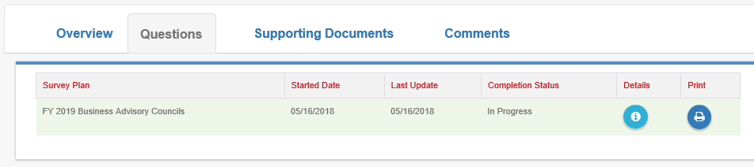

- In the QUESTIONS section, there are four questions the user must answer.

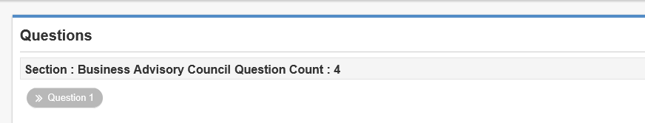

- Using the scroll bar on the right to scroll, the user will scroll down to answer the four questions. The user must ensure to answer the questions using the response radial button provided either to the left or below the question as indicated by the ovals.

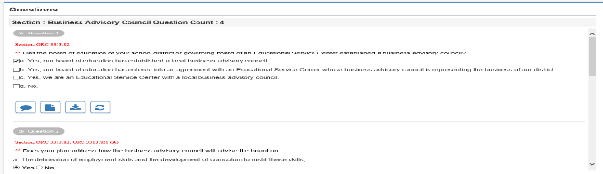

- After answering Question 4, the user will use the “Add Doc” button to upload the district’s Business Advisory Council Plan.

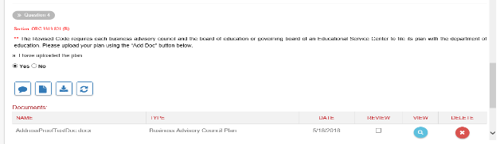

- When uploading the document make sure you select Business Advisory Council Plan from the Document Type dropdown.

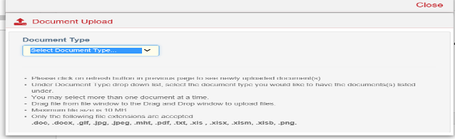

- Once the user has completed answering the four questions and uploading the district’s Business Advisory Council Plan, click the COMPLETE button.

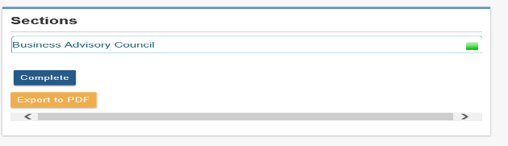

Comments

The COMMENTS tab will facilitate communication between the district and the Department of Education regarding the submission of the Business Advisory Council Plan.

- To create a new message, in the Comments Summary section, click the Add New Subject button.

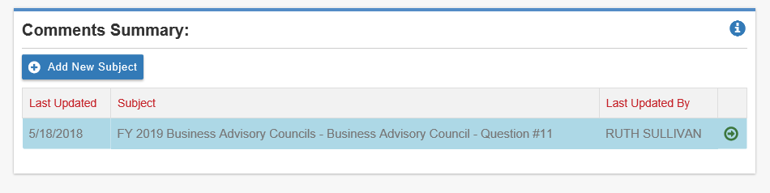
- Please choose if the message is Private, Public, or ODE Only in the drop down; identify intended recipient in the “To” by email address, and be sure to include a Subject so the content of the message is clear. Once drafted, select the Add button to save the message.

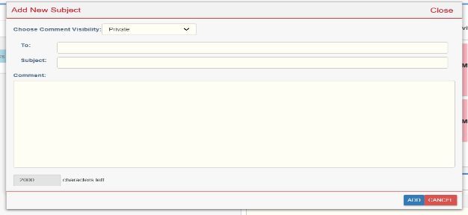

Supporting Documents

- On the supporting document tab, the user can view all the documents submitted or to upload additional documents.

