Career Readiness Leaders Network
Beyond High School – A Student Advising Panel
April 12, 2021 – 1:00p-2:00p

1:00p - Kick-off and welcome
1:10p - Apprenticeship Story – Sidney Young (Bloom-Carroll High School Grad – Kokosing employee)
- Keep your options open – apprenticeship is a great path
- Be open to untraditional paths
- Consider what a competitive wage is and do your research!
1:20p - Employment options - Dionnica Gaston, CDR, CIR, PRC (Director of Talent - Rev1 Ventures)
Advice to students about to enter the workforce:
  - Preparing for a first job interview with little or no experience
  - Employers may have internships, tuition assistance and scholarship options
1:30p - Enlistment options – William Stratton (Education Service Specialist – Army)
- Information about the Military Seal
- Advice to students about considering the military as a career preparation option:
  - ASVAB Career Exploration Program
  - Enlistment tips:
    - Qualifying for the military
    - Value of the ASVAB
    - Lifestyle advice
  - G.I. Bill
1:40 - Enrollment options – Mark Cortez (Director, Outreach and Recruitment – Ohio State University)
- Advice to students about enrolling in post-secondary education options:
  - Consider how you will finance your degree
  - Consider what you want to ultimately do as a career
  - Selecting the school that is the right fit for you
  - Lifestyle advice
1:50p - Questions

RESOURCES:
- Budget for Your Career
- Apprenticeship options
- OMJ Job Interview Portal
- Nationwide Children’s Teen Volunteer Scholarship
- Nationwide Children’s Education and Development
- OMJ ASVAB Practice Tests
- ASVAB Career Exploration Program
- Ohio’s Campuses
- How Financial Aid Works
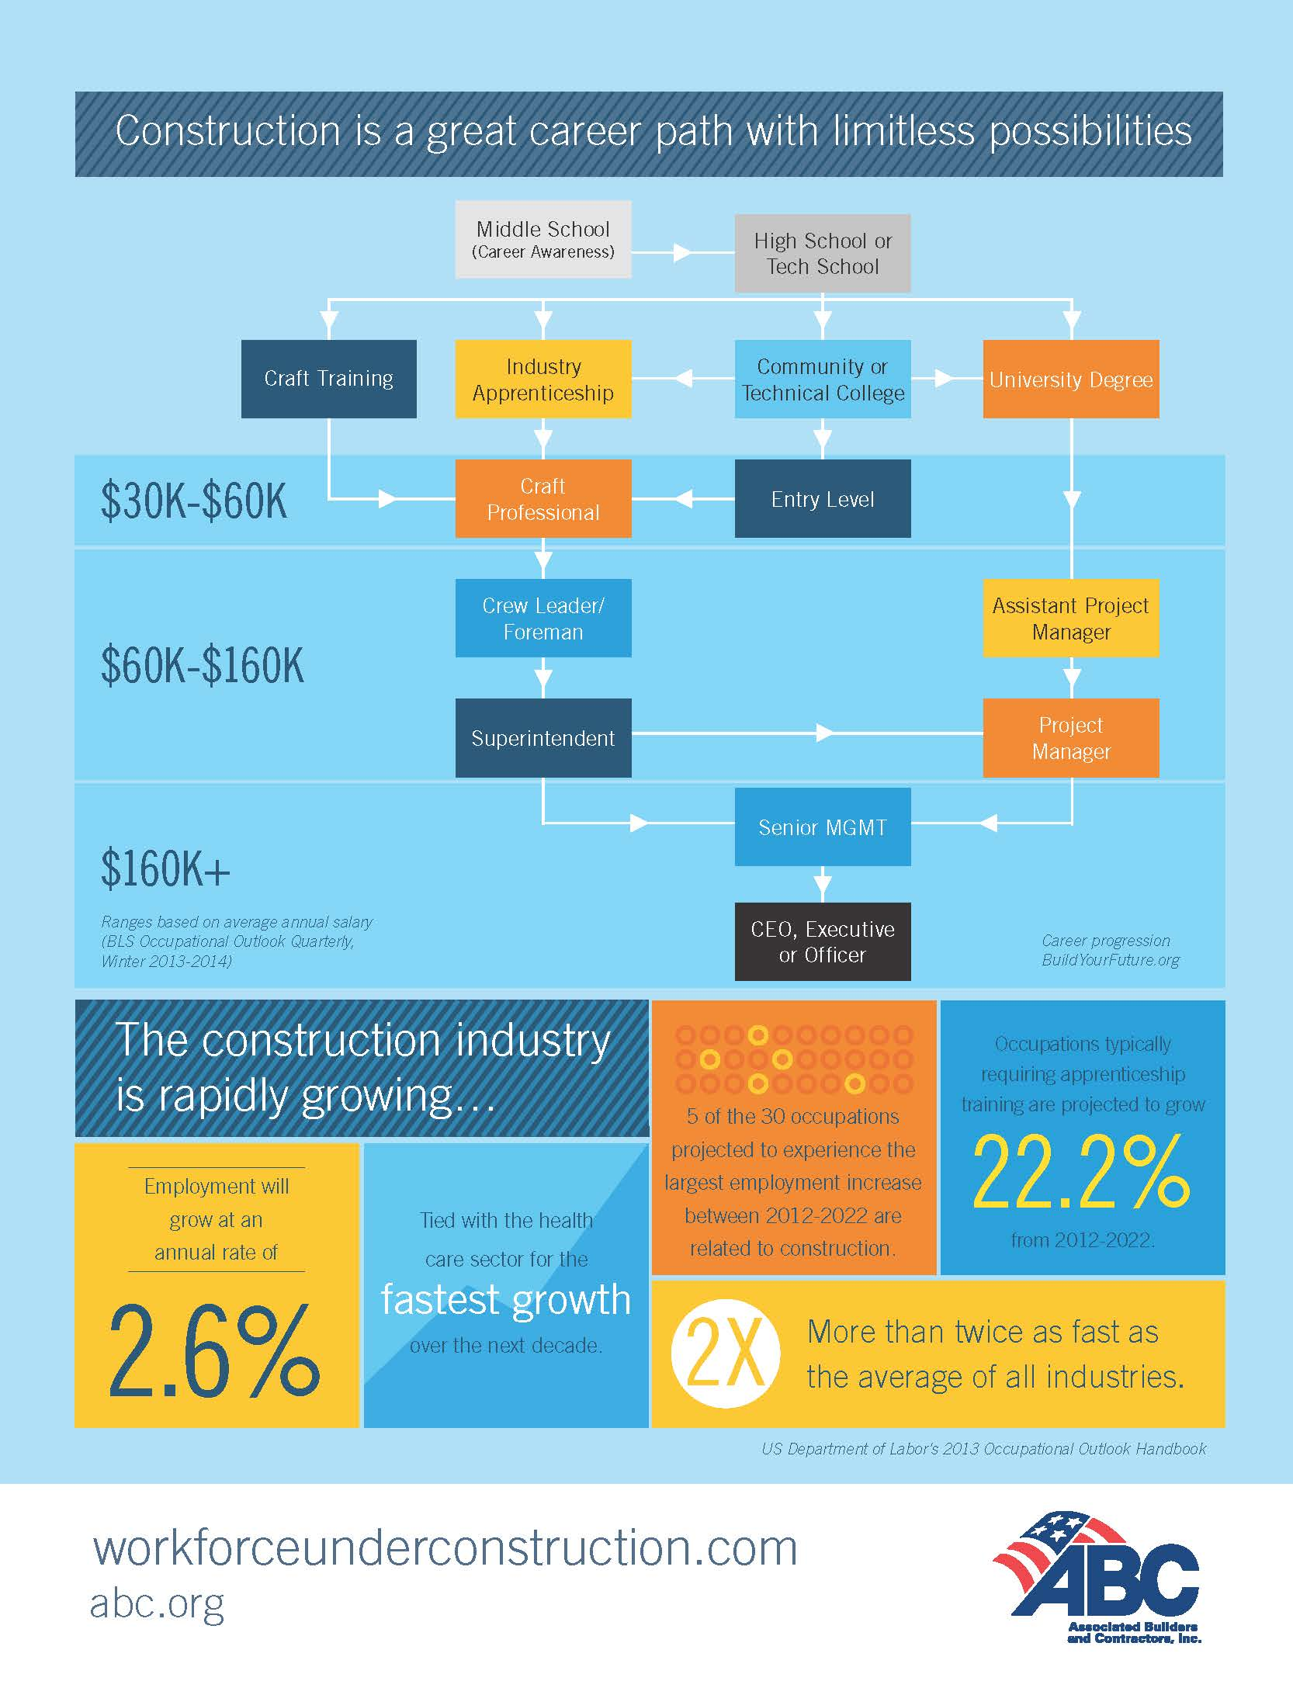
- What Can I Do With A Major In…

