EARLY CHILDHOOD EDUCATION (ECE) GRANTS DATA SYSTEMS ACCESS GUIDE
Step-by-step directions for accessing the Ohio Department of Education's software systems needed by ECE grantees
YOU WILL NEED INTERNET ACCESS TO COMPLETE THESE TASKS
TABLE OF CONTENTS
- Ohio Administrative Knowledge System (OAKS)
- Internal Retrieval Number (IRN)
- Link OAKS and IRN
- OH|ID
- Ohio Educational Directory System (OEDS)
- Comprehensive Continuous Improvement Plan (CCIP)
- Education Management Information System (EMIS)
- Enterprise Application System (EAS)
- Technical Assistance Contacts
- Checklist
Visit the Early Childhood Education Grants webpage! Also, be sure to sign up for Early Learning Education Updates!
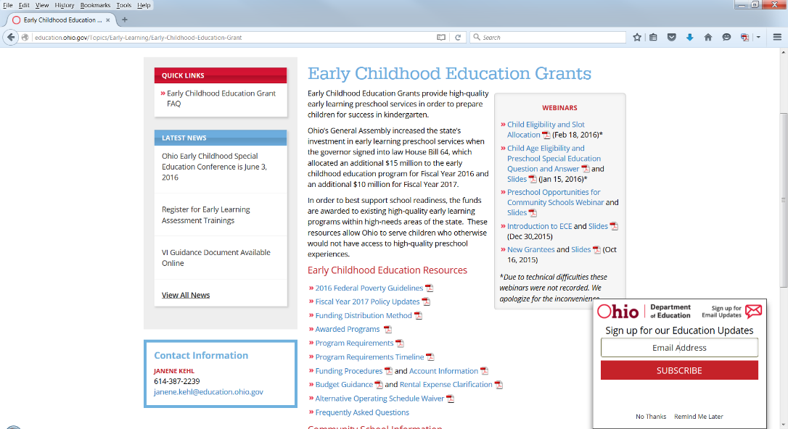

step 1: obtain an Ohio administrative knowledge system (oaks) id#
If you already have an OAKS ID#, proceed to Step 2.
To do business with the State of Ohio, each ECE grantee must have an OAKS ID#.
If you do not have an OAKS ID#, go to the OSS Site and Create a New Account.
For more information, please submit an inquiry via the OSS “Contact Us” page or call 877-644-6771.
Allow 5 business days for the documents to be processed. You will be notified via email of your OAKS ID#. You must have an OAKS ID# to complete Step 3.
Please proceed to Step 2.

step 2: internal retrieval number (irn)

If your program already has an IRN, proceed to Step 3.
Early Childhood Education grantees are required to have an IRN, which is a unique 6-digit number assigned to each organization that does business with the Ohio Department of Education. It is used frequently to extract or provide data.
If your organization does not have an IRN, use this link to request an IRN. You will receive an email notification with your IRN and your organization will be added to the Ohio Educational Directory System (OEDS). See Step 5 for more information about OEDS.

Each grantee should only apply for one IRN. If you have multiple locations that are serving ECE funded children, they do not each need a separate IRN.

You will need this IRN number to proceed to Step 3.

When completing the IRN request form, you will need to choose a District Type and a School Type from the list below.

DISTRICT TYPE | SCHOOL TYPE
5 Non Public | C Tech Post-Secondary with district C  or 1
6 Private | D 2-yr Colleges with district 9
7 4-Yr Universities/Colleges | E Food Service Schools – “Kitchens”
8 Boards of DD & MH Institutions | F Child Care Centers with district F
9 Community Junior Colleges
C Technical Institutes/Colleges
F Child Day Care Centers
G Community School – Startup
H Community Schools –
Conversion

step 3: link oaks and irn

To receive payment of ECE funds, your OAKS ID# and your IRN must be linked. To complete this step, you must have your IRN and your OAKS Supplier/Vendor ID.
Use this link to submit information.
After you have sent this information, you will not need to wait for any confirmation before proceeding to the next step.
Proceed to Step 4.

step 4: OH|ID

If you already have a OH|ID, proceed to Step 5. All employees who will need data entry or approval privileges will need to apply for a OH|ID using this link.
OH|ID is a "single sign on" for ODE customers that allows access various to accounts and applications on the ODE website in a convenient way. It provides an electronic signature authority, as well. It used to be referred to as the SAFE account.
- The user must have his/her state-issued driver’s license or state identification card on hand. Information from a valid state driver’s license or state ID card will be needed to create a OH|ID. Note: For those without an Ohio driver’s license or ID card, there is a manual process for obtaining a OH|ID; Step-by-step directions are available in this help document.

- Carefully read the agreement. OH|IDs are for individual staff at your school, they are NOT assigned to schools. Each member of your school’s staff who is assigned to work with on-line applications MUST obtain their own OH|ID by using their state-issued driver's license and social security number. A school CANNOT share OH|IDs between different staff, even if that staff member leaves.

- After reading the agreement, scroll down to the bottom of the page and click the I Agree button.

- Enter the required information in the appropriate boxes and follow the directions posted on the screen.

- Once all required information has been successfully entered, the user will receive a user name and password via e-mail with which to log onto his/her OH|ID.

Please call toll free: 1-877-644-6338 if you have any questions.
After you have accessed your OH|ID, proceed to Step 5.

step 5: ohio educational directory system (oeds)

If your organization already has an OEDS Administrator assigned, proceed to Step 6.
The Ohio Educational Directory System is a Web-based system of directory information for educational entities. Along with the Superintendent and Treasurer roles, the OEDS Administrator has the needed privileges to assign roles to other program staff within the CCIP (Step 6) and EAS (Step 8) systems. When the personnel holding any of these roles are replaced, OEDS must be updated to give appropriate access to the new personnel.
You will need to know the person’s date of birth and the last four digits of their social security number in order for them to be assigned the role of OEDS Administrator.
Use this link to send information, and please attach documentation to verify when a new individual has replaced an old one.
Please note: All personnel who are assigned roles in OEDS or EAS must have a OH|ID before being assigned their role.
You will receive an email notification when this has been completed.
For future reference, OEDS can be found in your Applications tab. You must be signed into your OH|ID when making changes in OEDS.
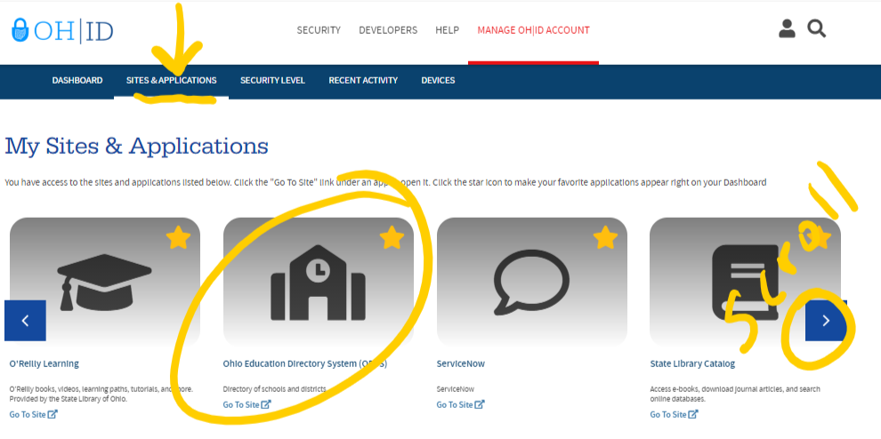

Please take note of the Help Text window at the right of each of the OEDS screens; this feature serves as the manual for the new OEDS.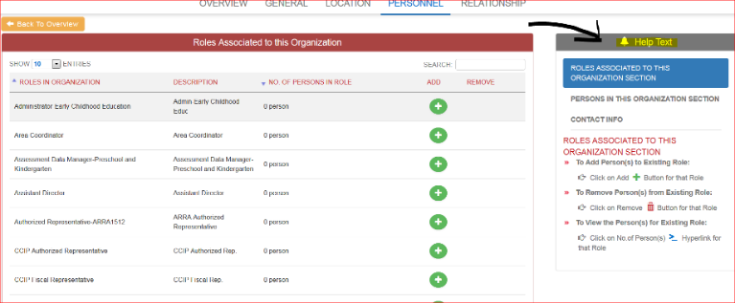
Proceed to Step 6.
step 6: comprehensive continuous improvement plan (CCIP)

If you already have access to your CCIP account, proceed to Step 7.
The Comprehensive Continuous Improvement Plan (CCIP) is a grants application and verification system that includes the Funding Application. The Funding Application contains the budget, the application and other related pages.
The user roles described below will be assigned in OEDS. The person the program named as the OEDS Administrator (Step 5) will assign these roles to program personnel in OEDS. It is important to remember to replace any personnel who have left your employment with someone new to fill these roles.
Required Roles – each role should only be assigned to one person at a time (can be the same person for both roles if appropriate).
- CCIP Authorized Representative is the lead person with ultimate responsibility in a community-based organization. This person gives final approval to the Funding Application, Budget Revision requests and the Final Expenditure Report. The Superintendent is the equivalent to this role in a school district.
- CCIP Fiscal Representative is the person in a community-based organization who has ultimate fiscal responsibility for fiscal matters. This person gives approval to the Funding Application, Budget Revision requests, Project Cash Requests and the Final Expenditure Report. The Treasurer is the equivalent to this role in a school district.

Optional Roles – can be assigned to multiple people

- Data View Funding CCIP person can only look at the grant application data.
- Data Entry Funding CCIP person can enter the application data.

To assign the required CCIP roles and grant access to the CCIP link available through the OH|ID, the person who is named as an organization’s OEDS Administrator will go to the department’s home page and click on the Login link at the top.
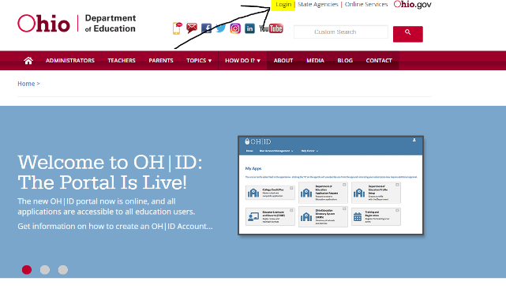
Choose the OH|ID Portal option.
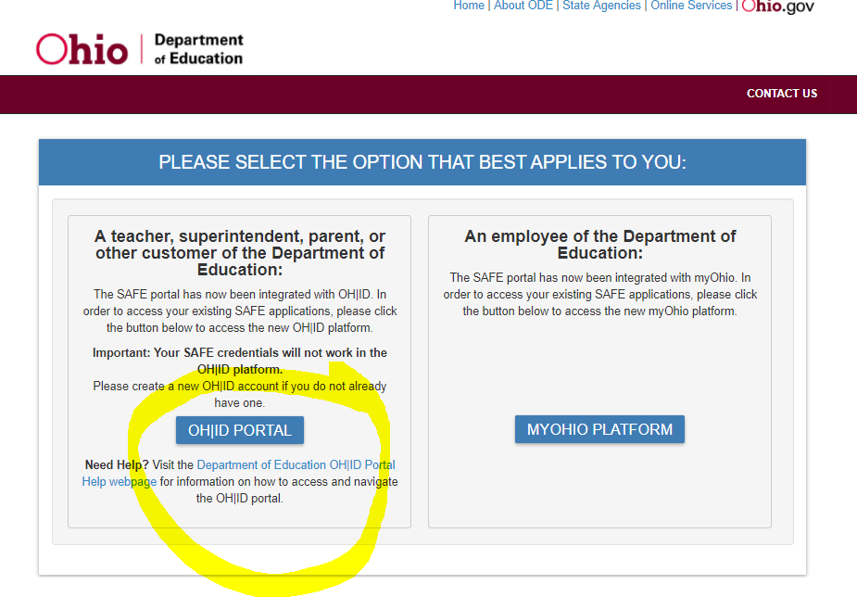
Choose the OEDS link from the list of web systems.
Search for your organization. For best results, type your IRN into the highlighted field and click on the blue Search button.
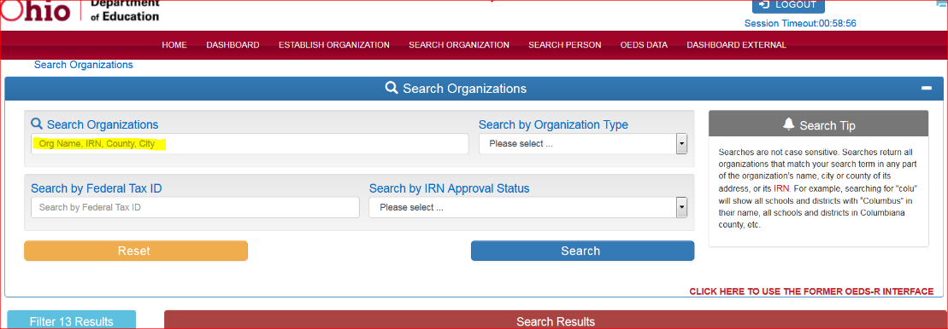

Click on your organization from the list of search results.
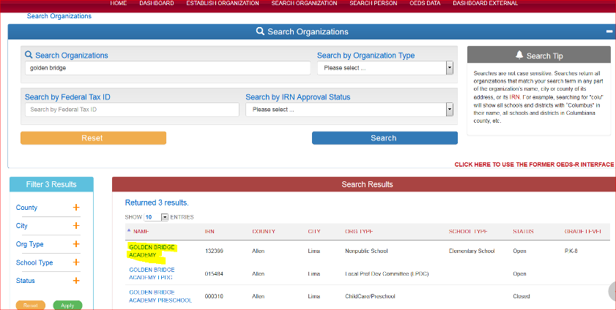
Click on the Personnel tab.
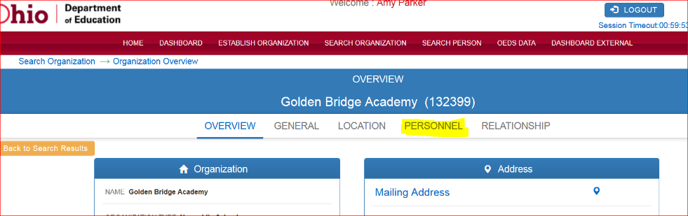
To assign your CCIP Authorized Representative, type CCIP in the search box and select the corresponding plus sign.
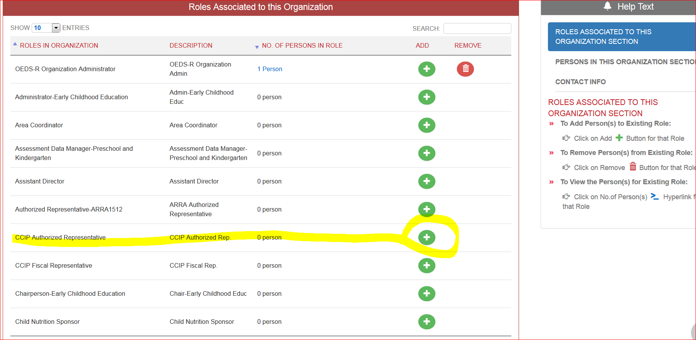

Enter the person whom you desire to be named the CCIP Authorized Representative in the highlighted fields and click SEARCH.
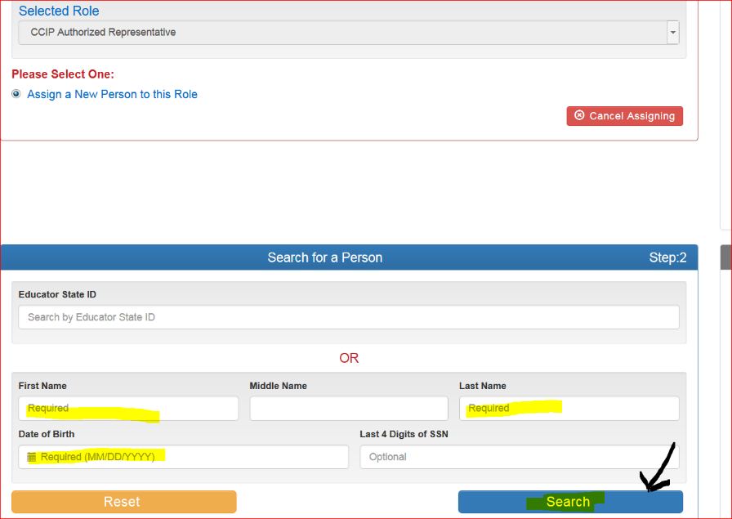
Scroll down to see the search results and select the correct person. If the person does not appear, go back and double check the data you’ve entered. If the person still does not appear, then they will need to apply for a OH|ID at this sign-up link.
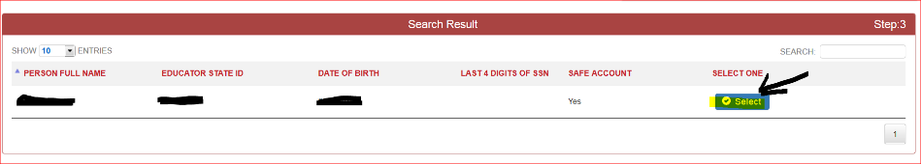
Click SAVE to confirm this assignment.
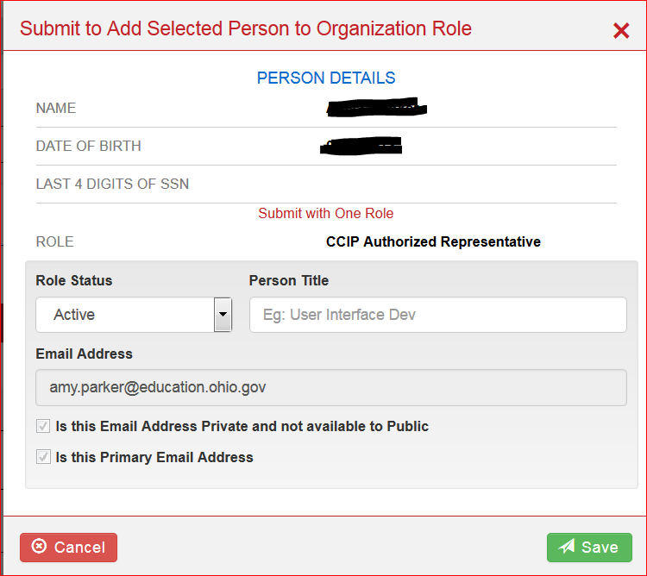
To assign your CCIP Fiscal Representative, type CCIP in the search box and select the corresponding plus sign.
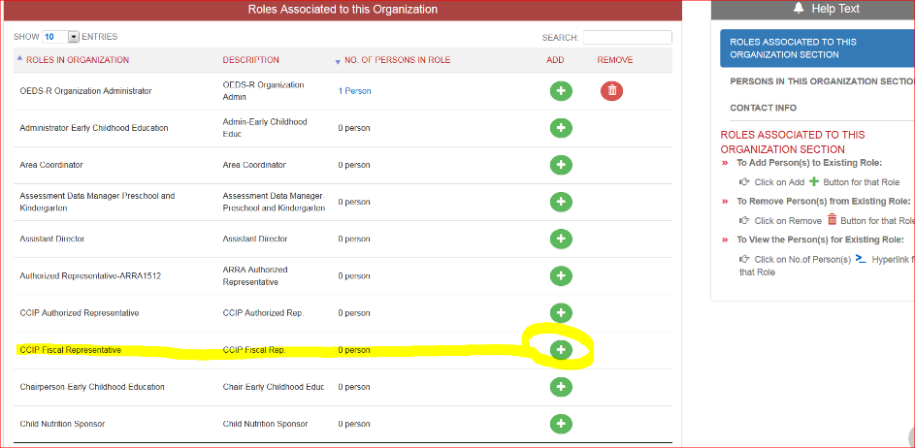
Enter the person whom you desire to be named the CCIP Fiscal Representative in the highlighted fields and click SEARCH.
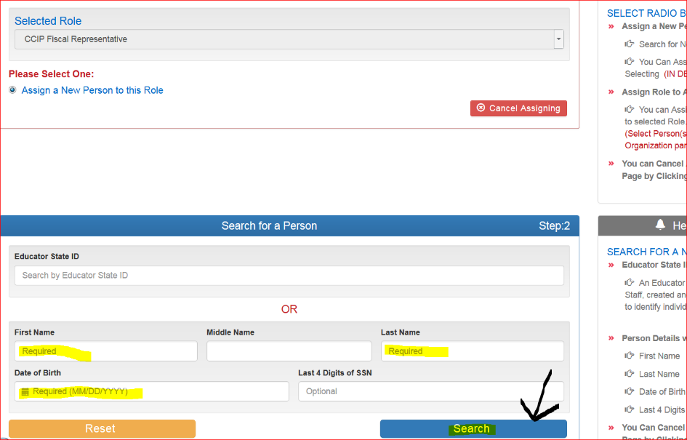
Scroll down to see the search results and select the correct person. If the person does not appear, go back and double check the data you’ve entered. If the person still does not appear, then they will need to apply for a OH|ID using this link.
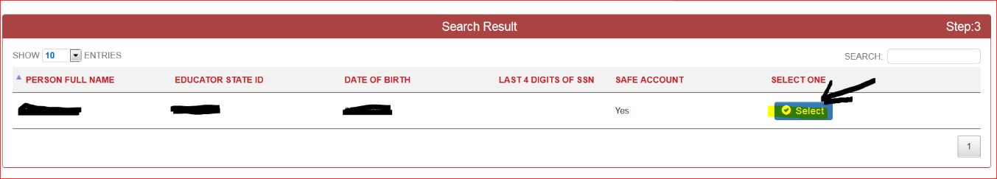

Click SAVE to confirm this assignment.
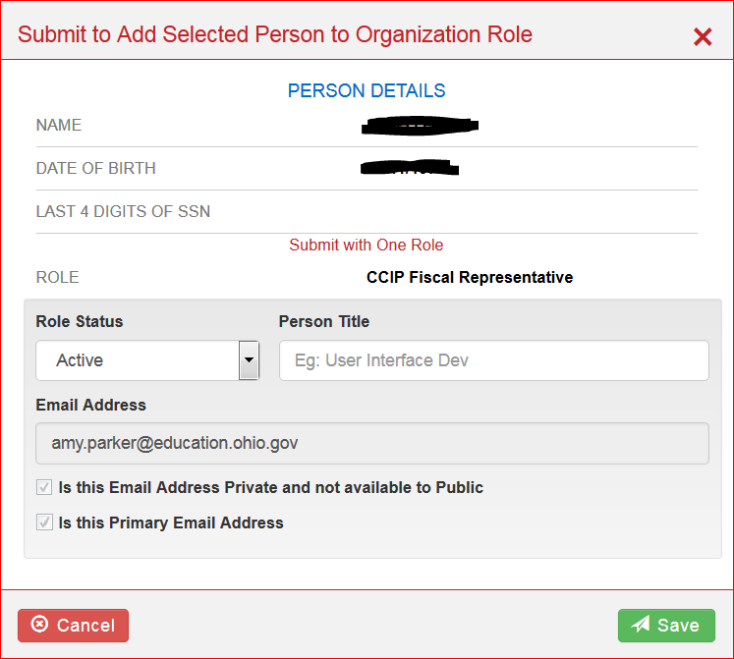
You can also modify these directions to assign any other roles desired (e.g. Data View Funding CCIP). Roles can be removed from personnel by clicking the trash can and following the prompts to confirm.
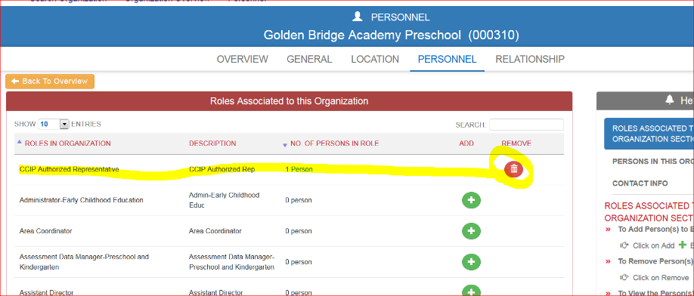
These are the key tasks that you need to complete in CCIP:
- Funding application – Budget guidance, code descriptions, restrictions, allowable/unallowable expenses, revision details, a sample budget, and other useful guidance can be found in the Grantee Manual.
- Draw funds out using a Project Cash Request (PCR)
- Final Expenditure Report

After you have arranged access to CCIP, proceed to Step 7 or 8.
step 7: education management information system (emis)

The following types of programs will use EMIS to report child, teacher and program data:
- Public school districts
- Educational Service Centers
- Joint Vocational Schools
- Department of Developmental Disabilities
- Community Schools

If you are not one of the types of programs listed above, skip to Step 8.
If you use EMIS, here is the current EMIS manual for future reference. Assistance can be obtained through your local ITC or by emailing emis@education.ohio.gov.
In order to enter Early Learning Assessment scores in EMIS, programs must convert skills, knowledge and behavior (SKB) scores into Learning Progression scores by using the KReady system or the Early Learning Assessment Bridge (Score Conversion) Form. The Early Learning Assessment webpage contains additional information regarding the use of the assessment. Step 9 contains information on how to access technical assistance if needed.
Proceed to Step 8.

step 8: enterprise application system (eas)
The following types of programs will use EAS to report child, teacher and program data:
- Ohio Department of Job and Family Services licensed programs
- Chartered Non-Public Schools

You will access EAS through your OH|ID.
The OEDS Administrator is the personnel who must start the EAS application. The CCIP Authorized Representative and CCIP Fiscal Representative roles will be able to access EAS for data entry.
The OEDS Administrator will also need the Data Entry – Early Childhood Education role if they do not also hold one of the CCIP roles.
Note: To submit the provider application, the user must hold either one of the CCIP roles or the Data Entry – Early Childhood Education role.
To assign the Data Entry – Early Childhood Education role, the person who is named as an organization’s OEDS Administrator will go to the department’s home page and click on the Login link at the top.
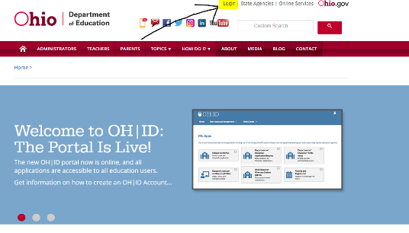
Choose the OEDS link from the list of web systems.
Search for your organization. For best results, type your IRN into the highlighted field and click on the blue Search button.
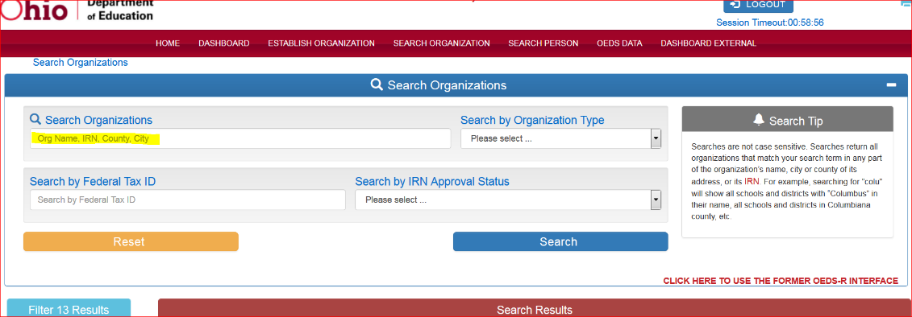
Click on your organization from the list of search results.
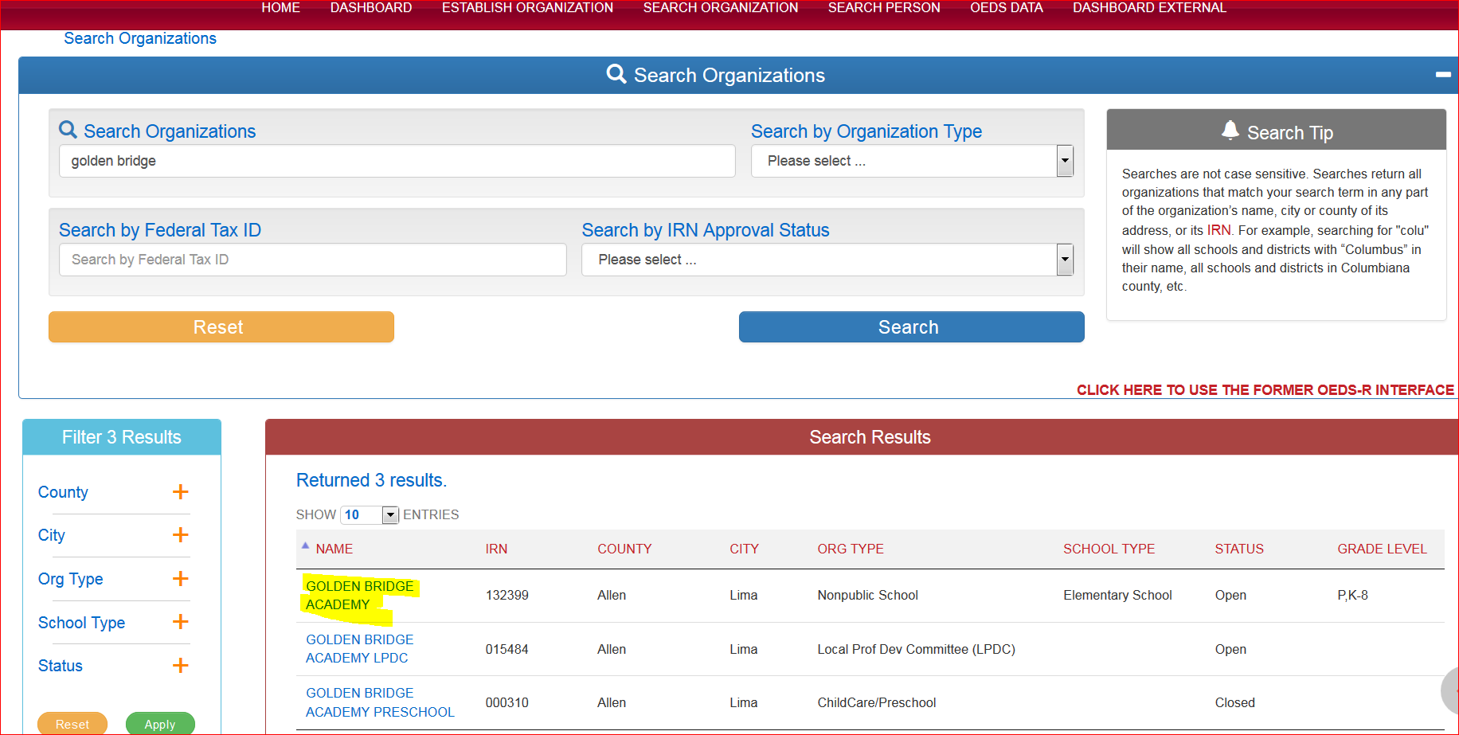
Click on the Personnel tab.
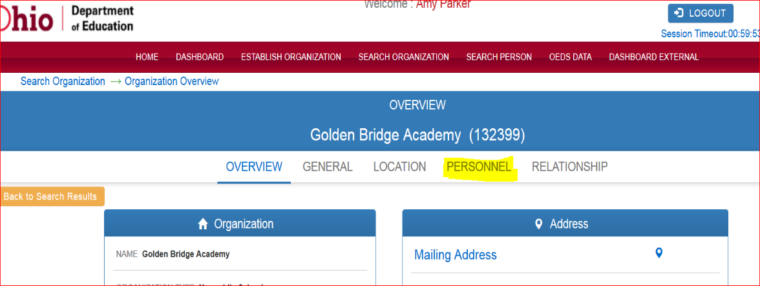
To assign your Data Entry – Early Childhood Education role, type Data Entry in the search box and select the corresponding plus sign.
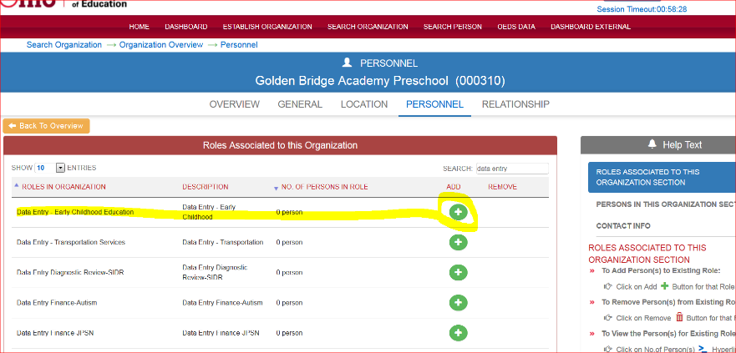
Enter the person whom you desire to be named to the Data Entry – Early Childhood Education role in the highlighted fields and click SEARCH.
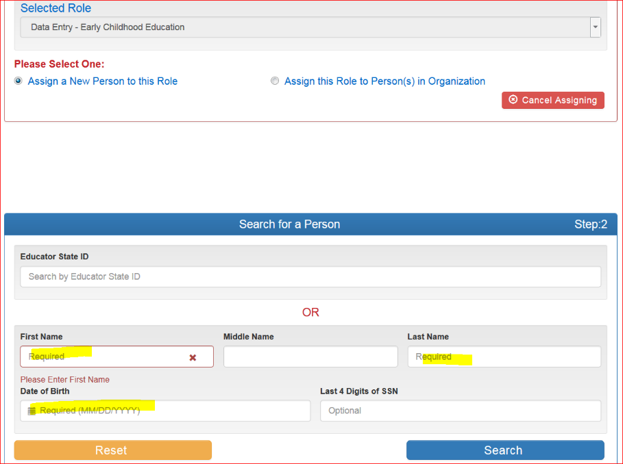
Scroll down to see the search results and select the correct person. If the person does not appear, go back and double check the data you’ve entered. If the person still does not appear, then they will need to apply for a OH|ID at this link.
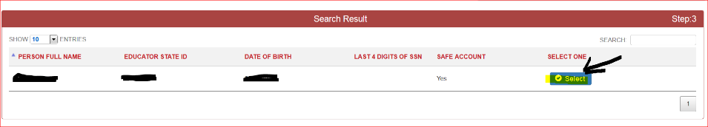
Click SAVE to confirm this assignment.
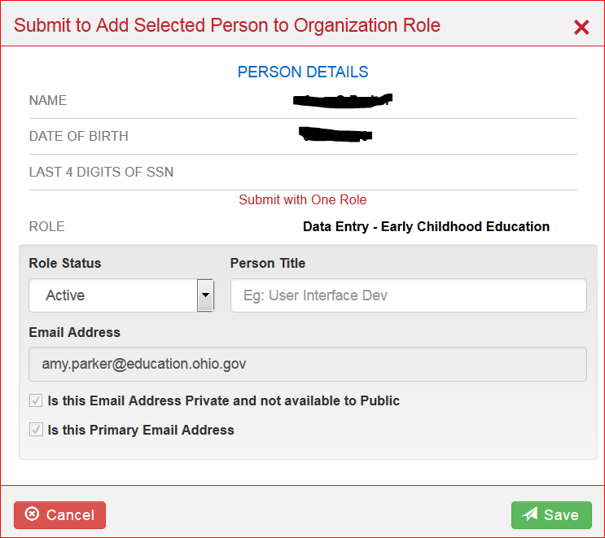
Repeat this step to name as many Data Entry – Early Childhood Education personnel as you desire.
You can also modify these directions to assign any other roles desired (e.g. Data View Funding CCIP). Roles can be removed from personnel by clicking the trash can and following the prompts to confirm.
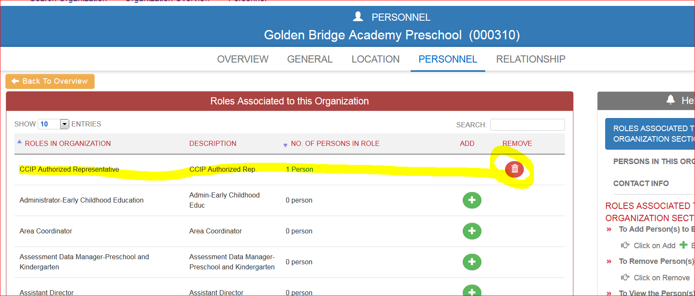
These are the key tasks that you need to complete in EAS:
- Provider application
- Student applications
  - ELA scores - To enter Early Learning Assessment scores in EAS, programs must convert skills, knowledge and behavior (SKB) scores into Learning Progression scores by using the KReady system or the Early Learning Assessment Bridge (Score Conversion) Form. The Early Learning Assessment webpage contains additional information regarding the use of the assessment. Here is the link to the Test Incident Form that can be used to report issues in reporting ELA scores.
  - Attendance
9: technical assistance
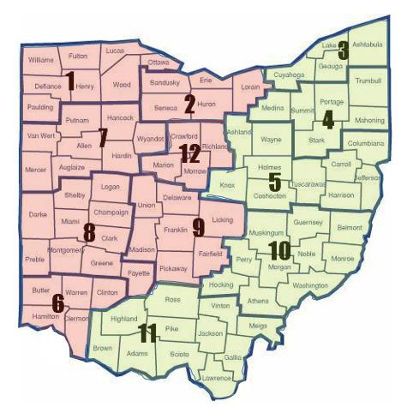
Amy Orr Parker  614-369-4918  Amy.Parker@education.ohio.gov | Erin Bagley  614-369-4917  Erin.Bagley@education.ohio.gov
REGION 1  Counties Served: Williams, Fulton, Lucas, Defiance, Henry, Wood, Paulding, Ottawa | REGION 3  Counties Served: Cuyahoga, Lake, Ashtabula, Geauga
REGION 2  Counties Served: Sandusky, Seneca, Erie, Huron, Lorain | REGION 4  Counties Served: Medina, Summit, Portage, Stark, Trumbull, Mahoning
REGION 6  Counties Served: Butler, Warren, Clinton, Hamilton, Clermont | REGION 5  Counties Served: Ashland, Wayne, Holmes, Knox, Coshocton, Carroll, Columbiana, Jefferson, Harrison, Tuscarawas
REGION 7  Counties Served: Putnam, Hancock, Van Wert, Allen, Hardin, Auglaize, Mercer, Wyandot | REGION 10  Counties Served: Muskingum, Guernsey, Belmont, Noble, Monroe, Morgan, Perry, Washington, Hocking, Athens
REGION 8  Counties Served: Darke, Shelby, Logan, Miami, Champaign, Clark, Greene, Montgomery, Preble, Fayette | REGION 11  Counties Served: Vinton, Meigs, Jackson, Gallia, Ross, Pike, Scioto, Lawrence, Highland, Adams, Brown
REGION 9
Counties Served: Union, Delaware, Licking, Franklin, Fairfield, Pickaway, Madison
REGION 12
Counties Served: Crawford, Richmond, Marion, Morrow

10: optional checklist

The following optional checklist is provided for your convenience. Please do not submit to the department.
Access to some of these systems are dependent on your enrollment in some of the other systems. Please attempt to complete these tasks in the order presented.
Deliverable: | Sent to: | Date Completed:
Obtain OAKS ID# | OSS Site
Request IRN | Ctrl+Click here to request an IRN
Link IRN and OAKS numbers | Ctrl+Click here to submit IRN/OAKS information.
Access OH|ID | Use this link.
Assign OEDS Administrator | Ctrl+Click here to send OEDS information.
Access CCIP | Access CCIP through your OH|ID.
Access EAS, if applicable | Access EAS through your OH|ID.

