Name of District: Click or tap here to enter text.
District IRN: Click or tap here to enter text.
Total number of preschool children with IEPs: Click or tap here to enter text.
Date Data Collected: Click or tap to enter a date.
Directions: Beginning on page 2, complete the yellow and green sections of the form. Responses should be based upon the district’s current preschool special education continuum of options and current number of preschool children with disabilities placed in each option.

For a complete set of directions and an example of the completed form, see Preschool Continuum of LRE Placement Options Directions.
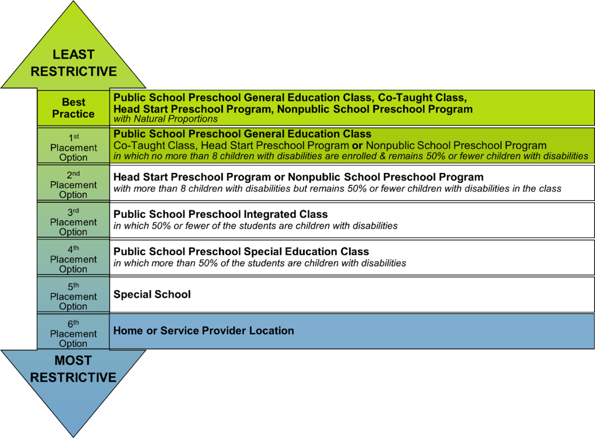
Preschool Continuum of LRE Placement Options  (For full descriptions, see page 1) | Best  Practice  Option | 1st  Placement Option | 2nd  Placement Option | 3rd  Placement Option | 4th  Placement Option | 5th  Placement Option | 6th  Placement  Option
 | General education, co-taught, Head Start, non-public classroom  Natural proportions | General education, co-taught, Head Start, non-public classroom  8 or fewer CWD | Head Start, non-public classroom  More than 8 CWD | Integrated classroom | Special education classroom | Special school | Home, service provider location
Options for Placement: District Operated | General education classrooms  Click or tap here to enter text.  Co-taught classrooms  Click or tap here to enter text.  Head Start classrooms  Click or tap here to enter text. | General education classrooms  Click or tap here to enter text.  Co-taught classrooms  Click or tap here to enter text.  Head Start classrooms  Click or tap here to enter text. | Head Start classrooms  Click or tap here to enter text. | Integrated classrooms  Click or tap here to enter text. | Special education classrooms  Click or tap here to enter text. | Special School classrooms  Click or tap here to enter text. | Home served by itinerant district staff  Click or tap here to enter text.  Service provider location served by district staff  Click or tap here to enter text.
Options for Placement: Non-district Operated * | General education classrooms  Click or tap here to enter text.  Co-taught classrooms  Click or tap here to enter text.  Head Start classrooms  Click or tap here to enter text.  Non-public classrooms  Click or tap here to enter text. | General education classrooms  Click or tap here to enter text.  Co-taught classrooms  Click or tap here to enter text.  Head Start classrooms  Click or tap here to enter text.  Non-public classrooms  Click or tap here to enter text. | Head Start classrooms  Click or tap here to enter text.  Non-public classrooms  Click or tap here to enter text. | Integrated classrooms  Click or tap here to enter text. | Special education classrooms  Click or tap here to enter text. | Special School classrooms  Click or tap here to enter text. | Home served by itinerant non-district staff  Click or tap here to enter text.  Service provider location served by non-district staff  Click or tap here to enter text.
Number  of preschool children with disabilities placed | Number receiving the majority of hours of special education and related services with typical peers:  Click or tap here to enter text.  Number receiving the majority of hours of special education and related services not with typical peers/outside the classroom:  Click or tap here to enter text. | Number receiving the majority of hours of special education and related services with typical peers:  Click or tap here to enter text.  Number receiving the majority of hours of special education and related services not with typical peers/outside the classroom:  Click or tap here to enter text. | Number receiving the majority of hours of special education and related services with typical peers:  Click or tap here to enter text.  Number receiving the majority of hours of special education and related services not with typical peers/outside the classroom:  Click or tap here to enter text. | Number receiving the majority of hours of special education and related services with typical peers:  Click or tap here to enter text.  Number receiving the majority of hours of special education and related services not with typical peers/outside the classroom:  Click or tap here to enter text. | Number receiving special education and related services in a special education classroom:  Click or tap here to enter text. | Number receiving special education and related services in a special school:  Click or tap here to enter text. | Number receiving services at home from itinerant staff:  Click or tap here to enter text.  Number receiving services at service provider location:  Click or tap here to enter text.
TOTAL number of preschool children with disabilities placed | Click or tap here to enter text. | Click or tap here to enter text. | Click or tap here to enter text. | Click or tap here to enter text. | Click or tap here to enter text. | Click or tap here to enter text. | Click or tap here to enter text.

*Non-district operated options include those options within and outside district boundaries.

