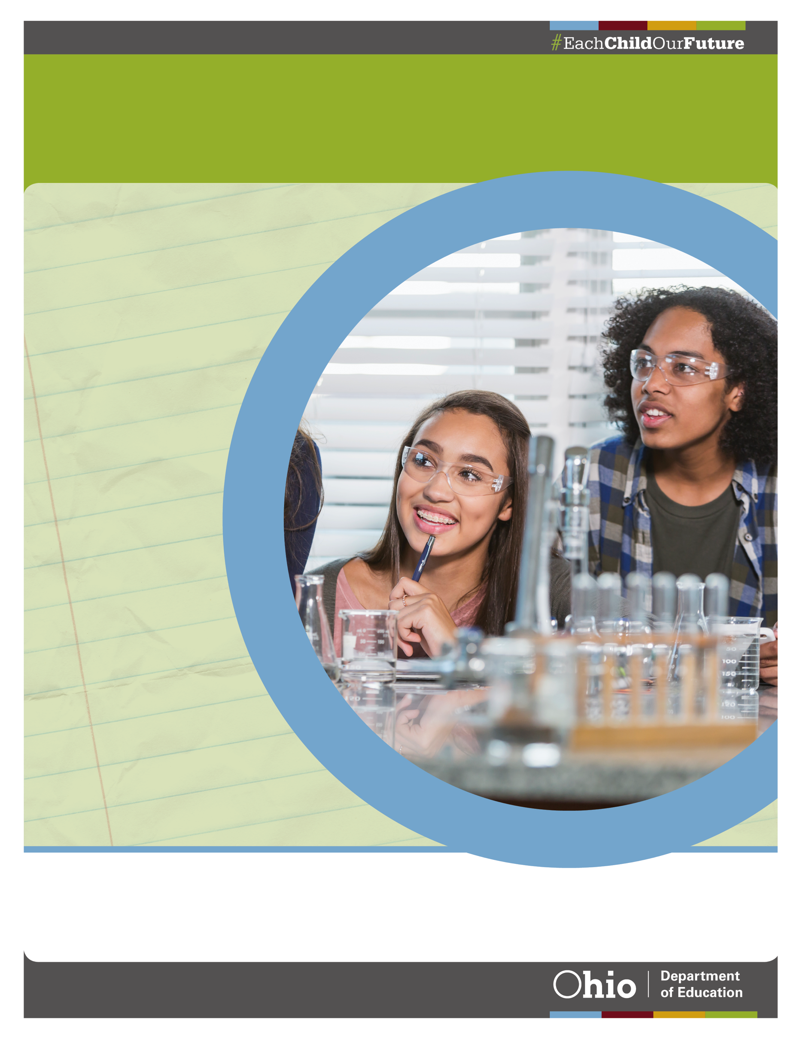
Application: Innovative Workforce Incentive Program Implementation Grant 2
September 1, 2021
IN PARTNERSHIP WITH THE gOVERNOR’S OFFICE OF WORKFORCE TRANSFORMATION

Application Information:

Applicant School: Click or tap here to enter text.
IRN: Click or tap here to enter text.
Mailing Address: Click or tap here to enter text.
City: Click or tap here to enter text.
State: Click or tap here to enter text.
Zip code: Click or tap here to enter text.

Grant Manager: Click or tap here to enter text.
Organization Name: Click or tap here to enter text.
Phone number: Click or tap here to enter text.
Email address: Click or tap here to enter text.

Other Contact (if applicable): Click or tap here to enter text.
Organization Name: Click or tap here to enter text.
Phone number: Click or tap here to enter text.
Email address: Click or tap here to enter text.

Fiscal Contact: Click or tap here to enter text.
Phone number: Click or tap here to enter text.
Email address: Click or tap here to enter text.

Innovative Workforce Incentive Program Credentials
List the credential(s) the district plans to offer under this grant.
Response should include school name and the credential(s) to be offered at each school. Due to an updated list of eligible credentials, the credential(s) may be different from those listed in the original grant application.

Current Credential Programs
Are the Innovative Workforce Incentive Program credentials listed in Question 1 currently available to students in the school?

Regional Industry and Occupations
What are the highest projected growth industries in the region and what are the emerging occupations in those industries?
The program(s) should be addressing a need in the region. Provide state and Local Labor Market Information (LMI) with current and projected employment. Input from local business and industry representatives should be referenced.

Credential Alignment to Regional Industry and Occupations
How does the qualifying credential program(s) align to the high-skill, high-wage or in-demand industry sectors and occupations in the region?
Provide a list of high-skill, high-wage or in-demand industry sectors and occupations in the region. Include how the program aligns to current and future employment projections. Links to job postings that support the need for this credential program are encouraged.

Industry Stakeholder Engagement
Who are the major industry partners/stakeholders who have committed to working with students in the program?
List three or more industry partners/stakeholders and explain how each partner will be involved in the program. Example activities of commitment: pre-apprenticeship or mentorship opportunities, assisting with classroom instruction, company site visits, supplemental funding or other opportunities. Missing or unsigned letters may result in the application being rejected.

Course Content Delivery for Credentials
How will course content be delivered (e.g., online provider, industry partner, separate course offering, integrated course offering)?
Describe how the program will provide an innovative approach to delivering course content that leads to students earning industry credentials. Instruction may include a combination of classroom, online and hands-on training.

Teacher(s)
Is there a teacher identified for this program?
Teacher(s) listed is currently employed by the school or teacher(s) will begin next school year.

Teacher Professional Development
What professional development will teachers engage in for this program?
Training is valuable and necessary to provide quality instruction and training to students. List training, qualifications and/or related industry credentials the instructor has already obtained or describe a plan for teacher professional development.

Number of Students Earning Innovative Workforce Incentive Credentials
How many students are expected to earn IWIP credentials in the 2022-2023 school year?
Provide the number of students enrolled or projected number of students to be enrolled in the program and the number of students expected to earn the qualifying credentials.

Credential Program Correlation to Ohio’s Top Jobs List
How does the credential program correlate to jobs listed on Ohio’s Top Jobs?
The credential program directly prepares students for employment in industries and occupations identified on Ohio’s Top Jobs list.

Current Resources for Program Implementation
What current resources will be used to support the program?
List current resources such as funding, curricular materials, equipment, facilities/labs, instructor(s) and other personnel.

Sustaining the Program
What is the applicant’s plan to sustain the credential program in the future?
Clearly describe a feasible plan for implementing student opportunities beyond the grant funding period. Strategies may include using Perkins funds, committed resources or other funding sources.

Program Implementation Timeline:
Provide a timeline that includes such activities as when students will be recruited, identification of or hiring of any new instructor(s), professional development for instructor(s), equipping the facility, etc.:
Time period, Date | Activity or event

Budget Narrative
Please provide a description of how the requested funds will be used in each of the categories listed in the table below. Provide an itemized list of expenditures that the program(s) expects to incur throughout the duration of the funding period. Additionally, provide information on any current resources that will be provided in support of the program(s).
Budget Category | Explain how the requested funds will be used to implement the Innovative Workforce Incentive Program credential program(s).
Instruction
Support Services
Governance/Admin
Professional Development
Family/Community
Safety
Facilities
Transportation
Nonpublic
Current Resources

Budget Worksheet

Applicants must submit the Budget Worksheet into the Comprehensive Continuous Improvement Plan based on the total sum awarded for the qualifying program(s).

Proposed Budget (submitted with grant application) | Salaries | Retirement Fringe Benefits | Purchased Services | Supplies | Capital Outlay | Other | Total
Instruction |  |  |  |  |  |  | $ -
Support Services |  |  |  |  |  |  | $ -
Governance/Admin |  |  |  |  |  |  | $ -
Prof Development |  |  |  |  |  |  | $ -
Family/Community |  |  |  |  |  |  | $ -
Safety |  |  |  |  |  |  | $ -
Facilities |  |  |  |  |  |  | $ -
Transportation |  |  |  |  |  |  | $ -
Nonpublic |  |  |  |  |  |  | $ -
Indirect Cost |  |  |  |  |  |  | $ -
Total | $ - | $ - | $ - | $ - | $ - | $ - | $ -

Grant Assurances:
Statement of Grant Specific Assurances

The grantee assures, if awarded a grant, that:
1 | The grantee plans to offer, beginning next school year, a qualifying credential program from the Governor’s Office of Workforce Transformation Innovative Workforce Incentive Program list. If this grant award is accepted, the grantee agrees to prepare students to earn the qualifying credential(s) in this application.
2 | The grantee will report students that earned the qualifying credential(s) from the Governor’s Office of Workforce Transformation Innovative Workforce Incentive Program list requested through this grant in the Education Management Information System. If no credentials are reported as earned, the Department reserves the right to request the grantee return the full amount of awarded funds.
3 | Expenditures will be incurred by June 30, 2023. If awarded funds are not used by Jan. 1, 2023, the balance of awarded funds must be returned to the Ohio Department of Education.
4 | The grant funds will not be used to pay for the cost of a student’s credential exam.
5 | The Department may terminate the grant award upon 30 days written notice if it is determined that the grantee, grantee staff or any individuals connected with the credential program have used grant funds for personal gain, performed criminal activities or broken any of the agreed-upon assurances listed in the grant application. If it is determined that any grant funds have been misused, the Department reserves the right to request the grantee return the full amount of awarded funds.
6 | The grantee will maintain records, including but not limited to invoices, purchase order requests, requisition orders, receipts, student and teacher credentialing certificates and related documentation of earned credentials. Grantee will provide the Ohio Department of Education access to those records in the conduct of audits or for supporting budget documentation. This cooperation includes access without unreasonable restrictions to its records and personnel for the purpose of obtaining relevant information.
CERTIFICATION
I HEREBY CERTIFY that, to the best of my knowledge, the information in this application is correct.

The applicant designated below hereby applies for an Innovative Workforce Incentive Program Implementation Grant for the purpose of establishing a qualifying credential program from the Governor’s Office of Workforce Transformation Innovative Workforce Incentive Program list and acknowledges to all Statement of Grant Specific Assurances.

Signature of Authorized Person: ______________________________ Date: ___________

Printed Name of Authorized Person: _________________________________

Application Submission:
Applicants will complete and upload the official Innovative Workforce Incentive Program Implementation Grant Application, Budget Worksheet and supporting documents into the Comprehensive Continuous Improvement Plan (CCIP) electronic system. For the purposes of the Innovative Workforce Incentive Program Implementation Grant award, applicants will only use the funding application that contains the budget page, assurances and the budget upload. Documents will not be accepted by post or electronic mail unless expressly directed by Department staff. For the application to be considered complete, the following documents are required:
- Official Innovative Workforce Incentive Program Implementation Grant Application
- Budget Narrative
- Completed Budget Worksheet
- Signed Statement of Grant Specific Assurances
- Three current letters of commitment from business and industry partners describing their level of involvement in the credential program

Questions should be directed to IWIP@education.ohio.gov.

