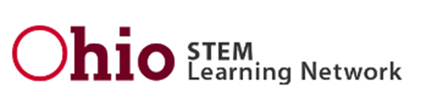

Ohio STEM and STEAM Designation Application FY2022

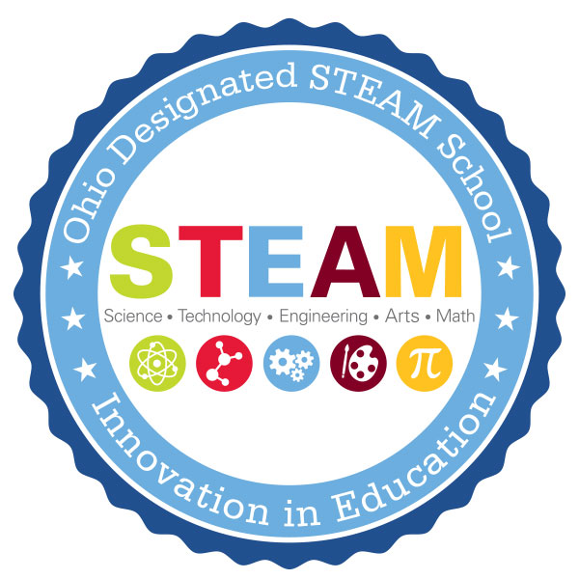
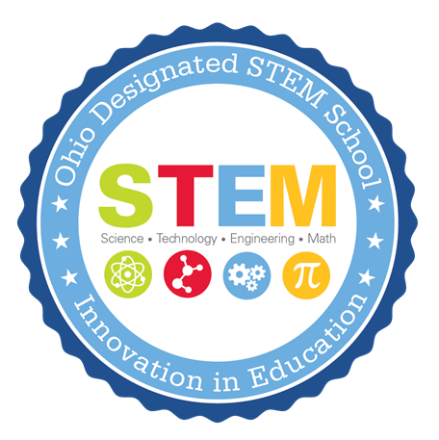

Approved: September 2020

Call for Proposals for STEM and STEAM School Designation and
STEM and STEAM School Equivalent for Schools in the State of Ohio

BACKGROUND AND PURPOSE

The Ohio STEM Committee, Ohio STEM Learning Network and the Ohio Department of Education are committed to ensuring each child in Ohio is challenged, prepared and empowered. STEM and STEAM education provides an opportunity for each child to discover and learn, pursue a fulfilling post-high school path and to become a resilient, lifelong learner who contributes to society.

STEM and STEAM education is an integrated approach to learning where rigorous academic concepts are learned through real-world, project-based experiences. Students use science, technology, engineering, arts/humanities and mathematics concepts to make authentic connections between school, community and work experiences. The Ohio STEM and STEAM School Designation was created to award and recognize schools that are exemplars of this work.

STEM and STEAM designated schools employ highly effective teachers and leaders who meet the needs of the whole child. In addition, these schools have well-established partnerships with businesses, non-profit organizations, institutes of higher education and other entities in their communities to prepare students for post-high school success.

The Ohio STEM Committee is responsible for determining STEM and STEAM designation. A designated school is expected to maintain its current designation level and demonstrate the continued implementation of the STEM and STEAM attributes.

The following application is aligned with Each Child, Our Future – Ohio’s strategic plan for education, Ohio’s Quality Model for STEM and STEAM Schools and section 3326.03 of Ohio law.

OBJECTIVES
Future economic growth and prosperity in Ohio depends on an aligned education system that supports the state’s economic development efforts and helps all Ohio students to become innovators and inventors, self‐reliant and logical thinkers, and technologically proficient problem solvers. This RFP invites proposals to do all of the following:
- Create a culture within an established (K-12) school (special consideration provided to schools seeking to be Independent STEM schools) to help generate a talent base that will establish Ohio as a catalyst and global leader in attracting, educating and producing the next generation of scientists, engineers and other professionals needed to create tomorrow's innovations for the betterment of all citizens;
- Foster increases in the number of Ohio’s citizens studying and working in STEM and STEAM fields;
- Foster development of stronger skills in problem solving, innovation and teamwork for all students.

ELIGIBILITY
Proposals may only be submitted by a partnership of public and private entities consisting of at least all of the following:
- A city, exempted village, local or joint vocational school district or an educational service center;
- Higher education entities
- Business organizations

A community school established under Chapter 3314 of the Ohio Revised Code, a chartered nonpublic school or both may be part of the partnership.

Schools submitting for the 2020 Spring Designation, must be opened prior to September 1, 2019. However, in accordance with ORC 3326, a newly created, independent STEM school (i.e. not a district STEM school) may apply for STEM designation prior to opening.

EVALUATION CRITERIA

All proposals will be reviewed according to the Portfolio Application Rubric. This rubric is aligned to Each Child, Our Future – Ohio’s strategic plan for education, the requirements in ORC 3326.03, which specifies the requirements of STEM and STEAM designation proposals, and the Ohio Quality Model of STEM and STEAM Schools, which outlines the essential criteria for high quality STEM and STEAM implementation. The criteria are used to assist schools in the innovation of a STEM culture within a school and the surrounding community.

PROPOSAL RATINGS

Initial | School will not receive designation. School is in the beginning stages of implementing STEM attributes, or school implements very few of the STEM attributes.
Approaching | School will not receive designation. School implements many but not all the STEM attributes, and or insufficient evidence of implementation. Some attributes are present, however, there is still room for growth in implementation
Accomplishing | School will receive designation. School is a prime example for the implementation of the STEM attributes. School implements all the STEM attributes throughout the school year to create a culture of STEM learning within the school and the surrounding community.
Model | School will receive designation. School is an exemplar in implementation of STEM attributes. School implements all the STEM attributes throughout the school year to create a culture of STEM learning within the school and the surrounding community.

REMINDERS
Applicants are strongly advised to review the “Quality Model for STEM and STEAM Schools,” for clarity and examples of high-quality STEM and STEAM practices.

Applicants are responsible for timely submission of proposals. Proposals become the property of the Ohio Department of Education. Proposals meeting the above requirements will receive careful consideration. This consideration will be regarding designation as a STEM or STEAM school in Ohio and will not include any consideration of grant funds or additional funding.

Applications will be reviewed by the STEM Committee and the Ohio STEM Learning Network in accordance with 3326. The rubric will be utilized in the review process.

CONTACT INFORMATION
Kimberly Bell, STEM Specialist, Ohio Department of Education - Kimberly.bell@education.ohio.gov
Heather Sherman, Director, Ohio STEM Learning Network- Battelle - osln@battelle.org

APPLICATION TIMELINE/PROCESS
October 1st: FY22 Application Posted

December 15th: Complete this survey to inform the Ohio Department of Education and the Ohio STEM Learning Network on your intent to apply and if technical assistance will be pursued.

January 15th: Submit a rough draft of the application/portfolio to the Ohio STEM Learning Network for technical assistance. Email rough drafts to osln@battelle.org. You will receive feedback on your draft application in time to make changes prior to the final submission to ODE.

February 15th: Final applications due to the Ohio Department of Education by 5 p.m. Email to kimberly.bell@education.ohio.gov

March 2020: After a preliminary review from the Ohio STEM Learning Network, site visits to selected schools will be conducted during the spring. A school may also request a site visit when submitting their application.
April 2021: Applicants will be notified of the Ohio STEM Learning Network’s recommendation.
May 2021: The Ohio STEM committee will vote on designated schools.

OPTIONAL LEARNING SESSIONS ON STEM

October 14th 3pm-5pm: Creating a culture of innovation to support STEM best practices
Shifting a school and community culture towards a STEM/STEAM mindset is a team effort. STEM leaders will share tangible ways to shift a school and community culture to include innovation, entrepreneurship, inquiry and collaboration. Topics will include building a school-wide design cycle, supporting teacher innovation in the classroom engaging parents and guardians in the process. Join webinar here.

October 28th 3pm-5pm: Beyond PBL: What does teaching and learning look like in a STEM school?
STEM and PBL go hand-in-hand, but what does it mean to implement project/problem-based learning and more? STEM leaders from across Ohio will guide participants through a deep dive into PBL and demonstrate how it is used as a launching pad to personalizing student learning.
Join webinar here.

November 11th 3pm-5pm: Building community partnerships to provide real-world context
.
How can partnerships deepen the education experience for students and the community? Participants will learn the role of partnerships in STEM from the Quality Model for STEM and STEAM schools. We will explore the nature of partnerships, provide time to brainstorm and share potential partnerships based on curriculum, events, and community needs. STEM Leaders from Ohio’s STEM designated schools will share their experiences and how community partnerships positively impact learning for all students.
Join webinar here.

SUBMISSION
For submission, please save this document as a PDF. All final applications must be emailed to Kimberly Bell at Kimberly.Bell@education.ohio.gov.
COVER SHEET
Type of Designation | STEM School ☐ STEAM School ☐  STEM School Equivalent ☐ STEAM School Equivalent ☐
School Information | School IRN: ___________________  School Name: _____________________________________________________________  School Mailing Address: _____________________________________________________  City: ________________________ Zip: _________ County: ______________  Type: ☐ District school ☐ Independent STEM/STEAM school ☐ Community school  ☐ Chartered nonpublic school
Grade Levels | Pre- K ☐ K☐ 1☐ 2☐ 3☐ 4☐ 5☐ 6☐ 7☐ 8☐ 9☐ 10☐ 11☐ 12☐  Other __________
Total Enrollment
Total # of Students Participating in STEM/STEAM

CONTACT INFORMATION:
 | Name | Email | Phone
School Principal/
Director
Treasurer/
Fiscal Officer
Superintendent/
CAO

Please print and attach as a separate document when submitting your application.
ASSURANCES
In accordance with ORC 3326.03 (or 3326.032 for community schools or chartered nonpublic schools), please provide the following assurances. By checking the “agree” box, you attest to the following:

Agree ☐ | The school will operate in compliance with the provisions of the proposal as accepted by the committee.
Agree ☐ | The school will operate in compliance with ORC 3326 (or sections 3326.032 and 3326.09 for community schools and chartered nonpublic schools).
Agree ☐ | The school will be under the oversight of a governing body. (Include a description in the narrative where indicated.) If applicant is a community school, the school has a sponsor and a letter of support from the sponsor is included. Governing authority support is indicated by the signature below.
Agree ☐ | In the event of closure, the assets of the school will be distributed in accordance with Ohio Revised Code.

SIGNATURES:

___________________________________ _____________________________ _________________
School Principal/Director signature Printed Name Date

___________________________________ _____________________________ _________________
Treasurer/Fiscal officer signature Printed Name Date

___________________________________ _____________________________ _________________
Superintendent/CAO signature Printed Name Date

For Community Schools:

___________________________________ _____________________________ _________________
Sponsor Representative Signature Printed Name Date

___________________________________ _____________________________ __________________
Governing Authority President Printed Name Date

In accordance with 3326.03
The following application was created to ensure applicants are implementing authentic STEM practices. The portfolio format will provide applicants the opportunity to provide evidence such as links, documents and artifacts the demonstrate that their school is offering a rigorous, diverse, integrated and project-based curriculum to students in any of the grades kindergarten through 12 while preparing students for college, workforce and citizenship. Question numbers reflect the rubric section the question fulfills.

Introduction:

Describe the characteristics of your STEM/STEAM practices and explain how they are different from traditional schools. (500 words max)

Part 1: A Culture for Learning- Beliefs and Disposition, Equity and Access

1.1 How does your school culture promote innovation, entrepreneurialism, inquiry and collaboration?

1.2 Describe how your school culture demonstrates an inclusive mission and commitment to personalized learning.
1.3a Describe how your leadership team exhibits flexible and autonomous leadership, communicates a shared vision and supports innovative instruction.

1.3b What school structures are in place to support innovative, problem-based learning throughout the entire school (i.e., common planning time, professional development funds)?

1.4a Describe how your school’s governing body (and/or STEM/STEAM advisory group) is selected and their level of support for the operation of a STEM/STEAM school.

1.4b Please provide a link to the listing of your school board members, or list below:

1.4c STEM/STEAM Advisory Group Members (if applicable):

Name | Email | Role

Please link 2 -3 meeting agendas.
1
2
3

1.4d Describe how you selected the members of your advisory group and how they have contributed to the growth of STEM/STEAM in the building.
1.4e Describe how the school’s curriculum will be developed by a curriculum team* consisting of, at minimum: 1) the chief academic officer, 2) a higher education partner, 3) a teacher and 4) a member of the public with expertise in the application of science, technology, engineering or mathematics. Describe how the team will develop an innovative curriculum.

*If the proposal is for a STEAM school or STEAM school equivalent, the curriculum team must also include an expert in the integration of arts and design into the STEM fields.
**Sometimes the STEM/STEAM Advisory Team and the Curriculum Team can be the same.

Part 2: Learning and Teaching

2.1 Show how reasoning and problem solving (e.g. scientific reasoning, engineering design, computational thinking, design thinking, argument from evidence) are embedded throughout the curriculum to prepare students to participate in a global society. Please include your design cycle/process image (if available) the school/district utilizes and integrates into learning experiences.

2.2a Describe how problem-based learning (PBL) drives instruction and curriculum.

2.2b Provide examples of Problem Based Learning
STEM/STEAM Learning Experience  (include hyperlink to view experience lesson plan and any additional documents necessary for implementation) | Description of Project | Grade Level/ # of Participating Students | **Samples of Student Work
STEM/STEAM Learning Experience  (include hyperlink to view experience lesson plan and any additional documents necessary for implementation) | Description of Project | Grade Level/ # of Participating Students | **Samples of Student Work
** Please submit 2-3 samples of student work. Please provide us with a variety of levels for each learning experience.

2.2c Describe how your school implements a curriculum with interdisciplinary connections and frequently uses technology to enhance student learning. Be sure to include how the arts and humanities are integrated in the STEM/STEAM disciplines.

2.3 Describe how student learning is assessed.

2.4a Describe how the school recruits and retains faculty members with a high interest in STEM/STEAM education and experience with innovative instructional methods.
2.4b Describe how teachers effectively and consistently use best practices in STEM/STEAM pedagogy.

2.4c Highlight any professional development sessions on STEM/STEAM best practices that school staff have attended.

Professional Development Session Name  (If possible, please hyperlink to PD website) | Date and Length of PD | Names and Roles of Attendees | How has the professional development content impacted the STEM/STEAM practices at your school?

Part 3: Pathways to Success in Careers

3.1 What access does the school provide to students to support career exploration/interests? If applicable, provide details about student participation in CCP/certification programs, etc.

3.2a Detail the established community partners and their role within your school. *STEAM applicants must provide an art/humanities partner
Partner Name | Type of Partnerships  (ex: Business, Non-Profit, Higher Ed) | Representative | Contact Email | Letter of Support  (Link the Letter of Support below)

3.2b Describe how partners are involved with curriculum development, provide practical, work-based learning experiences and student support, and/or share resources with the school.

3.3 Describe how your school provides STEM/STEAM-rich formal and informal relevant experiences with the community to your students.

Financial

Detail how the school has received or will receive in-kind and financial support from regional education partners and business entities.
  - Include examples of how the in-kind and financial support reflect the community’s priorities for STEM/STEAM education.
  - Describe how this will be used to support innovative STEM/STEAM programming.
Additional Considerations:
Please detail any additional information you believe the STEM Committee should know about your school. You may provide a narrative or links.

