Ohio STEM and STEAM Designation Application
Fiscal Year 2023

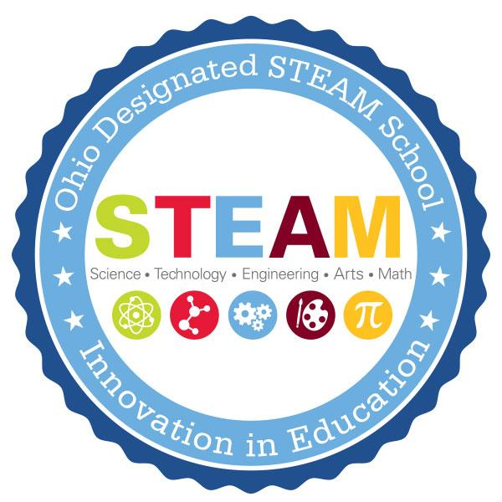
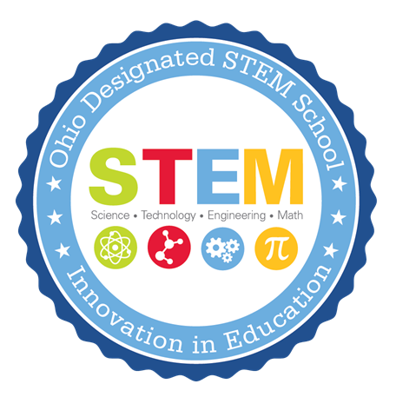

Approved: October 2021

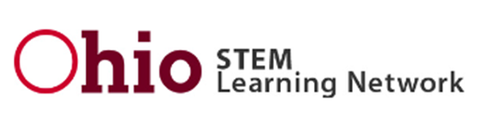

Call for Proposals for STEM and STEAM School Designation and
STEM and STEAM School-Equivalent for Schools in the State of Ohio

BACKGROUND AND PURPOSE
The Ohio STEM Committee, Ohio STEM Learning Network and Ohio Department of Education are committed to ensuring each child in Ohio is challenged, prepared and empowered for the future. STEM (science, technology, engineering and mathematics) and STEAM (science, technology, engineering, arts and mathematics) education provides an opportunity for each child to discover and learn, pursue a fulfilling post-high school path and become a resilient, lifelong learner who contributes to society.

STEM and STEAM education is an integrated approach to learning where rigorous academic concepts are learned through real-world, project-based experiences. Students use science, technology, engineering, arts/humanities and mathematics concepts to make authentic connections between school, community and work experiences. The Ohio STEM and STEAM School Designation was created to award and recognize schools that are exemplars of this work.

STEM- and STEAM-designated schools employ highly effective teachers and leaders who meet the needs of the whole child. In addition, these schools have well-established partnerships with businesses, nonprofit organizations, institutions of higher education and other entities in their communities to prepare students for post-high school success.

The Ohio STEM Committee is responsible for determining STEM and STEAM designation. A designated school is expected to maintain its current designation level and demonstrate the continued implementation of the STEM and STEAM attributes.

The following application is aligned with Ohio’s strategic plan for education, Each Child, Our Future, Ohio’s Quality Model for STEM and STEAM Schools and Ohio law.

OBJECTIVES
Future economic growth and prosperity in Ohio depend on an aligned education system that supports the state’s economic development efforts and helps all Ohio students to become innovators and inventors, self‐reliant and logical thinkers and technologically proficient problem-solvers. This Request for Proposal invites proposals to do all of the following:
- Create a culture within an established (K-12) school (special consideration provided to schools seeking to be Independent STEM schools) to help generate a talent base that will establish Ohio as a catalyst and global leader in attracting, educating and producing the next generation of scientists, engineers and other professionals needed to create tomorrow's innovations for the betterment of all citizens;
- Foster increases in the number of Ohio’s citizens studying and working in STEM and STEAM fields;
- Foster development of stronger skills in problem-solving, innovation and teamwork for all students.

ELIGIBILITY
Proposals may only be submitted by a partnership of public and private entities consisting of at least all of the following:
- A city, exempted village, local or joint vocational school district or an educational service center;
- Higher education entities;
- Business organizations.

A community school established under Ohio law (Ohio Revised Code 3314), a chartered nonpublic school or both may be part of the partnership.

Schools submitting for the 2023 Spring Designation must be opened prior to September 1, 2021. However, in accordance with Ohio law (ORC 3326), a newly created, independent STEM school (not a district STEM school) may apply for STEM designation prior to opening.

EVALUATION CRITERIA
All proposals will be reviewed according to the Portfolio Application Rubric outlined below. This rubric is aligned to Ohio’s strategic plan for education, Each Child, Our Future, the requirements in Ohio law (ORC 3326.03), which specifies the requirements of STEM and STEAM designation proposals and the Ohio’s Quality Model for STEM and STEAM Schools, which outlines the essential criteria for high-quality STEM and STEAM implementation. The criteria are used to assist schools in the innovation of a STEM culture within a school and the surrounding community.

PROPOSAL RATINGS
Initial | School will not receive designation. School is in the beginning stages of implementing STEM attributes, or school implements very few of the STEM attributes.
Approaching | School will not receive designation. School implements many but not all the STEM attributes, and/or insufficient evidence of implementation. Some attributes are present, however, there still is room for growth in implementation.
Accomplishing | School will receive designation. School is a prime example for the implementation of the STEM attributes. School implements all the STEM attributes throughout the school year to create a culture of STEM learning within the school and surrounding community.
Model | School will receive designation. School is an exemplar in implementation of STEM attributes. School implements all the STEM attributes throughout the school year to create a culture of STEM learning within the school and surrounding community.

REMINDERS
Applicants strongly are advised to review the “Quality Model for STEM and STEAM Schools,” for clarity and examples of high-quality STEM and STEAM practices.

Applicants are responsible for timely submission of proposals. Proposals become the property of the Ohio Department of Education. Proposals meeting the above requirements will receive careful consideration. This consideration will be regarding designation as a STEM or STEAM school in Ohio and will not include any consideration of grant funds or additional funding.

Applications will be reviewed by the STEM Committee and Ohio STEM Learning Network in accordance with Ohio law (ORC 3326). The rubric will be used in the review process.

CONTACT INFORMATION
STEM, Ohio Department of Education - stem@education.ohio.gov
Director, Ohio STEM Learning Network - Battelle - osln@battelle.org

APPLICATION TIMELINE/PROCESS
Nov. 15, 2021: FY23 Application Posted

Dec. 15, 2021: Complete this survey to inform the Ohio Department of Education and the Ohio STEM Learning Network on your intent to apply and if technical assistance will be pursued.

Jan. 19, 2022: Submit a rough draft of the application/portfolio to the Ohio STEM Learning Network for technical assistance. Email rough drafts to osln@battelle.org. You will receive feedback on your draft application in time to make changes prior to the final submission to the Ohio Department of Education.

Feb. 24, 2022: Final applications due to the Ohio Department of Education by 5 p.m. Email to stem@education.ohio.gov

March-April 2022: After a preliminary review from the Ohio STEM Learning Network, site visits to selected schools will be conducted during the spring. A school may also request a site visit when submitting their application.
April 2022: Applicants will be notified of the Ohio STEM Learning Network’s recommendation.
May 2022: The Ohio STEM committee will vote on designated schools.

SUBMISSION
For submission, please save the completed document as a PDF. All final applications must be emailed to the Ohio Department of Education at stem@education.ohio.gov.

Ohio STEM and STEAM Designation Application
Fiscal Year 2023

COVER SHEET
Type of Designation | STEM School ☐ STEAM School ☐  STEM School Equivalent ☐ STEAM School Equivalent ☐  STEM Program of Excellence (ESC, JVSD and CTE only) ☐
School Information | School IRN: ___________________  School Name: _____________________________________________________________  School Mailing Address: _____________________________________________________  City: ________________________ Zip: _________ County: ______________  Type: ☐ District school ☐ Independent STEM/STEAM school ☐ Community school  ☐ Chartered nonpublic school ☐ ESC ☐ JVSD ☐ CTE (comprehensive) ☐ CTE (compact)
Grade Levels | K☐ 1☐ 2☐ 3☐ 4☐ 5☐ 6☐ 7☐ 8☐ 9☐ 10☐ 11☐ 12☐ Other __________
Total Enrollment
Total # of Students Participating in STEM/STEAM

CONTACT INFORMATION:
 | Name | Email | Phone
School Principal/
Director
Treasurer/
Fiscal Officer
Superintendent/
CAO

Please print this page and attach as a separate document when submitting your application.

ASSURANCES
In accordance with Ohio Revised Code 3326.03 (or ORC 3326.032 and ORC 3326.09 for community schools or chartered nonpublic schools), please provide the following assurances. By checking the “agree” box, you attest to the following:

Agree ☐ | The school will operate in compliance with the provisions of the proposal as accepted by the committee.
Agree ☐ | The school will operate in compliance with ORC 3326 (or sections 3326.032 and 3326.09 for community schools and chartered nonpublic schools).
Agree ☐ | The school will be under the oversight of a governing body. (Include a description in the narrative where indicated.) If applicant is a community school, the school has a sponsor and a letter of support from the sponsor is included. Governing authority support is indicated by the signature below.
Agree ☐ | In the event of closure, the assets of the school will be distributed in accordance with Ohio law.
Agree ☐ | Effective 2021, schools designated under ORC 3326.03 shall maintain that designation for five years unless the STEM committee revokes its designation during that five-year period. At the end of the five-year period, the school shall reapply to the STEM committee in order to maintain that designation.

SIGNATURES

___________________________________ _____________________________ _________________
School principal/director signature Printed Name Date

___________________________________ _____________________________ _________________
Treasurer/fiscal officer signature Printed Name Date

___________________________________ _____________________________ _________________
Superintendent/chief academic officer signature Printed Name Date

FOR COMMUNITY SCHOOLS

___________________________________ _____________________________ _________________
Sponsor Representative Signature Printed Name Date

___________________________________ _____________________________ __________________
Governing Authority President Printed Name Date

STEM SCHOOL APPLICATION
The following application was created to ensure applications are in accordance with the requirements stated in Ohio law (ORC 3326.03). The portfolio format gives applicants the opportunity to provide evidence such as links, documents and artifacts that demonstrate the school is offering a rigorous, diverse, integrated and project-based curriculum to students in grades kindergarten through grade 12 while preparing students for college, workforce and citizenship. Question numbers reflect the rubric section the question fulfills.

Introduction
Describe the characteristics of the school’s STEM/STEAM practices and explain how they are different from traditional schools. (500 words maximum.)

Part 1: A Culture for Learning - Beliefs and Disposition, Equity and Access
1.1 How does the school culture promote innovation, entrepreneurialism, inquiry and collaboration?

1.2 Describe how the school culture demonstrates an inclusive mission and commitment to personalized learning.

1.3a Describe how the school’s leadership team exhibits flexible and autonomous leadership, communicates a shared vision and supports innovative instruction.

1.3b Provide evidence of school structures in place to support routine STEM-focused professional development throughout the entire school. (i.e., common planning time, professional development funds).

1.4a Describe how the school’s governing body (and/or STEM/STEAM advisory group) is selected and its level of support for the operation of a STEM/STEAM school.

1.4b Please provide a link to the listing of the school’s board members or list below:

1.4c STEM/STEAM Advisory Group Members (if applicable):
Name | Email | Role

Please link two-three meeting agendas.
1
2
3

1.4d Describe how members of the advisory group were selected and how they have contributed to the growth of STEM/STEAM in the building.

1.4e Describe how the school’s curriculum will be developed by a curriculum team* consisting of, at minimum: 1) the chief academic officer; 2) a higher education partner; 3) a teacher; and 4) a member of the public with expertise in the application of science, technology, engineering or mathematics. Describe how the team will develop an innovative curriculum.

*If the proposal is for a STEAM school or STEAM school equivalent, the curriculum team also must include an expert in the integration of arts and design into the STEM fields. Sometimes, the STEM/STEAM advisory team and curriculum team can be the same.

Part 2: Learning and Teaching
2.1 Show how personalized learning, reasoning and problem solving (scientific reasoning, engineering design, computational thinking, design thinking, argument from evidence) are emphasized throughout the curriculum. Please include your design cycle/process image (if available) the school/district utilizes and integrates into learning experiences.

2.2a Describe how problem-based learning drives instruction and curriculum.

2.2b Provide examples of Problem-based Learning.
STEM/STEAM Learning Experience  (include hyperlink to view experience lesson plan and any additional documents necessary for implementation) | Description of Project | Grade Level and # of Participating Students | **Samples of Student Work

** Please submit two to three samples of student work. Please provide a variety of levels for each learning experience.

2.2c Describe how the school implements a curriculum with interdisciplinary connections and frequently uses technology to enhance student learning. Be sure to include how the arts and humanities are integrated in the STEM/STEAM disciplines.

2.3 Describe how student learning is assessed.

2.4a Describe how the school recruits and retains faculty members with a high interest in STEM/STEAM education and experience with innovative instructional methods.

2.4b Describe how teachers effectively and consistently use best practices in STEM/STEAM pedagogy.

2.4c Highlight any professional development sessions on STEM/STEAM best practices that school staff have attended.
Professional Development Session Name  (If possible, please hyperlink to PD website) | Date and Length of Professional Development | Names and Roles of Attendees | How has the professional development content impacted the STEM/STEAM practices at your school?

Part 3: Pathways to Success in Careers
3.1 What access does the school provide to students to support career exploration/interests? If applicable, provide details about student participation in College Credit Plus and other certification programs.

3.2a Detail the established community partners and their roles within the school. *STEAM applicants must provide an art/humanities partner.
Partner Name | Type of Partnerships  (ex: Business, Nonprofit, Higher Ed) | Representative | Contact Email | Letter of Support  (Link the Letter of Support below)

3.2b Describe how partners are involved with curriculum development, provide practical, work-based learning experiences and student support and/or share resources with the school.

3.3 Describe how the school provides students with STEM/STEAM-rich formal and informal relevant experiences with the community.

Financial
Detail how the school has received or will receive in-kind and financial support from regional education partners and business entities:
  - Include examples of how the in-kind and financial support reflect the community’s priorities for STEM/STEAM education;
  - Describe how this will be used to support innovative STEM/STEAM programming.

Additional Considerations
Please detail any additional information the STEM Committee should know about the school. A narrative and/or links are allowed.

