**Student Absence Intervention Plan Template**

This form can be used by schools and districts during absence intervention team meetings to develop and implement student absence intervention plans and should be tailored to meet local needs. This plan can be copied onto a district/school letterhead.

|  |  |  |  |  |
| --- | --- | --- | --- | --- |
| **Absence Intervention Team Meeting Date:** | | | **Does the student already have an attendance intervention plan?**   * Yes * No | |
| **Team Members present (include role):** | | | | |
| **Parent/Guardian present?**   * Yes * No | | | **If no, was a parent designee present?** o Yes o No  Name of designee and relationship to student: | |
| **Student name:** *(First and Last)* | | | | |
| **Student’s grade level:** | | **Student date of birth** *(mm/dd/yyyy):* | | **Student’s SSID number:** |
| **Name of school:** | | | | |
| **Current academic progress**  *Including grades; to be completed with the student* | 1. **Favorite course/subject? ___________________________________________** 2. **What does the student enjoy about being in school? _____________________________**   **__________________________________________________________________________**   1. **Least favorite course/subject? ___________________________________________** 2. **Extracurricular activities the student participates in:** _________________________   **________________________________________________________________________** | | | |
| **Student and Family Strengths:** |  | | | |
| **Graduation Plan reviewed** (*for HS students only*)**?**   * Yes * No   **Is the student being evaluated for/currently on an IEP?**   * Yes * No   **If yes, has the IEP team reviewed the IEP for absence of services?**o Yes o No | | | | |

|  |  |
| --- | --- |
| **Student Attendance for Current School Year** | |
| **Student has been present for _______________ hours/days of the school year.** | |
| **Student has been absent for _______________ hours/days of the school year.** | |
| **Student has been tardy for _______________ hours/days of the school year** | |
| **Student has left early for _______________ hours/days of the school year** | |
| **Student has ______________ excused absences.** | **Student has ____________ unexcused absences.** |
| **What patterns regarding the student’s absences does the team observe?** | |

|  |
| --- |
| **Early Intervention Strategies**  **What Tier 1 and Tier 2 strategies have been implemented to date?** |
| * **Personalized positive calls by the teacher when the student misses a day of school** * **Involve the student in before- and after-school activities** * **Recognition of good and improved attendance** * **Small group sessions** * **Counseling** * **Check in/check out** * **Connected to a mentor or caring adult** * **Student success plan and family help bank** * **Tutoring** * **Alternative schedule** * **Extracurricular activities** * **Positive home visit** * **Connection to mental health resources and supports (in school and out of school)** |

**Root Cause Analysis**

*Reasons for absences typically fall into four broad categories: (1) Barriers to attendance, (2) Aversion to school, (3) Disengagement from school, and (4) Misconceptions about the impact of absences.*

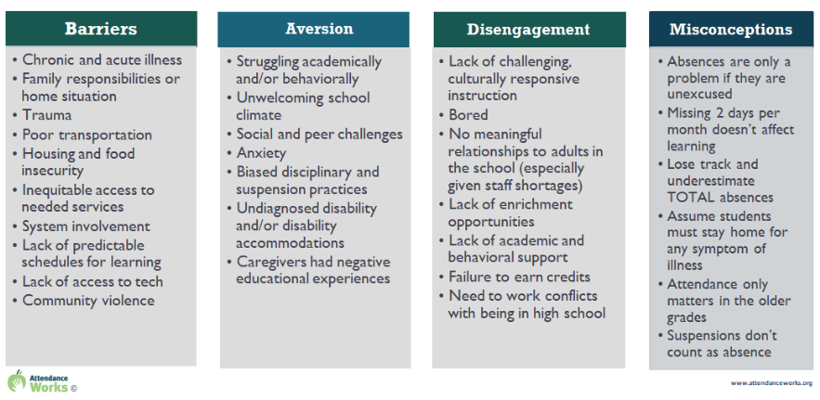

*Using the worksheet below, list the barriers to attendance from the student and family perspective:*

|  |  |
| --- | --- |
| WORKSHEET: UNDERSTANDING THE ROOT CAUSES FOR STUDENT ABSENTEEISM | |
| **Academic Conditions** |  |
| Is the student struggling academically? | Y/N |
| Does the student need accommodations to benefit from classroom instructions? (e.g. breaks, material presented in different ways) | Y/N |
| Does the student have language or communication challenges? | Y/N |
| Does the student struggle with organizational tasks? | Y/N |
| Are there barriers to homework completion? | Y/N |
| Do you suspect that the student has an unidentified disability? | Y/N |
| Has the IEP/504 team met recently to review/revise the student’s educational plan? | Y/N |
| Is the student avoiding difficult social/academic situations by staying away from school? | Y/N |
| **Safety Concerns** |  |
| Have there been any reports of bullying? | Y/N |
| Is the student exposed to race, disability, cultural, or LGBTQ biases? | Y/N |
| **School Culture** |  |
| Are transitions difficult for the student? (e.g. entering the school building, moving from class to class) | Y/N |
| Are there any clubs, programs, or resources during the school day and after school that might help engage the student? | Y/N |
| Is there a caring adult at the school that could mentor the student? | Y/N |
| **Home Situation** |  |
| Do the parents/guardians recognize the importance of and support regular school attendance? | Y/N |
| Are there problems in the home that contribute to frequent absences? (e.g., parental illness, homelessness, child care) | Y/N |
| Does the student exhibit anxiety due to separation from parent/caregiver? | Y/N |
| Does the student require health or mental health-related treatment that interferes with attendance? | Y/N |
| **Health Status** |  |
| Are there conditions in the school that affect the student’s health or safety? (e.g. mold or other asthma triggers, food allergens) | Y/N |
| Does the student or family member have a chronic medical condition? | Y/N |
| **Student & Family Voice** |  |
| Has the student identified the reasons for missing school? | Y/N |
| Have you met with the parent/caregiver to discuss attendance concerns? | Y/N |
| Has the parent/caregiver identified specific barriers to attendance? | Y/N |
| Are there cultural, language, or other types of barriers that require extra effort on the part of the school to work with the parent/caregiver? | Y/N |

|  |  |
| --- | --- |
| **Strategies to Address the Barriers Identified Through the Root Cause Analysis** | |
| * **Extracurricular activities** * **Tutoring** * **Mentor** * **Small support group** * **Parent education program** * **Mediation** * **Alternative academic program** * **IEP/504 consideration** * **IEP/504 review** * **Student counseling** * **Parent/Family counseling** * **Basic needs (food, shelter, etc.)** * **Employment** * **Work-based learning** * **Community organization referral (insert name): __________________________________________** * **Other: ____________________________________________________________________________________** | |
| **Attendance Improvement Plan** |
| **Attendance improvement goal:** |
| **Identified areas for support:** |
| **To Improve Attendance:** |
| **The student has agreed to do the following:** |
| **The parent/guardian has agreed to do the following:** |
| **The school has agreed to do the following:** |

|  |  |  |
| --- | --- | --- |
| **Record of Absence Intervention Team Meeting** | | |
| I/we understand this plan has been created as a support for the student to improve attendance at school. In the event the student is absent for any reason, the school will be contacted as instructed by the attendance procedures received.  I/we also understand if the student fails to improve their attendance per this plan or has refused to participate in this plan, the attendance officer, obligated by Ohio law, shall file a complaint not later than sixty-one (61) days after the plan was implemented. The attendance officer may file a complaint prior to the 61st day if the student is absent without legitimate excuse for 30 consecutive hours or 42 hours in one school month during the implementation period of the plan. | | |
| **Absence Intervention Team Meeting Date:** | | |
| **Plan Start Date:** | **Plan End Date:** | **Plan Review Date:** |
| **___________________________________________________________________________________**  **Student signature Date**  **___________________________________________________________________________________**  **Parent/Guardian signature Date**  **___________________________________________________________________________________**  **School Official signature Date** | | |

|  |  |
| --- | --- |
| **Should we have difficulty in implementing the plan or are not clear on our roles in the plan, we can contact the following with questions or concerns:**  **Name of school contact: _________________________________________________________**  **Phone number: ______________________________________________**  **Email address: _______________________________________________** | |
| **Parent/Guardian contact information:** | **Street address:**  **____________________________________________________________________**  **Mailing address (if different):**  **____________________________________________________________________**  **Home phone: __________________**  **Cell phone: ____________________**  **Work phone: ___________________** |
| **Parent/Guardian contact information:** | **Street address:**  **___________________________________________________________________**  **Mailing address (if different):**  **___________________________________________________________________**  **Home phone: _____________________________**  **Cell phone: _______________________________**  **Work phone: ______________________________** |

|  |  |
| --- | --- |
| **Parent/Guardian Preferred Communication**   * *Emergency contact form reviewed and updated (if necessary)* | * **Home phone** * **Cell phone** * **Work phone** * **Mail** * **Email:**   **________________________________**   * **Other:**   **________________________________** |