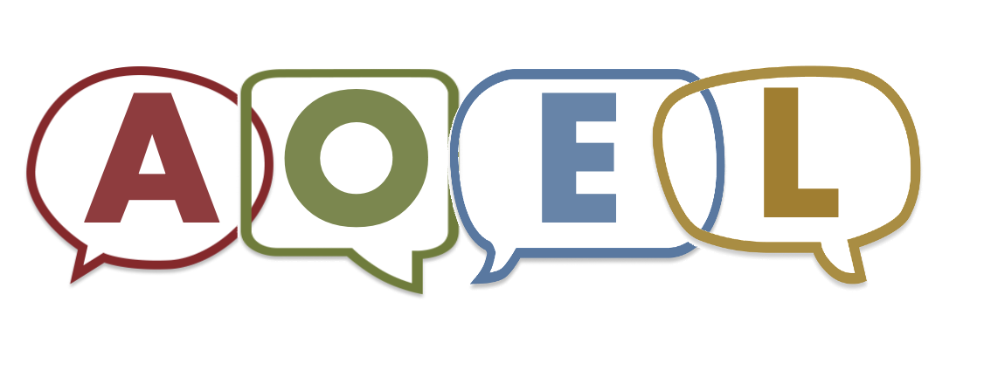**Advancing Ohio’s English Learners**

Tips and Questions Families Can Use During Enrollment

The school may ask for a lot of information from you. This is also a good time for you to learn about the school. You can ask questions that will be helpful to you and your child. Here is a list of possible questions.

# Questions You Can Ask During Enrollment

* How can the school help my child learn English?
* How will I get information from the school once my child is enrolled?
* Can the school help with getting my child to school or home?
* Does the school have before- or after-school programs? How do I enroll my child in those programs?
* My child takes medicine during the day. How can I make sure my child takes the medication during school?
* Where can I find information about the meals offered by the school?
* Does the school require uniforms or have a dress code?
* What are the school’s hours?
* Is there a school calendar available that shows holidays and school breaks?
* What can I do if my family celebrates a holiday that is not on the school calendar?
* What school supplies does my child need for the first few days of school?

# Tips for Families

* When you are making an appointment to enroll your child let the school know if you would like help from an interpreter.
* Make sure to tell the school about any allergies, medical conditions or medications your child needs.
* If possible, visit your school and district websites to see what information is available to help you prepare for enrolling your child.
* Ask for a school calendar and information about when the school may open late or close early.