Helping Your Child with Virtual (or Online) Learning

# How do schools use virtual learning?

Virtual learning is a way of learning using technology and has changed the way we learn in school. It provides children of all ages the opportunity to quickly grow their understanding of the world around them. To make the most of this technology, schools use virtual learning to help students with their learning. The way schools use virtual learning can be different at each school and grade level. It is important to understand how to support virtual learning at home.

Other names for virtual learning are remote learning and online learning.

# What is virtual learning?

Virtual learning is when students use technology to learn. Some schools have a mix of in-person and online learning. *This may also be called blended learning or hybrid.* This means students go to school but also learn online. Other schools are fully online where all the learning happens on the computer.

## Examples of virtual learning:

* A mix of online and in-person activities.
* Activities or meetings led by the teacher during school time. Activities students complete online outside of school.
* Online projects students work on together. Communicating with teachers or classmates online.

# How can I help my child with virtual learning?

## 1. Communicate with teachers.

You can build a stronger relationship with teachers. This helps them understand your child’s needs or the challenges they may face. You can also reach out to your child’s teacher when you have questions or need help.

### Tips:

* To get in touch with your child’s teachers, ask them the easiest way to contact them. [Explore our How to Participate in School Committees and Teams page to learn more.](https://education.ohio.gov/Topics/Student-Supports/English-Learners/AOEL/Family-Roadmap/Participate-in-School)
* Let the teacher know if you have any issues getting internet or any other devices your child needs. They may be able to connect you with resources. If you have internet needs, you may ask the teacher if there are other ways for your child to complete assignments. They may have worksheets your child can do at home.
* If your child cannot attend live video lessons, let the teacher know. They may have other ways your child can participate.
* Find out how to use the virtual learning platform used at your child’s school. See if there are ways to change the language settings to help you or your child translate materials when this is needed.

## 2. Create a learning environment for virtual learning.

Creating spaces in your home for your childʼs learning can help them be more creative. It can also improve their focus and motivation. Your child needs a space where they can move around and be comfortable.

### Here are some of the types of spaces your child may need:

* A quiet space where your child can be comfortable reading, drawing, or writing.
* A space for virtual learning where your child can use a computer, laptop, or other devices. This area should be somewhere where you can see your child easily. This will help you monitor their learning and online interactions. Also, make it a space where they have better internet access.
* Space outside where your child can take breaks. They can exercise, breathe some fresh air, and play.

## 3. Help your child balance their screen time.

It is becoming more common for children to use devices and technology to learn. Sometimes families may worry about how much time children spend online or looking at screens. It may be helpful to consider how much time your child spends online and how your child is using their devices. Talk with your teacher if you have concerns about the time your child spends on the internet or using computers.

### Helpful ways children may use devices:

* To connect with others, like video chats with classmates or teachers.
* For entertainment, like gaming and social media use; at the right age, both can have a place in your child’s life, but they should not spend too much time on devices.
* For learning, like a virtual story time, class lessons or other online activities.

### Connections Matter

Encourage your child to use technology to connect with teachers, friends, and family. Children can use technology to practice their learning. Your family can also use technology to connect with your child’s school.

## 4. Establish routines and a schedule.

Children learn best when they have a routine and a schedule. For virtual learning from home, some experts recommend making time at the start of the day to plan. They also recommend making time in the afternoon. This is when your child can show you their work and what they learned.

### Here are tips for creating a routine:

* Write out a schedule.
* Make your schedule easy to see and follow. Plan breaks.
* Work as a team. Ask for your child’s input. Schedule family time.

## 5. Use breaks to improve your child’s learning.

Without breaks, your child may have difficulty staying focused. They may take breaks at a certain time or after completing a task. Help your child decide what to do during their break. It is better if your child is active during breaks. For example, you can do exercise or stretch together. It will help them remember what they learned.

### Benefits of Breaks

Breaks can help your child focus and complete their work.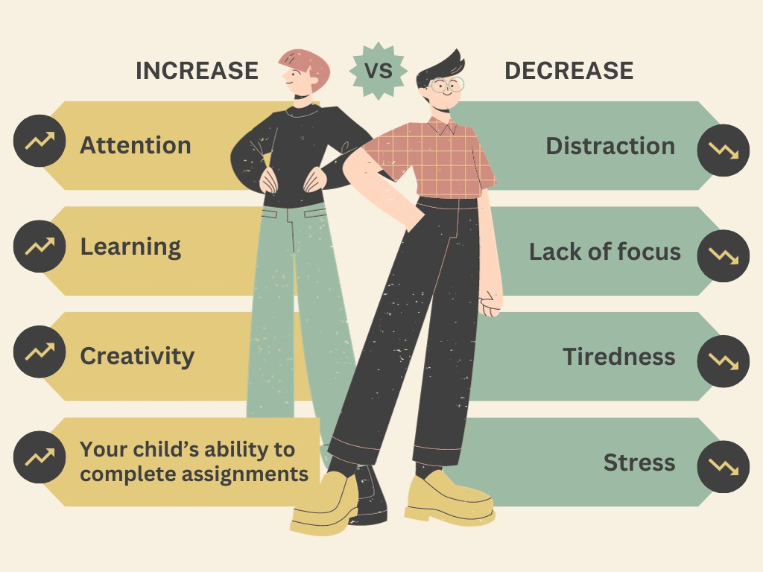

There are different things younger and older children can do for breaks. Here are some examples:

### Breaks for younger children:

* Be physically active, like jumping, running, and dancing. Play with a pet.
* Read with someone.
* Color or draw.
* Do something with hands, like playing with clay.

### Breaks for older children and youth:

* Talk with a friend or classmate.
* Stretch.
* Walk or play outside.
* Cook or make a snack.
* Draw or paint.

# What can I do if I do not have internet or the devices my child needs?

Sometimes families have trouble connecting to the internet. They may not have devices that children may need for virtual learning.

### Here are some things you can do:

* Talk with your child’s teachers and the school staff. Most schools have resources and programs to help students. These programs can help with getting internet, access to a computer and much more.
* Ask your child’s teachers if there are other ways your child can complete online assignments. Ask community leaders or organizations for help.
* Check resources in your community, like the public library. They often have computers, internet, and other resources for virtual learning.
* Use [Library Ohio to find a public near you](https://library.ohio.gov/using-the-library/find-an-ohio-library).

# Questions You Can Ask

* I am not comfortable with my computer skills, who can help my child with their online work?
* What can I do to support my child’s learning online if we do not have access to a computer? Or, if we do not have access to the internet?
* What is screen time and is it helpful for my child?
* My child always tells me they need the computer for homework, but I catch them using it for other things instead. How can I help them stay focused?
* What can I do to help them focus on their schoolwork?
* Does the school provide any materials or help for virtual learning?

## Additional Resources

Check out these resources about virtual learning.

* Discounts for internet services can be found on the Ohio Department of Developmental Disabilities website. [https://dodd.ohio.gov/about-us/resources/tech-first/Internet_Discount](https://dodd.ohio.gov/about-us/resources/tech-first/Internet_Discount%20)
* Edmentum provides a guide for parents with tips for supporting virtual learning. <https://blog.edmentum.com/resource-parent-guide-support-your-child-during-virtual-learning>
* This Immigrants, Refugees and Schools webpage has videos that explain how to use Google Classroom and other online education tools. <https://www.immigrantsrefugeesandschools.org/post/google-classroom-and-more-in-multiple-languages>
* This Google file has examples about Google apps and other education apps. The first tab of the Google file has all Google apps. The second tab has examples of other apps. <https://docs.google.com/spreadsheets/d/1_S9A45vTRArvGC7OUwfCzEwRgNRUypjLNlX9vO8_MOs/edit?pli=1#gid=0>
* On this Learning Learn English Kids site, young students learning English can practice reading, writing, speaking, and listening skills. They can practice through a variety of games, videos, and printable activities. [https://learnenglishkids.britishcouncil.org](https://learnenglishkids.britishcouncil.org/)
* This free Wright and Improve website helps students improve their writing. <https://writeandimprove.com/free>
* Your public library may be a great resource. They may help students with virtual learning. They can also help them get access to computers, internet, and other technology they may need. To find a public library near you, visit this Library Ohio page. <https://library.ohio.gov/using-the-library/find-an-ohio-library>
* Learn about other educational programs and services for your child in the English Learner Family Toolkit. Just select the link and select Chapter 3. It is available in four languages (English, Arabic, Chinese, and Spanish). <https://ncela.ed.gov/educator-support/toolkits/family-toolkit>

*These resources aim to bolster academic, student wellness and college and career outcomes for Ohio's multilingual learners. Resources were created through a collaborative effort between the Ohio Department of Education and Workforce and The Ohio State University's Center on Education and Training for Employment along with a dedicated group of family advocates, community leaders, school district personnel and teachers.*