McKinney-Vento Social Media Guide
This guide is an optional tool for schools, districts, and Educational Service Centers (ESCs) to reference in developing social media communications around educational rights and supports for children and youth experiencing homelessness.

Liaisons have a responsibility to spread public notice of McKinney-Vento rights in locations frequented by families and youth in a manner and form understandable to them. Social media communication can be a valuable way to connect with students and families and increase awareness of the educational rights and services available to them. This guide provides a list of concepts that can be communicated via social media and sample language and imagery that schools, districts and ESCs can use as a reference when creating their own communications.

Liaisons are encouraged to work with their school or district’s communications team to develop content for social media messaging.

Additional Tools:
For guidance on McKinney-Vento website communication or displaying outreach and awareness materials in your school, district, and community, download the McKinney-Vento Website Communication Guide and the McKinney-Vento Poster Tracker, both available on the Ohio Department of Education and Workforce’s Professional Development web page.

McKinney-Vento Social Media Guide
Consider using social media posts to communicate the following concepts to raise awareness of student homelessness:

The McKinney-Vento Definition of Homelessness
Utilize social media platforms to communicate the McKinney-Vento definition of homelessness and outline specific living situations that meet this definition. Inform students that meeting this definition qualifies them for rights and protections under federal law and include your contact information.

Example:
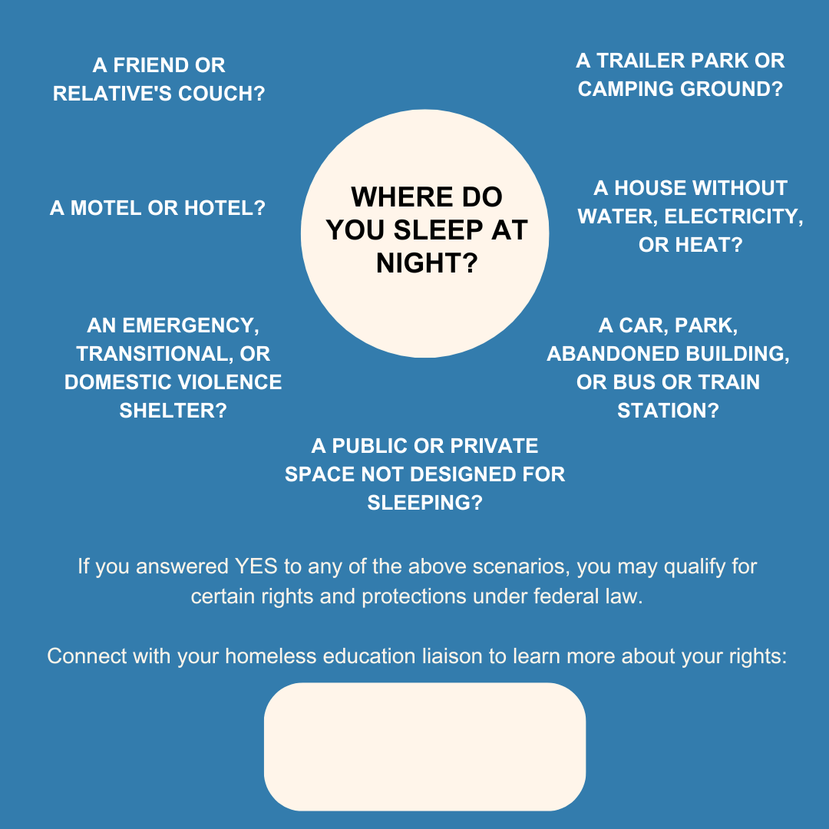

Alt Text: Where do you sleep at night? A friend or relative's couch? A motel or hotel? An emergency, transitional, or domestic violence shelter? A trailer park or camping ground? A house without water, electricity, or heat? A car, park, abandoned building, or bus or train station? A public or private space not designed for sleeping? If you answered yes to any of the above scenarios, you may qualify for certain rights and protections under federal law. Connect with your homeless education liaison to learn more about your rights.

Educational Rights
Understanding the educational rights and services that children and youth experiencing homelessness are eligible for can incentivize students to self-identify and reach out for support. Liaisons are encouraged to utilize social media platforms to make students aware of these rights and services. Explain these rights in terms and language that is easy for students to understand. Be sure to include your contact information.

Example:
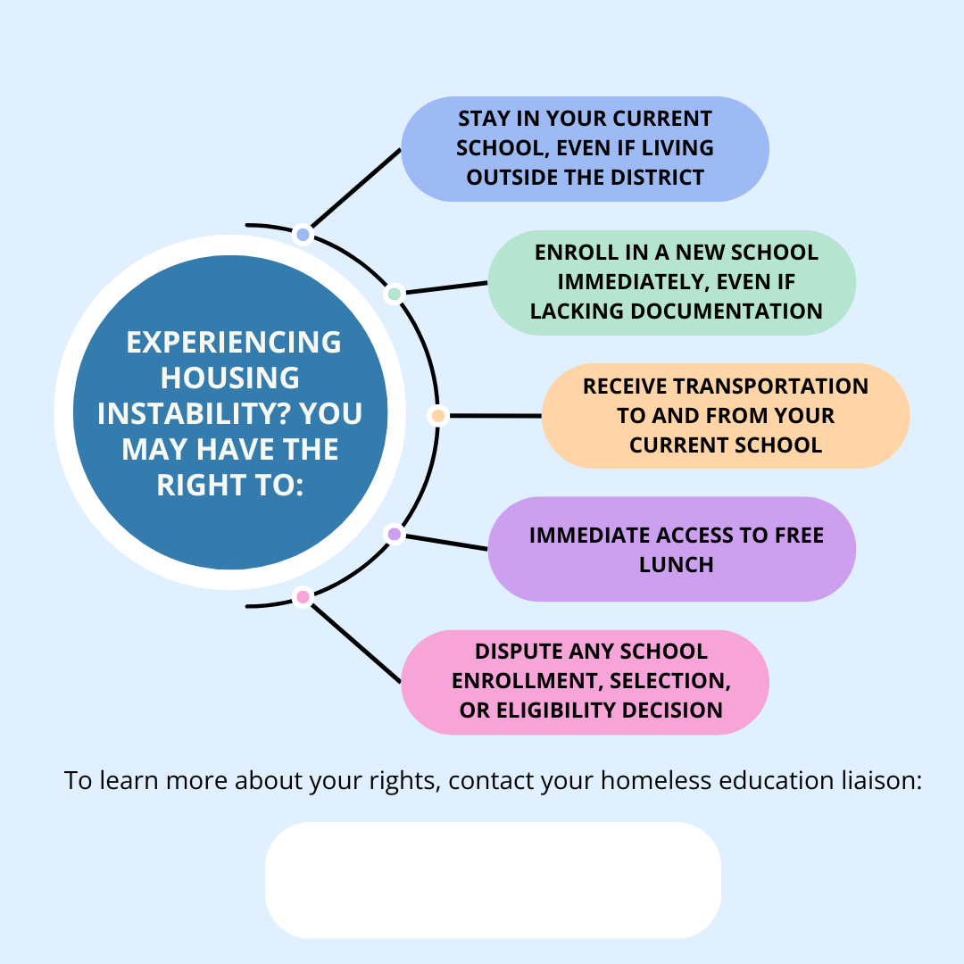

Alt Text: Experiencing housing instability? You may have the right to:
- Stay in your current school, even if living outside the district;
- Enroll in a new school immediately, even if lacking documentation;
- Receive transportation to and from your current school;
- Immediate access to free lunch; and
- Dispute any school enrollment, selection, or eligibility decision.

To learn more about your rights, contact your homeless education liaison.

District Programs and Services
Social media platforms can be an effective avenue for informing students and families about current school or district programming. Liaisons are encouraged to create communications about available programs and services. When creating announcements and other materials, do not emphasize the word “homeless.” Instead, use more general language to shift the focus on the need that the program is addressing.

Example:

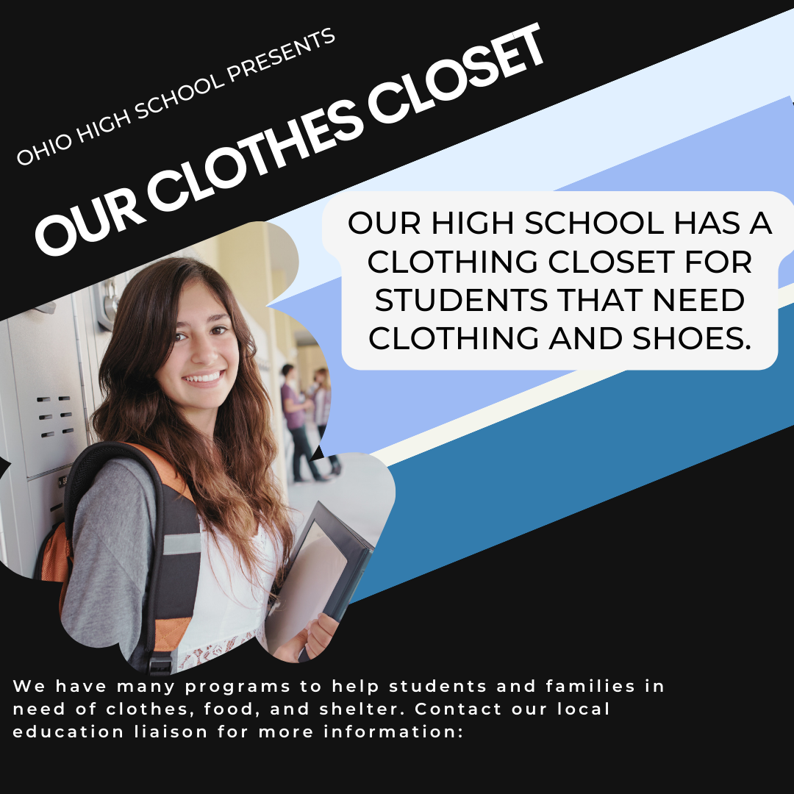

Alt Text: Ohio High School presents Our Clothes Closet. Our high school has a clothing closet for students that needs clothing and shoes. We have many programs to help students and families in need of clothes, food, and shelter. Contact our homeless education liaison for more information.

Community Resources
Social media platforms can additionally be an effective avenue for informing students and families about local community resources. Liaisons are encouraged to create communications about the programs and services available in your area so students and families can access additional supports after school and on weekends.

Example:

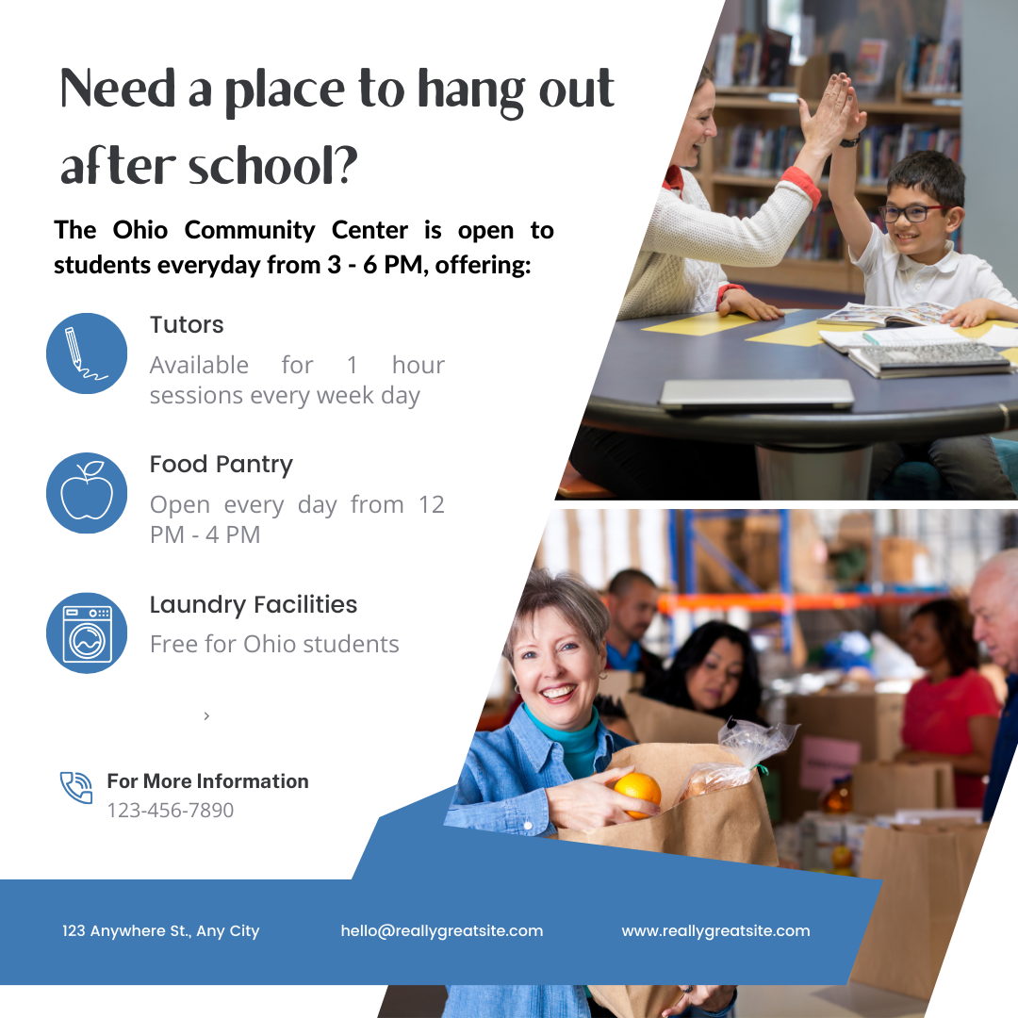

Alt Text: Need a place to hang out after school? The Ohio Community Center is open to students every day from 3 - 6 p.m., offering tutors, a food pantry, and laundry facilities.

Prevalence of Student Homelessness
Additionally, liaisons are encouraged to utilize social media platforms to raise awareness about the prevalence of student homelessness in their school or district. Raising awareness about the number of students experiencing homelessness in your community can help reduce stigma around homelessness. Students may be more likely to identify themselves as experiencing homelessness and seek support if they don’t feel alone in their experience. For state and county level data on students experiencing homelessness, visit Ohio’s Enrollment Dashboard.

Example:

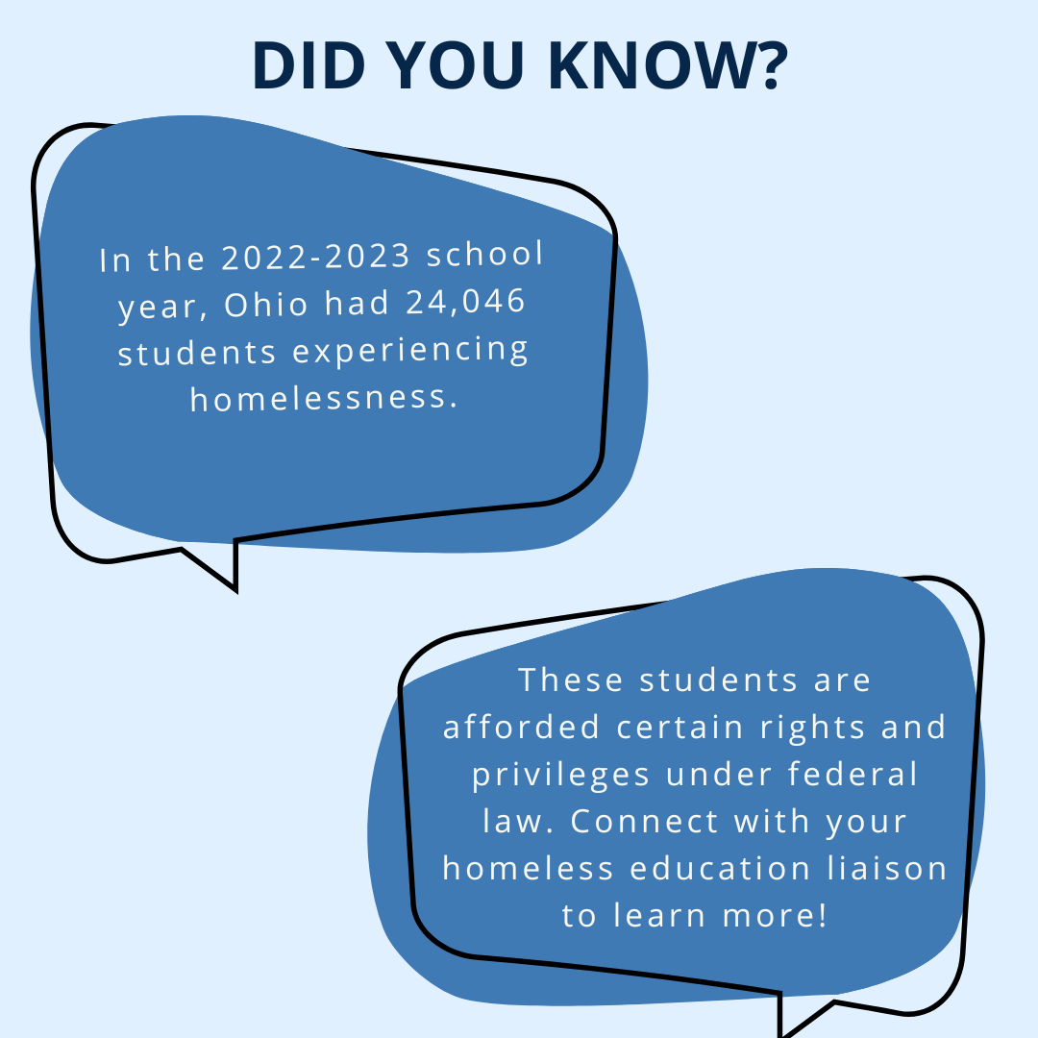

Alt Text: Did you know? In the 2022-2023 school year, Ohio had 24,046 students experiencing homelessness. These students are afforded certain rights and privileges under federal law. Connect with your homeless education liaison to learn more!

Liaison Availability
Social media can be an effective method for connecting with students. Let students know that they can approach you to voice concerns, ask questions, and seek support. Include your contact information and availability.

Example:

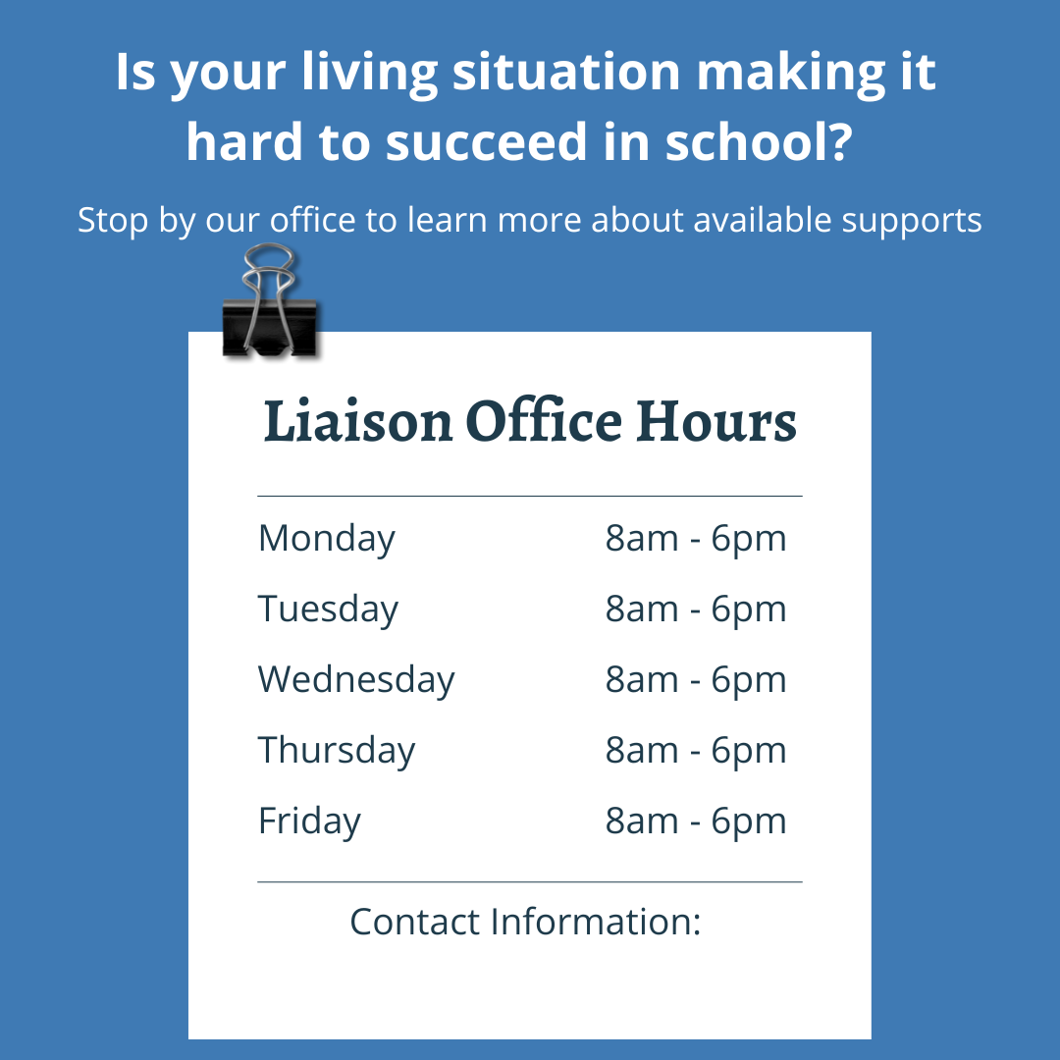

Alt Text: Is your living situation making it hard to succeed in school? Stop by our office to learn more about available supports. Liaison Office Hours: Monday – Friday, 8 a.m. – 6 p.m.

Reminders and Deadlines
In conjunction with alternative modes of communication, social media can be a useful tool to increase student attention to timely information, such as deadlines or information about services for which they may be eligible.

Example:

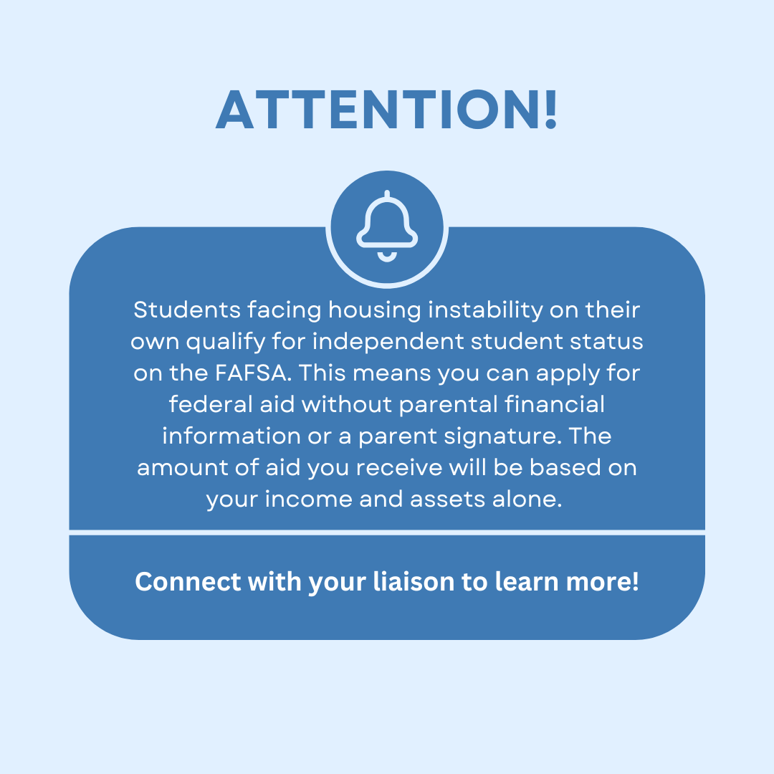

Alt Text: Attention! Students facing housing instability on their own qualify for independent student status on the FAFSA. This means you can apply for federal aid without parental financial information or a parent signature. The amount of aid you receive will be based on your income and assets alone. Connect with your liaison to learn more!

Additional Tips and Tricks
- Always include your contact information.
- Provide information in multiple languages to increase accessibility.
- Use youth-friendly language and avoid jargon.
- Avoid stigmatizing language such as “homeless.”
- Make your social media accounts welcoming, engaging, and easy to navigate.
- Check your accounts often for broken links or outdated information.

